**Database Systems Handbook**

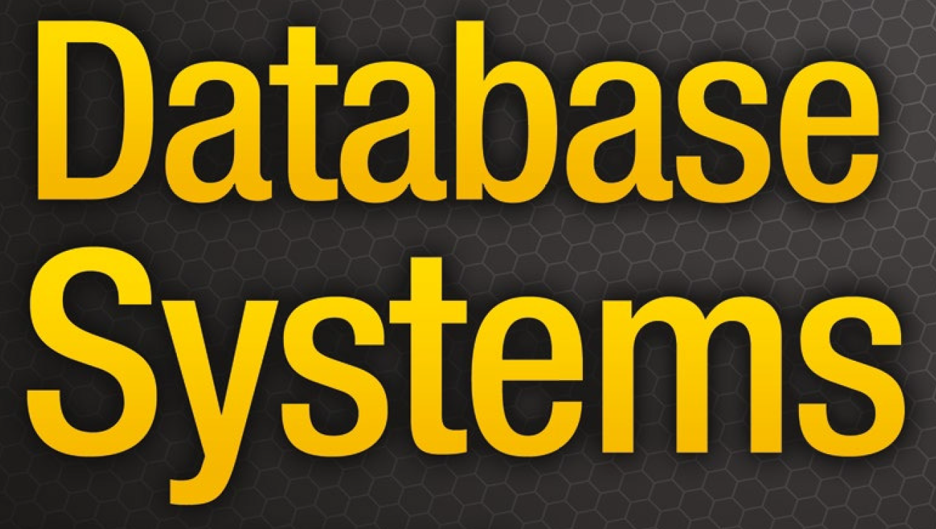

**Prepared by:**

**Muhammad Sharif**

**Senior Database Administrator**

**SKMCH&RC**

**Lahore, Punjab, Pakistan**

🡸==============🡺

**Dedication**

**I dedicate all my efforts to my reader who gives me an urge and inspiration**

**to work more.**

***Muhammad Sharif***

**Author**

|  |
| --- |
| **CHAPTER 1 INTRODUCTION TO DATABASE AND DATABASE MANAGEMENT SYSTEM** |
|  |
| **CHAPTER 2 DATA TYPES, DATABASE KEYS, SQL FUNCTIONS AND OPERATORS** |
|  |
| **CHAPTER 3 DATA MODELS, ITS TYPES, AND MAPPING TECHNIQUES** |
|  |
| **CHAPTER 4 DISCOVERING BUSINESS RULES AND DATABASE CONSTRAINTS** |
|  |
| **CHAPTER 5 DATABASE DESIGN STEPS AND IMPLEMENTATIONS** |
|  |
| **CHAPTER 6 DATABASE NORMALIZATION AND DATABASE JOINS** |
|  |
| **CHAPTER 7 FUNCTIONAL DEPENDENCIES IN THE DATABASE MANAGEMENT SYSTEM** |
|  |
| **CHAPTER 8 DATABASE TRANSACTION, SCHEDULES, AND DEADLOCKS** |
|  |
| **CHAPTER 9 RELATIONAL ALGEBRA AND QUERY PROCESSING** |
|  |
| **CHAPTER 10 FILE STRUCTURES, INDEXING, AND HASHING** |
|  |
| **CHAPTER 11 DATABASE USERS AND DATABASE SECURITY MANAGEMENT** |
|  |
| **CHAPTER 12 BUSINESS INTELLIGENCE TERMINOLOGIES IN DATABASE SYSTEMS** |
|  |
| **CHAPTER 13 DBMS INTEGRATION WITH BPMS** |
|  |
| **CHAPTER 14 RAID STRUCTURE AND MEMORY MANAGEMENT** |
|  |
| **CHAPTER 15 ORACLE DATABASE FUNDAMENTAL AND ITS ADMINISTRATION** |
|  |
| **CHAPTER 16 DATABASE BACKUPS AND RECOVERY, LOGS MANAGEMENT** |
|  |
| **CHAPTER 17 PREREQUISITES OF STORAGE MANAGEMENT FOR ORACLE INSTALLATION** |
|  |
| **CHAPTER 18 ORACLE DATABASE APPLICATIONS DEVELOPMENT USING ORACLE APPLICATION EXPRESS** |
|  |
| **CHAPTER 19 ORACLE WEBLOGIC SERVERS AND ITS CONFIGURATIONS** |

**🡸=============================================🡺**

**Acknowledgments**

We are grateful to numerous individuals who contributed to the preparation of relational database systems and management, 2nd edition. First, we wish to thank our reviewers for their detailed suggestions and insights, characteristic of their thoughtful teaching style.

All glories praises and gratitude to Almighty Allah, who blessed us with a super and unequaled Professor as ‘Brain’.

**THANKS**

**CHAPTER 1 INTRODUCTION TO DATABASE AND DATABASE MANAGEMENT SYSTEM**

**What is Data?**

Data – The World’s Most Valuable Resource. Data are the raw bits and pieces of information with no context. If I told you, “15, 23, 14, 85,” you would not have learned anything. But I would have given you data. Data are facts that can be recorded, having explicit meaning.

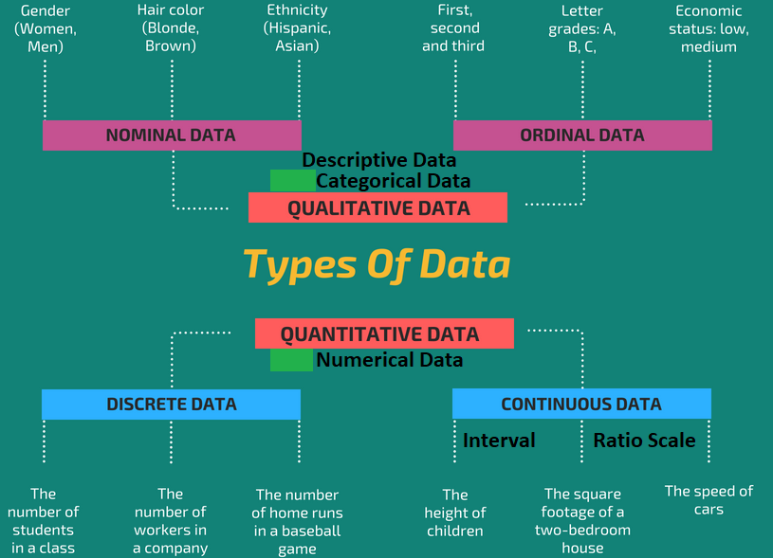

We can **classify data** as structured, unstructured, or semi-structured data.

1. **Structured data** is generally quantitative data, it usually consists of hard numbers or things that can be counted.
2. **Unstructured data** is generally categorized as qualitative data, and cannot be analyzed and processed using conventional tools and methods.
3. **Semi-structured data** refers to data that is not captured or formatted in conventional ways. Semi-structured data does not follow the format of a tabular data model or relational databases because it does not have a fixed schema. XML, JSON are semi-structured example.

**Properties**

Structured data is generally stored in data warehouses.

Unstructured data is stored in data lakes.

Structured data requires less storage space while Unstructured data requires more storage space.

**Examples:**

* Structured data (Table, tabular format, or Excel spreadsheets.csv)
* Unstructured data (Email and Volume, weather data)
* Semi-structured data (Webpages, Resume documents, XML)

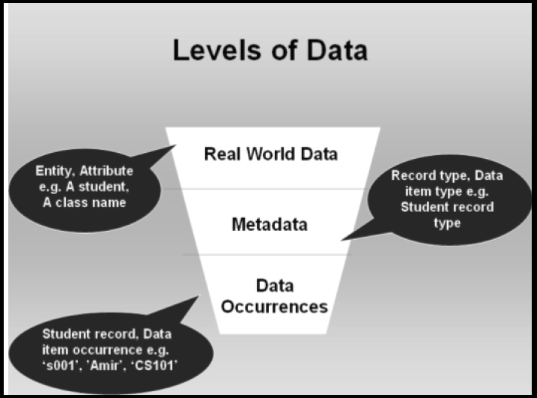

**Categories of Data**

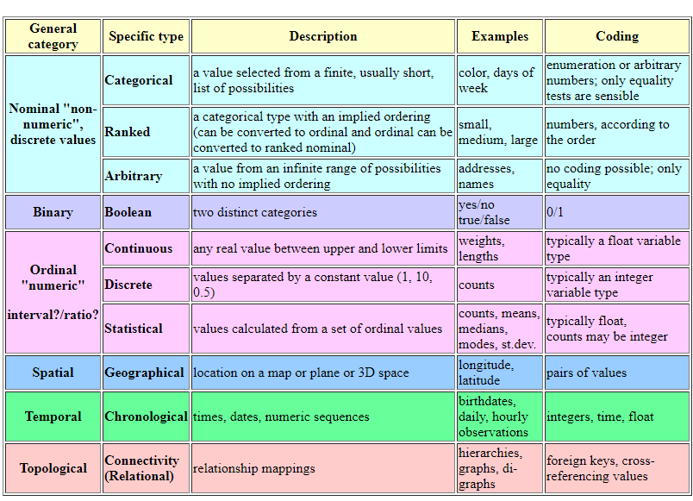

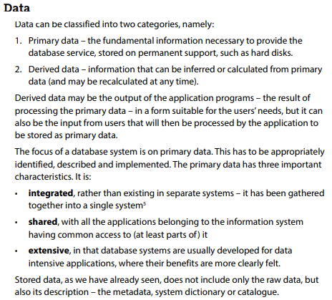

**Implicit data** is information that is not provided intentionally but gathered from available data streams, either directly or through analysis of explicit data.

**Explicit data** is information that is provided intentionally, for example through surveys and membership registration forms. Explicit data is data that is provided intentionally and taken at face value rather than analyzed or interpreted.

**Data hacking Method**

A data breach is a cyber attack in which sensitive, confidential or otherwise protected data has been accessed or disclosed.

**What is a data item?**

The basic component of a file in a file system is a data item.

**What are records?**

A group of related data items treated as a single unit by an application is called a record.

**What is the file?**

A file is a collection of records of a single type. A simple file processing system refers to the first computer-based approach to handling commercial or business applications.

**Mapping from file system to Relational Database**

In a relational database, a data item is called a column or attribute; a record is called a row or tuple, and a file is called a table.

**Mainchallenges from file system to database movements**

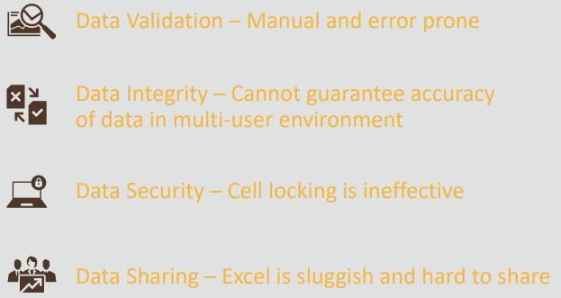

**What is information?**

When we organized data that has some meaning, we called information.

**What is the database?**

A database is an organized collection of related information or collection of related data. It is an interrelated collection of many different types of database objects (tables, indexes).

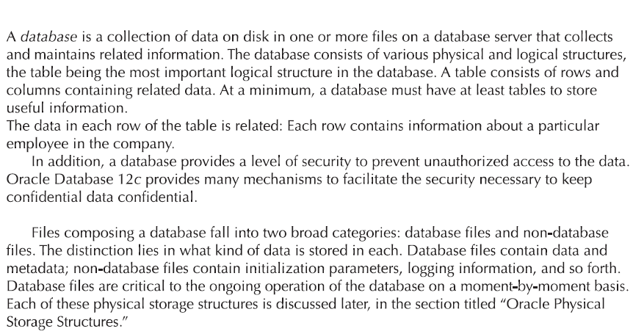

**What is Database Application?**

A database application is a program or group of programs that are used for performing certain operations on the data stored in the database. These operations may contain insertion of data into a database or extracting some data from the database based on a certain condition, updating data in the database. Examples: (GIS/GPS).

**What is Knowledge?**

Knowledge = information + application

**What is Meta Data?**

The database definition or descriptive information is also stored by the DBMS in the form of a database catalog or dictionary, it is called meta-data. Data that describe the properties or characteristics of end-user data and the context of those data. Information about the structure of the database.

**Example Metadata** for Relation Class Roster catalogs (Attr_Cat(attr_name, rel_name, type, position like 1,2,3, access rights on objects, what is the position of attribute in the relation). Simple definition is data about data.

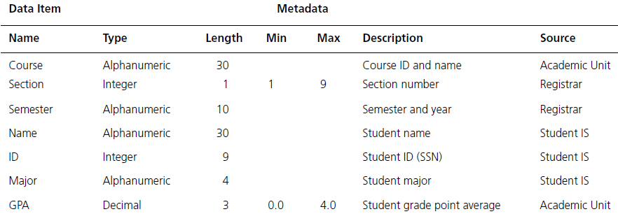

**What is Shared Collection?**

The logical relationship between data. Data inter-linked between data is called a shared collection. It means data is in the repository and we can access it.

**What is Database Management System (DBMS)?**

A database management system (DBMS) is a software package or programs designed to define, retrieve, Control, manipulate data, and manage data in a database.

**What are database systems?**

A shared collection of logically related data (comprises entities, attributes, and relationships), is designed to meet the information needs of the organization. The database and DBMS software together is called a database system.

**Components of a Database Environment**

1. Hardware (Server),
2. Software (DBMS),
3. Data and Meta-Data,
4. Procedure (Govern the design of database)
5. Resources (Who Administer database)

**History of Databases**

From 1970 to 1972, E.F. Codd published a paper proposed using a relational database model. RDBMS is originally based on E.F. Codd's relational model invention. Before DBMS, there was a file-based system in the era the 1950s.

**Evolution of Database Systems**

* Flat files - 1960s - 1980s
* Hierarchical – 1970s - 1990s
* Network – 1970s - 1990s
* Relational – 1980s - present
* Object-oriented – 1990s - present
* Object-relational – 1990s - present
* Data warehousing – 1980s - present
* Web-enabled – 1990s – present

Here, are the important landmarks from evalution of database systems

* 1960 – Charles Bachman designed the first DBMS system
* 1970 – Codd introduced IBM’S Information Management System (IMS)
* 1976- Peter Chen coined and defined the Entity-relationship model also known as the ER model
* 1980 – Relational Model becomes a widely accepted database component
* 1985- Object-oriented DBMS develops.
* 1990- Incorporation of object-orientation in relational DBMS.
* 1991- Microsoft MS access, a personal DBMS and that displaces all other personal DBMS products.
* 1995: First Internet database applications
* 1997: XML applied to database processing. Many vendors begin to integrate XML into DBMS products.

**The ANSI-SPARC Database systems Architecture levels**

1. The Internal Level (Physical Representation of Data)
2. The Conceptual Level (Holistic Representation of Data)
3. The External Level (User Representation of Data)

Internal level store data physically. The conceptual level tells you how the database was structured logically. External level gives you different data views. This is the uppermost level in the database.

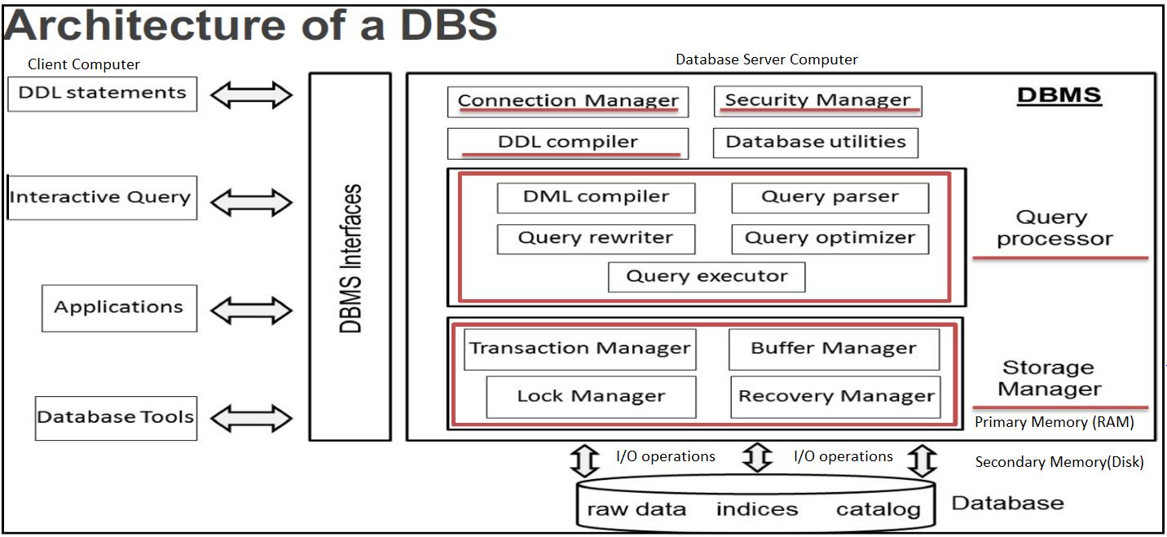

**Database architecture tiers**

Database architecture has 4 types of tiers.

**Single tier** architecture (for local applications direct communication with database server/disk. It is also called physical centralized architecture.

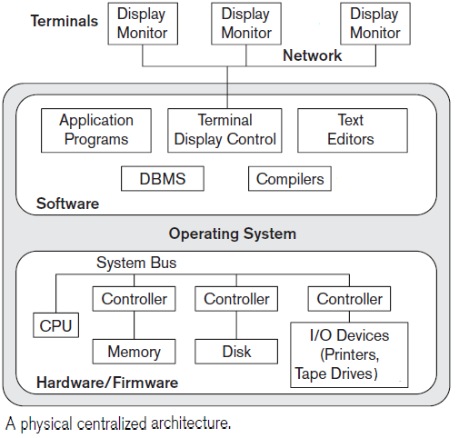

**2-tier** architecture (basic client-server APIs like **ODBC**, **JDBC**, and ORDS are used), Client and disk are connected by APIs called network.

**3-tier** architecture (Used for web applications, it uses a web server to connect with a database server).

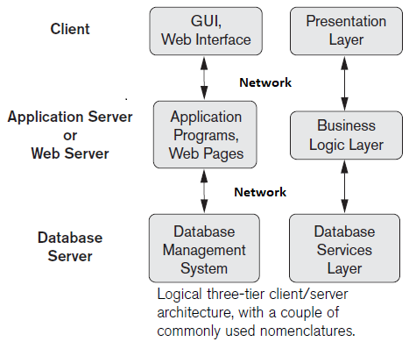

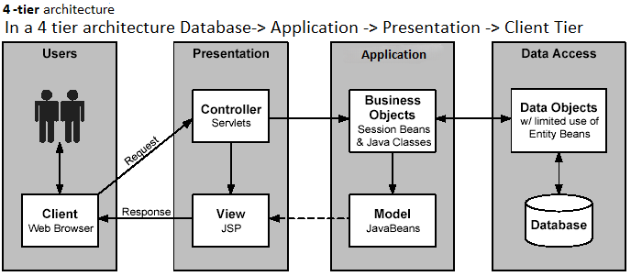

**Advantages of ANSI-SPARC Architecture**

The ANSI-SPARC standard architecture is three-tiered, but some books refer 4 tiers. These 4-tiered representation offers several advantages, which are as follows:

* Its main objective of it is to provide data abstraction.
* Same data can be accessed by different users with different customized views.
* The user is not concerned about the physical data storage details.
* Physical storage structure can be changed without requiring changes in the internal structure of the database as well as users view.
* The conceptual structure of the database can be changed without affecting end users.
* It makes the database abstract.
* It hides the details of how the data is stored physically in an electronic system, which makes it easier to understand and easier to use for an average user.
* It also allows the user to concentrate on the data rather than worrying about how it should be stored.

**Types of databases**

There are various types of databases used for storing different varieties of data in their respective DBMS data model environment. Each database has data models except NoSQL. One is Enterprise Database Management System that is not included in this figure. I will write details one by one in where appropriate. Sequence of details is not necessary.

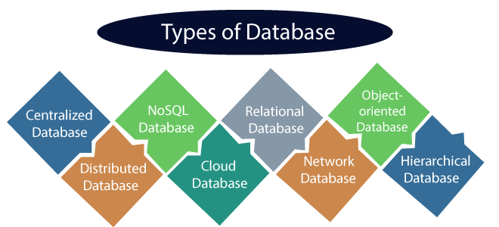

**Parallel database architectures**

Parallel Database architectures are:

1. Shared-memory
2. Shared-disk
3. Shared-nothing (the most common one)
4. Shared Everything Architecture
5. Hybrid System
6. Non-Uniform Memory Architecture

A hierarchical model system is a hybrid of the shared memory system, a shared disk system, and a shared-nothing system. The hierarchical model is also known as Non-Uniform Memory Architecture (NUMA). NUMA uses local and remote memory (Memory from another group); hence it will take a longer time to communicate with each other.

In NUMA, were different memory controller is used.

|  |  |  |
| --- | --- | --- |
| S.NO | UMA | NUMA |
| 1 | There are 3 types of buses used in uniform Memory Access which are: Single, Multiple and Crossbar. | While in non-uniform Memory Access, There are 2 types of buses used which are: Tree and hierarchical. |

**Advantages of NUMA**

* Improves the scalability of the system.
* Memory bottleneck (shortage of memory) problem is minimized in this architecture.
* NUMA machines provide a linear address space, allowing all processors to directly address all memory.

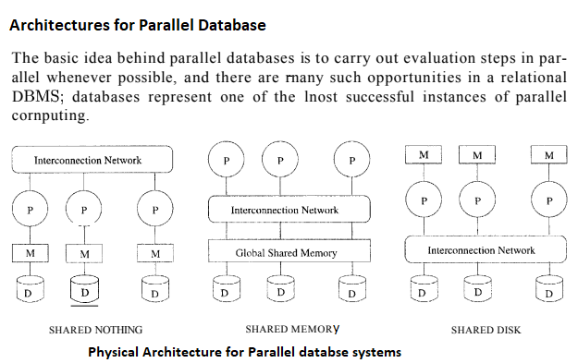

**Distributed Databases**

Distributed database system (DDBS) = Database Systems + Communication

A set of databases in a distributed system that can appear to applications as a single data source.

A distributed DBMS (DDBMS) can have the actual database and DBMS software distributed over many sites, connected by a computer network.

**Distributed DBMS architectures**

Three alternative approaches are used to separate functionality across different DBMS-related processes. These alternative distributed architectures are called

1. Client-server,
2. Collaborating server or multi-Server
3. Middleware or Peer-to-Peer

* **Client-server:** Client can send query to server to execute. There may be multiple server process. The two different client-server architecture models are:

1. Single Server Multiple Client
2. Multiple Server Multiple Client

**Client Server architecture layers**

1. Presentation layer
2. Logic layer
3. Data layer

**Presentation layer**

The basic work of this layer provides a user interface. The interface is a graphical user interface. The graphical user interface is an interface that consists of menus, buttons, icons, etc. The presentation tier presents information related to such work as browsing, sales purchasing, and shopping cart contents. It attaches with other tiers by computing results to the browser/client tier and all other tiers in the network. Its other name is external layer.

**Logic layer**

The logical tier is also known as the data access tier and middle tier. It lies between the presentation tier and the data tier. it controls the application’s functions by performing processing. The components that build this layer exist on the server and assist the resource sharing these components also define the business rules like different government legal rules, data rules, and different business algorithms which are designed to keep data structure consistent. This is also known as conceptual layer.

**Data layer**

The 3-Data layer is the physical database tier where data is stored or manipulated. It is internal layer of database management system where data stored.

* **Collaborative/Multi server**: This is an integrated database system formed by a collection of two or more autonomous database systems. Multi-DBMS can be expressed through six levels of schema:

1. **Multi-database View Level** − Depicts multiple user views comprising subsets of the integrated distributed database.
2. **Multi-database Conceptual Level** − Depicts integrated multi-database that comprises global logical multi-database structure definitions.
3. **Multi-database Internal Level** − Depicts the data distribution across different sites and multi-database to local data mapping.
4. **Local database View Level** − Depicts a public view of local data.
5. **Local database Conceptual Level** − Depicts local data organization at each site.
6. **Local database Internal Level** − Depicts physical data organization at each site.

**There are two design alternatives for multi-DBMS −**

1. A model with a multi-database conceptual level.
2. Model without multi-database conceptual level.

* **Peer-to-Peer:**  Architecture model for DDBMS, In these systems, each peer acts both as a client and a server for imparting database services. The peers share their resources with other peers and coordinate their activities. Its scalability and flexibility is growing and shrinking. All nodes have the same role and functionality. Harder to manage because all machines are autonomous and loosely coupled.

**This architecture generally has four levels of schemas:**

1. Global Conceptual Schema − Depicts the global logical view of data.
2. Local Conceptual Schema − Depicts logical data organization at each site.
3. Local Internal Schema − Depicts physical data organization at each site.
4. Local External Schema − Depicts user view of data

**Example of Peer-to-peer architecture**

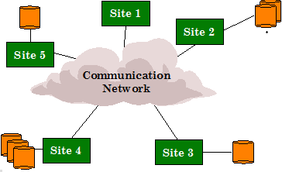

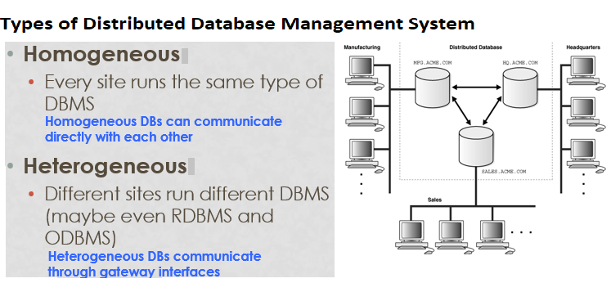

**Types of homogeneous distributed database**

**Autonomous** − Each database is independent and functions on its own. They are integrated by a controlling application and use message passing to share data updates.

**Non**-**autonomous** − Data is distributed across the homogeneous nodes and a central or master DBMS coordinates data updates across the sites.

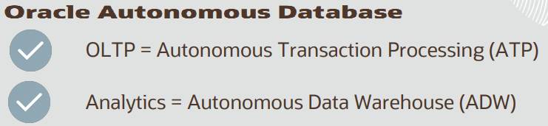

**Autonomous databases**

1. Autonomous Transaction Processing - Serverless
2. Autonomous Transaction Processing – Dedicated

**Serverless** is a simple and elastic deployment choice. Oracle autonomously operates all aspects of the database lifecycle from database placement to backup and updates.

**Dedicated** is a private cloud in public cloud deployment choice. A completely dedicated compute, storage, network, and database service for only a single tenant.

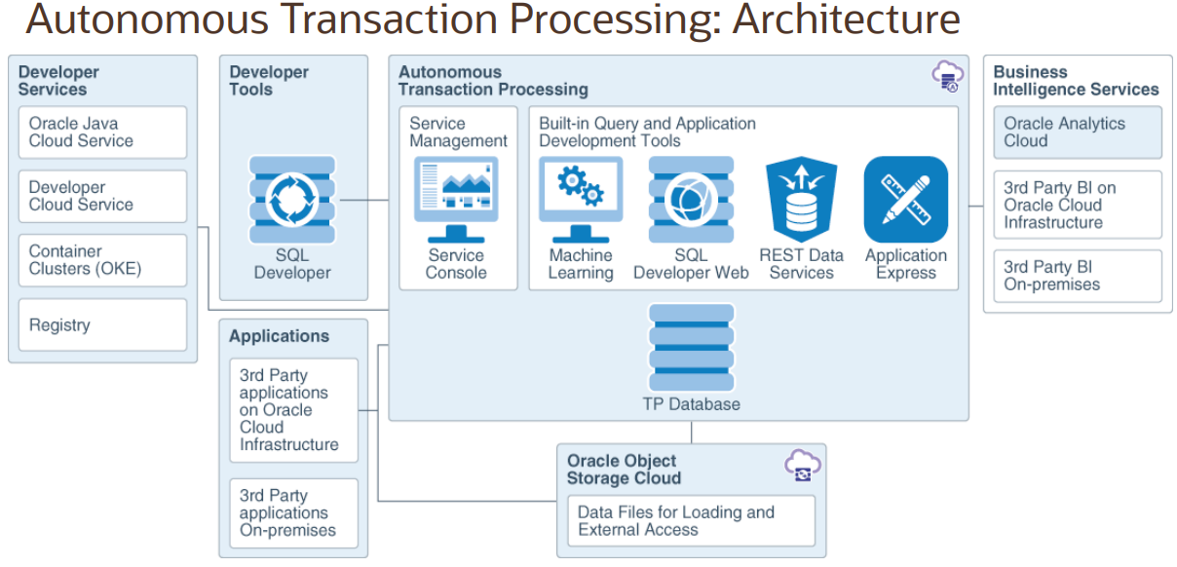

Autonomous transaction processing: Architecture

**Heterogeneous Distributed Databases (**Dissimilar schema for each site database, it can be any variety of dbms, relational, network, hierarchical, object oriented**)**

Types of Heterogeneous Distributed Databases

1. **Federated** − The heterogeneous database systems are independent and integrated so that they function as a single database system.
2. **Un-federated** − The database systems employ a central coordinating module

In a heterogeneous distributed database, different sites have different operating systems, DBMS products, and data models.

**Parameters at which distributed DBMS architectures developed**

DDBMS architectures are generally developed depending on three parameters:

1. **Distribution** − It states the physical distribution of data across the different sites.
2. **Autonomy** − It indicates the distribution of control of the database system and the degree to which each constituent DBMS can operate independently.
3. **Heterogeneity** − It refers to the uniformity or dissimilarity of the data models, system components, and databases.

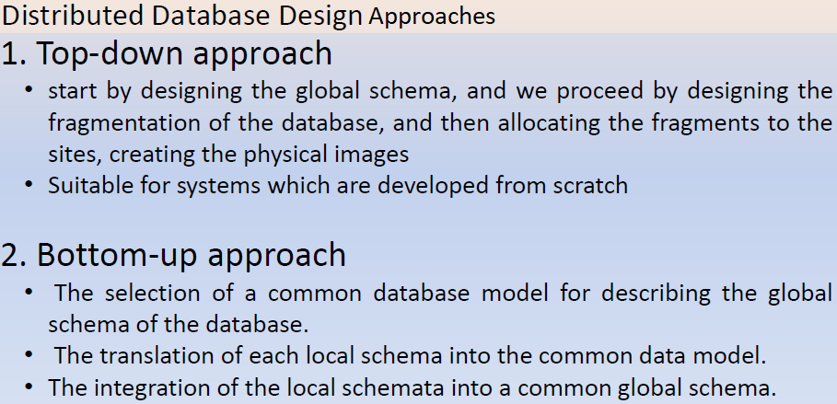

Note: The **Semi Join** and **Bloom Join** are two techniques/data fetching method in distributed databases.

**Some Popular databases and respective data models**

* **Native XML Databases**

We were not surprised that the number of start-up companies as well as some established data management companies determined that XML data would be best managed by a DBMS that was designed specifically to deal with semi-structured data — that is, a native XML database.

* **Conceptual Database**

This step is related to the modeling in the Entity-Relationship (E/R) Model to specify sets of data called entities, relations among them called relationships and cardinality restrictions identified by letters N and M, in this case, the many-many relationships stand out.

* **Conventional Database**

This step includes Relational Modeling where a mapping from MER to relations using rules of mapping is carried out. The posterior implementation is done in Structured Query Language (SQL).

* **Non-Conventional database**

This step involves Object-Relational Modeling which is done by the specification in Structured Query Language. In this case, the modeling is related to the objects and their relationships with the Relational Model.

* Traditional database
* Temporal database
* Conventional Databases
* NewSQL Database
* Autonomous database
* Cloud database
* Spatiotemporal
* Enterprise Database Management System
* Google Cloud Firestore
* Couchbase
* Memcached, Coherence (key-value store)
* HBase, Big Table, Accumulo (Tabular)
* MongoDB, CouchDB, Cloudant, JSON-like (Document-based)
* Neo4j (Graph Database)
* Redis (Data model: Key value)
* Elasticsearch (Data model: search engine)
* Microsoft access (Data model: relational)
* Cassandra (Data model: Wide column)
* MariaDB (Data model: Relational)
* Splunk (Data model: search engine)
* Snowflake (Data model: Relational)
* Azure SQL Server Database (Relational)
* Amazon DynamoDB (Data model: Multi-Model)
* Hive (Data model: Relational)

**Non-relational (NoSQL) Data model**

**BASE Model:**

Basically Available – Rather than enforcing immediate consistency, BASE-modelled NoSQL databases will ensure the availability of data by spreading and replicating it across the nodes of the database cluster.

Soft State – Due to the lack of immediate consistency, data values may change over time. The BASE model breaks off with the concept of a database that enforces its consistency, delegating that responsibility to developers.

Eventually Consistent – The fact that BASE does not enforce immediate consistency does not mean that it never achieves it. However, until it does, data reads are still possible (even though they might not reflect the reality).

Just as SQL databases are almost uniformly ACID compliant, NoSQL databases tend to conform to BASE principles.

**NewSQL Database**

NewSQL is a class of relational database management systems that seek to provide the scalability of NoSQL systems for online transaction processing (OLTP) workloads while maintaining the ACID guarantees of a traditional database system.

Examples and properties of Relational Non-Relational Database:

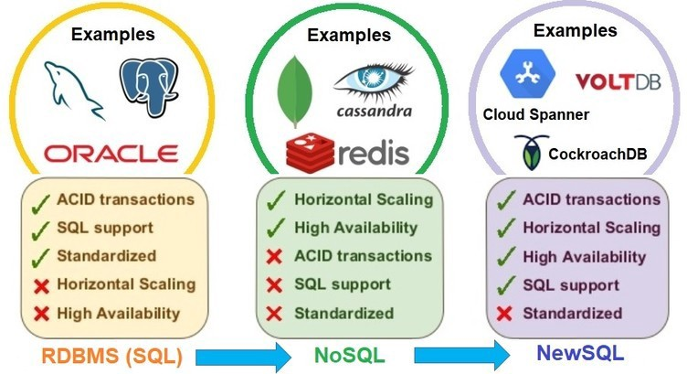

The term NewSQL categorizes databases that are the combination of relational models with the advancement in scalability, and flexibility with types of data. These databases focus on the features which are not present in NoSQL, which offers a strong consistency guarantee. This covers two layers of data one relational one and a key-value store.

| **Sr. No** | **NoSQL** | **NewSQL** |
| --- | --- | --- |
| 1. | NoSQL is schema-less or has no fixed schema/unstructured schema. So BASE Data model exists in NoSQL. NoSQL is a schema-free database. | NewSQL is schema-fixed as well as a schema-free database. |
| 2. | It is horizontally scalable. | It is horizontally scalable. |
| 3. | It possesses automatically high availability. | It possesses built-in high availability. |
| 4. | It supports cloud, on-disk, and cache storage. | It fully supports cloud, on-disk, and cache storage. It may cause a problem with in-memory architecture for exceeding volumes of data. |
| 5. | It promotes [CAP](https://www.geeksforgeeks.org/the-cap-theorem-in-dbms/) properties. | It promotes [ACID](https://www.geeksforgeeks.org/acid-properties-in-dbms/) properties. |
| 6. | Online Transactional Processing is not supported. | [Online Transactional Processing](https://www.geeksforgeeks.org/on-line-transaction-processing-oltp-system-in-dbms/) and implementation to traditional relational databases are fully supported |
| 7. | There are low-security concerns. | There are moderate security concerns. |
| 8. | Use Cases: [Big Data](https://www.geeksforgeeks.org/what-is-big-data/), Social Network Applications, and [IoT](https://www.geeksforgeeks.org/introduction-to-internet-of-things-iot-set-1/). | Use Cases: E-Commerce, Telecom industry, and Gaming. |
| 9. | Examples: DynamoDB, MongoDB, RaveenDB etc. | Examples: VoltDB, CockroachDB, NuoDB etc. |

**Advantages of Database management systems:**

* It supports a logical view (schema, subschema),
* It supports a physical view (access methods, data clustering),
* It supports data definition language, data manipulation language to manipulate data,
* It provides important utilities, such as transaction management and concurrency control, data integrity, crash recovery, and security. Relational database systems, the dominant type of systems for well-formatted business databases, also provide a greater degree of data independence.
* The motivations for using databases rather than files include greater availability to a diverse set of users, integration of data for easier access to and updating of complex transactions, and less redundancy of data.
* Data consistency, Better data security

**CHAPTER 2 DATA TYPES, DATABASE KEYS, SQL FUNCTIONS AND OPERATORS**

**Data types Overview**

|  |  |  |
| --- | --- | --- |
| BINARY_FLOAT  BINARY_DOUBLE | 32-bit floating point number. This data type requires 4 bytes.  64-bit floating point number. This data type requires 8 bytes. | |
| There are two classes of date and time-related data types in  PL/SQL −   1. Datetime datatypes 2. Interval Datatypes | The DateTime datatypes are −   * Date * Timestamp * Timestamp with time zone * Timestamp with local time zone   The interval datatypes are −   * Interval year to month * Interval day to second | |
| If max_string_size = extended  32767 bytes or characters  If max_string_size = standard  Number(p,s) data type 4000 bytes or characters | Number having precision p and scale s. The precision p can range from 1 to 38. The scale s can range from -84 to 127. Both precision and scale are in decimal digits. A number value requires from 1 to 22 bytes. | |
| Character data types | The character data types represent alphanumeric text. PL/SQL uses the SQL character data types such as CHAR, VARCHAR2, LONG, RAW, LONG RAW, ROWID, and UROWID.  CHAR(n) is a fixed-length character type whose length is from 1 to 32,767 bytes.  VARCHAR2(n) is varying length character data from 1 to 32,767 bytes. | |
| **Data Type** | **Maximum Size in PL/SQL** | **Maximum Size in SQL** |
| CHAR | 32,767 bytes | 2,000 bytes |
| NCHAR | 32,767 bytes | 2,000 bytes |
| RAW | 32,767 bytes | 2,000 bytes |
| VARCHAR2 | 32,767 bytes | 4,000 bytes ( 1 char = 1 byte) |
| NVARCHAR2 | 32,767 bytes | 4,000 bytes |
| LONG | 32,760 bytes | 2 gigabytes (GB) – 1 |
| LONG RAW | 32,760 bytes | 2 GB |
| BLOB | 8-128 terabytes (TB) | (4 GB - 1) database_block_size |
| CLOB | 8-128 TB (Used to store large blocks of character data in the database.) | (4 GB - 1) database_block_size |
| NCLOB | 8-128 TB ( Used to store large blocks of NCHAR data in the database.) | (4 GB - 1) database_block_size |
| Scalar | No Fixed range  Single values with no internal components, such as a NUMBER, DATE, or BOOLEAN. | Numeric values on which arithmetic operations are performed like Number(7,2).  Stores dates in the Julian date format.  Logical values on which logical operations are performed. |
| NUMBER Data Type | No fixed Range | DEC, DECIMAL, DOUBLE PRECISION, FLOAT, INTEGER, INT, NUMERIC, REAL, SMALLINT |
| **Type** | **Size in Memory** | **Range of Values** |
| Byte | 1 byte | 0 to 255 |
| Boolean | 2 bytes | True or False |
| Integer | 2 bytes | –32,768 to 32,767 |
| Long (long integer) | 4 bytes | –2,147,483,648 to 2,147,483,647 |
| Single  (single-precision real) | 4 bytes | Approximately –3.4E38 to 3.4E38 |
| Double  (double-precision real) | 8 bytes | Approximately –1.8E308 to 4.9E324 |
| Currency  (scaled integer) | 8 bytes | Approximately –922,337,203,685,477.5808 to 922,337,203,685,477.5807 |
| Date | 8 bytes | 1/1/100 to 12/31/9999 |
| Object | 4 bytes | Any Object reference |
| String | Variable length:  10 bytes + string length; Fixed length: string length | Variable length: <= about 2 billion (65,400 for Win 3.1)  Fixed length: up to 65,400 |
| Variant | 16 bytes for numbers  22 bytes + string length |  |

**The Concept of Signed and Unsigned Integers**

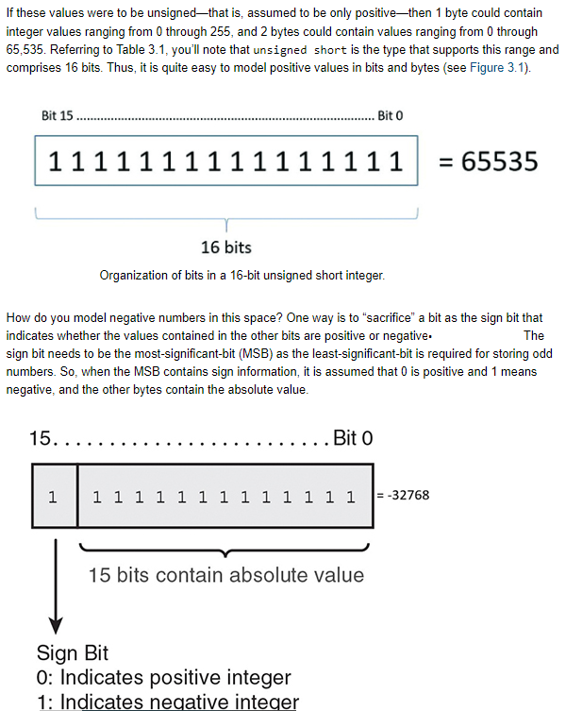

**Organization of bits in a 16-bit signed short integer.**

Thus, a signed number that stores 16 bits can contain values ranging from –32,768 through 32,767, and one that stores 8 bits can contain values ranging from –128 through 127.

**Data Types can be further divided as:**

* Primitive
* Non-Primitive

Primitive data types are pre-defined whereas non-primitive data types are user-defined. Data types like byte, int, short, float, long, char, bool, etc are called Primitive data types. Non-primitive data types include class, enum, array, delegate, etc.

**User-Defined Datatypes**

There are two categories of user-defined datatypes:

* Object types
* Collection types

A user-defined data type (UDT) is a data type that derived from an existing data type. You can use UDTs to extend the built-in types already available and create your own customized data types.

**There are six user-defined types:**

1. Distinct type
2. Structured type
3. Reference type
4. Array type
5. Row type
6. Cursor type

**Here the data types are in different groups:**

* **Exact Numeric**: bit, Tinyint, Smallint, Int, Bigint, Numeric, Decimal, SmallMoney, Money.
* **Approximate Numeric:** float, real
* **Data and Time:**DateTime, Smalldatatime, date, time, Datetimeoffset, Datetime2
* **Character Strings:** char, varchar, text
* **Unicode Character strings:** Nchar, Nvarchar, Ntext
* **Binary strings:** binary, Varbinary, image
* **Other Data types:** sql_variant, timestamp, Uniqueidentifier, XML
* **CLR data types:** hierarchyid
* **Spatial data types:** geometry, geography

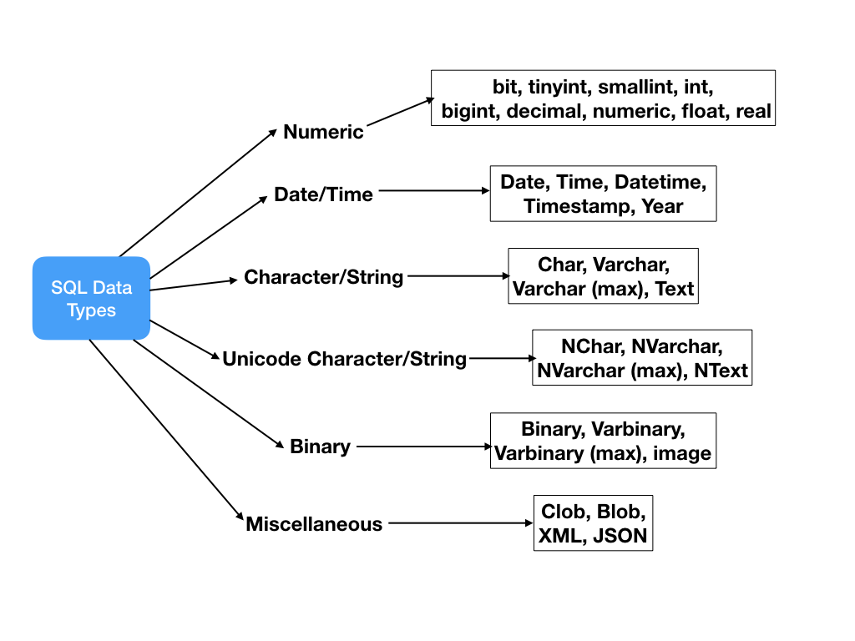

**Abstract Data Types in Oracle**

One of the shortcomings of the Oracle 7 database was the limited number of intrinsic data types.

**Abstract Data Types**

An Abstract Data Type (ADT) consists of a data structure and subprograms that manipulate the data. The variables that form the data structure are called attributes. The subprograms that manipulate the attributes are called methods. ADTs are stored in the database and instances of ADTs can be stored in tables and used as PL/SQL variables. ADTs let you reduce complexity by separating a large system into logical components, which you can reuse. In the static data dictionary view.

**ANSI SQL Datat type convertions with Oracle Data type**

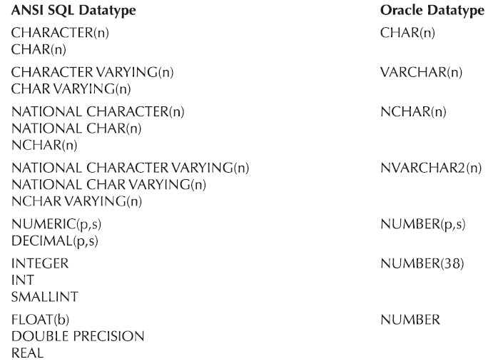

**Database Key** A key is a field of a table that identifies the tuple in that table.

* **Super key**

An attribute or a set of attributes that uniquely identifies a tuple within a relation.

* **Candidate key**

A super key such that no proper subset is a super key within the relation. Contains no unique subset (irreducibility). Possibly many candidate keys (specified using UNIQUE), one of which is chosen as the primary key. PRIMARY KEY (sid), UNIQUE (id, grade)) A candidate can be unique but its value can be changed.

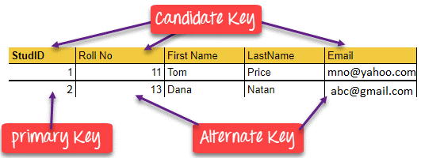

* **Natural key** PK in OLTP.

It may be a PK in OLAP. A natural key (also known as business key or domain key) is a type of unique key in a database formed of attributes that exist and are used in the external world outside the database like natural key (SSN column)

* **Composite key or concatenate** key

A primary key that consists of two or more attributes is known as a composite key.

* **Primary key**

The candidate key is selected to identify tuples uniquely within a relation. Should remain constant over the life of the tuple. PK is unique, Not repeated, not null, not change for life. If the primary key is to be changed. We will drop the entity of the table, and add a new entity, In most cases, PK is used as a foreign key. You cannot change the value. You first delete the child, so that you can modify the parent table.

* **Minimal Super Key**

All super keys can't be primary keys. The primary key is a minimal super key. KEY is a minimal SUPERKEY, that is, a minimized set of columns that can be used to identify a single row.

* **Foreign key**

An attribute or set of attributes within one relation that matches the candidate key of some (possibly the same) relation. Can you add a non-key as a foreign key? Yes, the minimum condition is it should be unique. It should be candidate key.

* **Composite Key**

The composite key consists of more than one attribute. COMPOSITE KEY is a combination of two or more columns that uniquely identify rows in a table. The combination of columns guarantees uniqueness, though individually uniqueness is not guaranteed. Hence, they are combined to uniquely identify records in a table. You can you composite key as PK but the Composite key will go to other tables as a foreign key.

* **Alternate key**

A relation can have only one primary key. It may contain many fields or a combination of fields that can be used as the primary key. One field or combination of fields is used as the primary key. The fields or combinations of fields that are not used as primary keys are known as candidate keys or alternate keys.

* **Sort Or control key**

A field or combination of fields that are used to physically sequence the stored data is called a sort key. It is also known s the control key.

* **Alternate key**

An alternate key is a secondary key it can be simple to understand an example:

Let's take an example of a student it can contain NAME, ROLL NO., ID, and CLASS.

* **Unique key**

A unique key is a set of one or more than one field/column of a table that uniquely identifies a record in a database table.

You can say that it is a little like a primary key but it can accept only one null value and it cannot have duplicate values.

The unique key and primary key both provide a guarantee for uniqueness for a column or a set of columns.

There is an automatically defined unique key constraint within a primary key constraint.

There may be many unique key constraints for one table, but only one PRIMARY KEY constraint for one table.

* **Artificial Key**

The key created using arbitrarily assigned data are known as artificial keys. These keys are created when a primary key is large and complex and has no relationship with many other relations. The data values of the artificial keys are usually numbered in a serial order.

For example, the primary key, which is composed of Emp_ID, Emp_role, and Proj_ID, is large in employee relations. So it would be better to add a new virtual attribute to identify each tuple in the relation uniquely. Rownum and rowid are artificial keys. It should be a number or integer, numeric.

**Format of Rowid of :**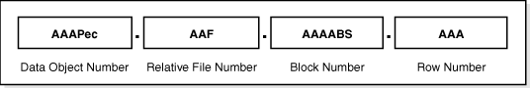

* **Surrogate key**

SURROGATE KEYS is An artificial key that aims to uniquely identify each record and is called a surrogate key. This kind of partial key in DBMS is unique because it is created when you don’t have any natural primary key. You can't insert values of the surrogate key. Its value comes from the system automatically.

No business logic in key so no changes based on business requirements

Surrogate keys reduce the complexity of the composite key.

Surrogate keys integrate the extract, transform, and load in DBs.

* **Compound Key**

COMPOUND KEY has two or more attributes that allow you to uniquely recognize a specific record. It is possible that each column may not be unique by itself within the database.

**Database Keys and Its Meta data’s description:**

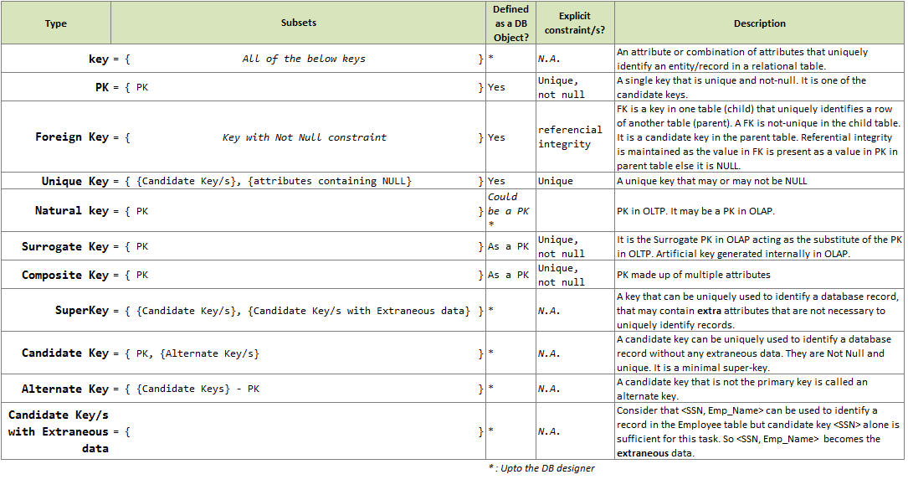

**Operators**

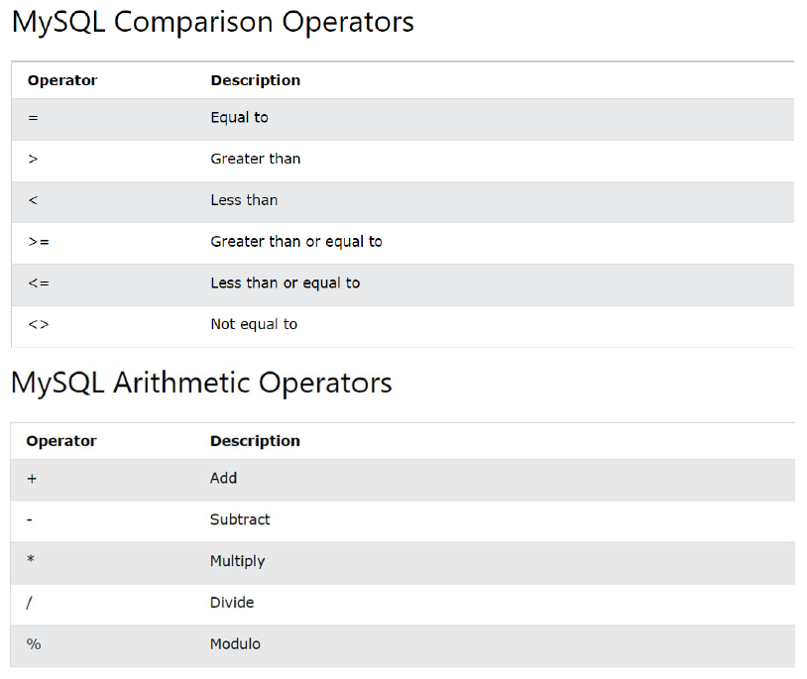

< > or != Not equal to like salary <>500.

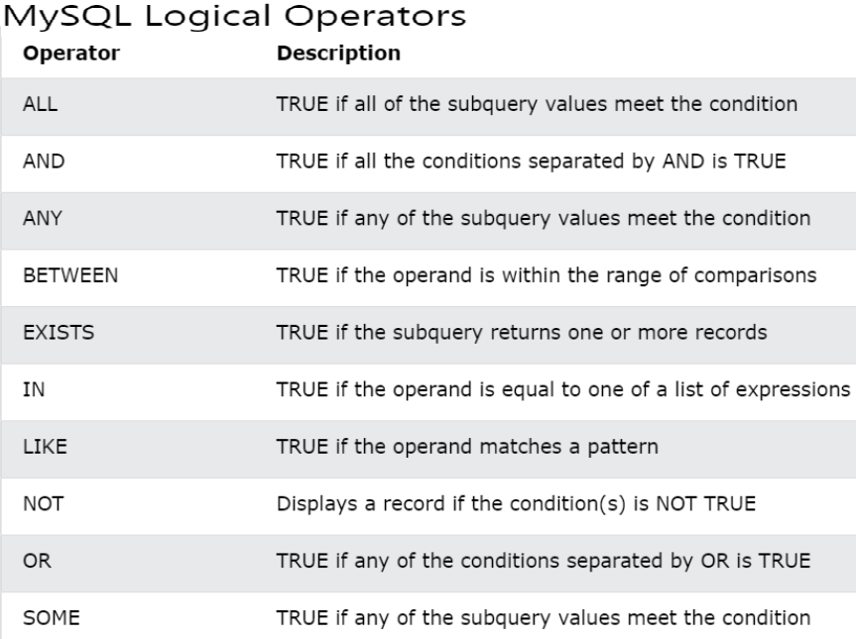

**Wildcards and Unions Operators**

**LIKE** operator is used to filter the result set based on a string pattern. It is always used in the WHERE clause.

**Wildcards** are used in SQL to match a string pattern. A wildcard character is used to substitute one or more characters in a string. Wildcard characters are used with the LIKE operator.

There are two wildcards often used in conjunction with the LIKE operator:

1. The percent sign (%) represents zero, one, or multiple characters
2. The underscore sign (_) represents one, a single character

**Two maindifferences between like, Ilike Operator:**

1. LIKE is case-insensitive whereas iLIKE is case-sensitive.
2. LIKE is a standard SQL operator, whereas ILIKE is only implemented in certain databases such as PostgreSQL and Snowflake.

To ignore case when you're matching values, you can use the ILIKE command:

**Example 1:** SELECT * FROM tutorial.billboard_top_100_year_en WHERE "group" ILIKE 'snoop%'

**Example 2:** SELECT FROM Customers WHERE City LIKE 'ber%';

**SQL UNION** clause is used to select distinct values from the tables.

**SQL UNION ALL** clause used to select all values including duplicates from the tables

The UNION operator is used to combine the result-set of two or more SELECT statements.

Every SELECT statement within UNION must have the same number of columns

The columns must also have similar data types

The columns in every SELECT statement must also be in the same order

**EXCEPT or MINUS** These are the records that exist in Dataset1 and not in Dataset2.

Each SELECT statement within the EXCEPT query must have the same number of fields in the result sets with similar data types.

The difference is that EXCEPT is available in the PostgreSQL database while MINUS is available in MySQL and Oracle. There is absolutely **no difference** between the EXCEPT clause and the MINUS clause.

**IN** operator allows you to specify multiple values in a WHERE clause. The **IN** operator is a shorthand for multiple OR conditions.

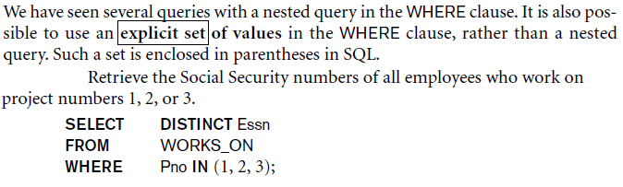

**ANY operator**

Returns a Boolean value as a result Returns true if any of the subquery values meet the condition . ANY means that the condition will be true if the operation is true for any of the values in the range.

**NOT IN** can also take literal values whereas not existing need a query to compare the results.

SELECT CAT_ID FROM CATEGORY_A WHERE CAT_ID NOT IN (SELECT CAT_ID FROM CATEGORY_B)

**NOT EXISTS**

SELECT A.CAT_ID FROM CATEGORY_A A WHERE NOT EXISTS (SELECT B.CAT_ID FROM CATEGORY_B B WHERE B.CAT_ID = A.CAT_ID)

NOT EXISTS could be good to use because it can join with the outer query & can lead to usage of the index if the criteria use an indexed column.

**EXISTS AND NOT EXISTS** are typically used in conjuntion with a correlated nested query. The result of EXISTS is a boolean value, TRUE if the nested query ressult contains at least one tuple, or FALSE if the nested query result contains no tuples

**Supporting operators in different DBMS environments:**

Keyword Database System

TOP SQL Server, MS Access

LIMIT MySQL, PostgreSQL, SQLite

FETCH FIRST Oracle

But 10g onward TOP Clause no longer supported replace with ROWNUM clause.

**SQL FUNCTIONS**

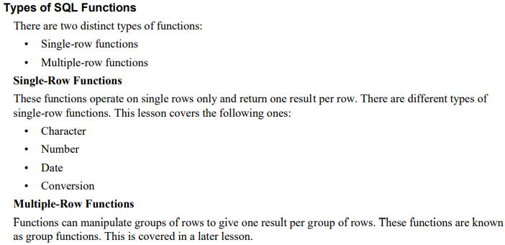

**Types of Multiple Row Functions in Oracle (Aggrigate functions)**

**AVG**: It retrieves the average value of the number of rows in a table by ignoring the null value

**COUNT**: It retrieves the number of rows (count all selected rows using *, including duplicates and rows with null values)

**MAX**: It retrieves the maximum value of the expression, ignores null values

**MIN**: It retrieves the minimum value of the expression, ignores null values

**SUM**: It retrieves the sum of values of the number of rows in a table, it ignores null values

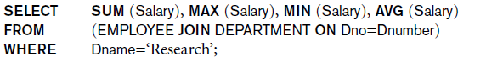

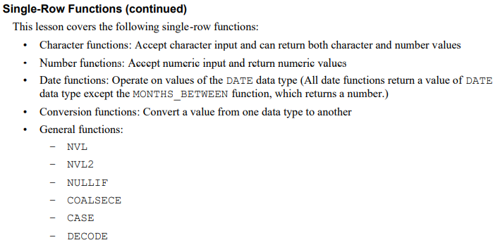

**Explanation of Single Row Functions**

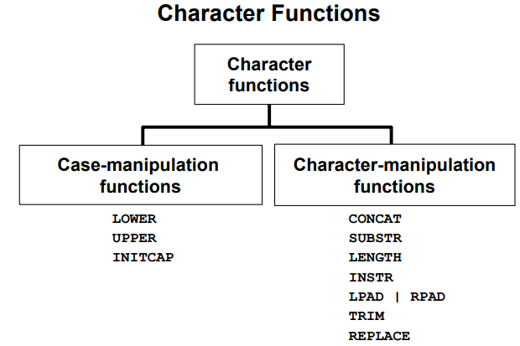

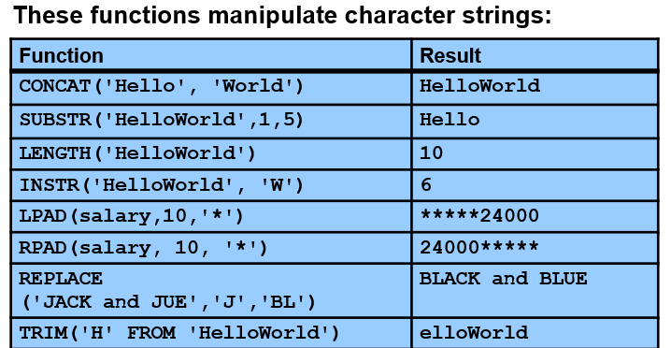

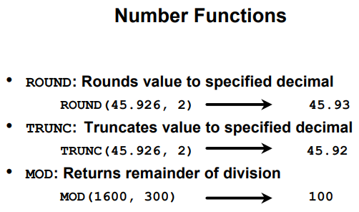

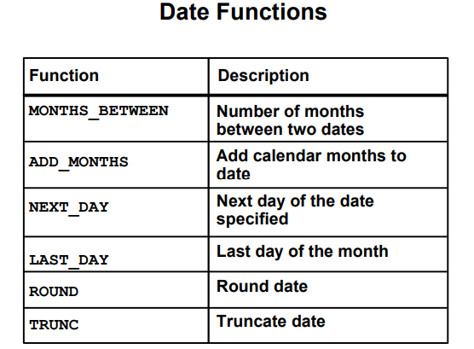

**Examples of date functions**

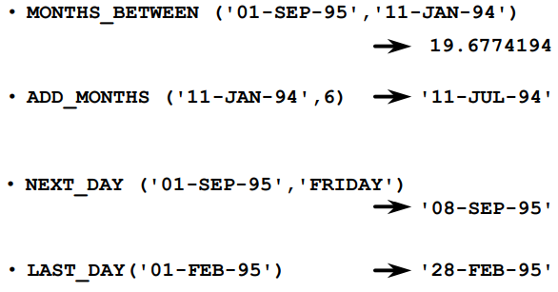

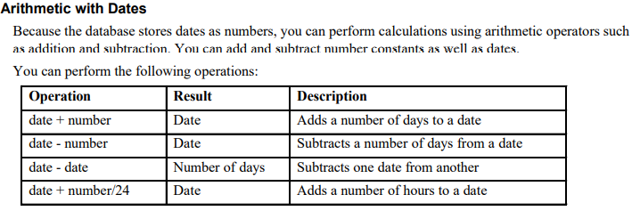

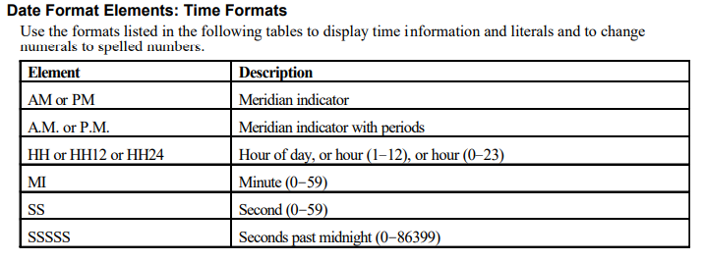

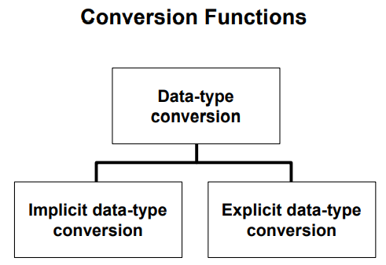

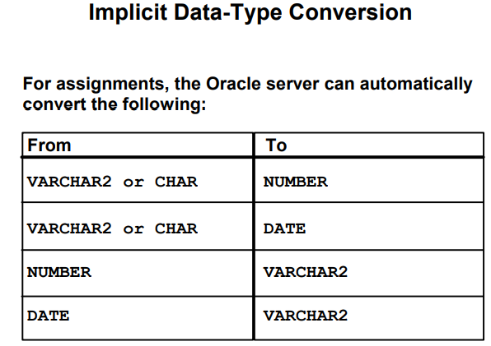

CHARTOROWID converts a value from CHAR, VARCHAR2, NCHAR, or NVARCHAR2 datatype to ROWID datatype.

This function does not support CLOB data directly. However, CLOBs can be passed in as arguments through implicit data conversion.

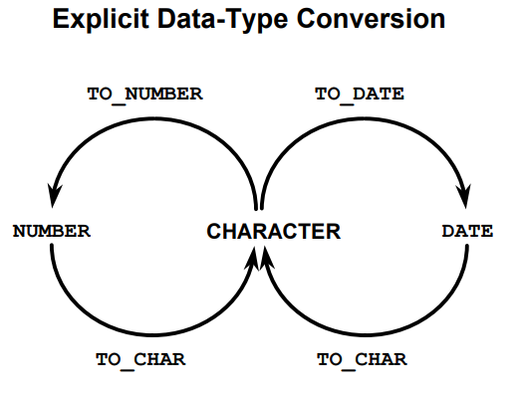

**For assignments, Oracle can automatically convert the following:**

* VARCHAR2 or CHAR to MLSLABEL
* MLSLABEL to VARCHAR2
* VARCHAR2 or CHAR to HEX
* HEX to VARCHAR2

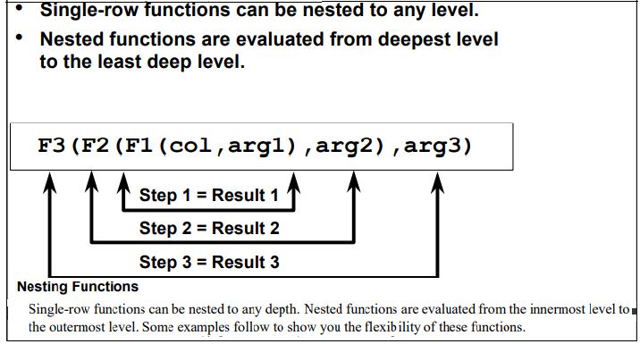

**Example of Conversion Functions**

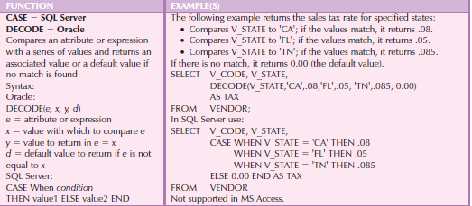

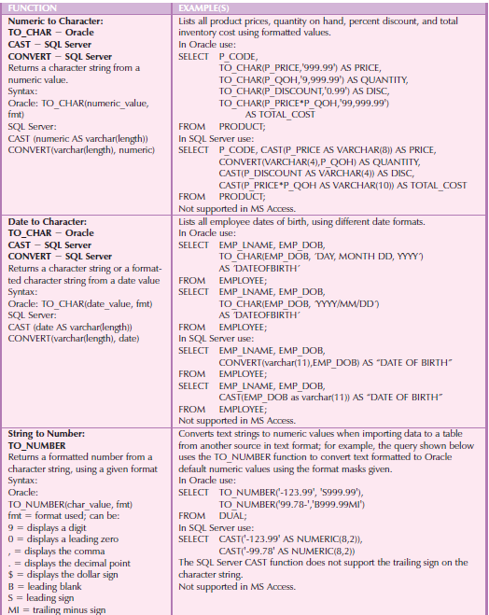

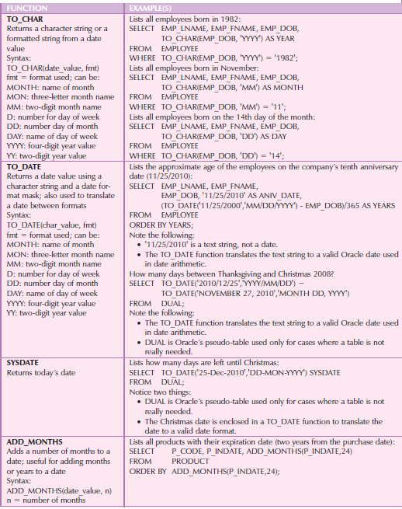

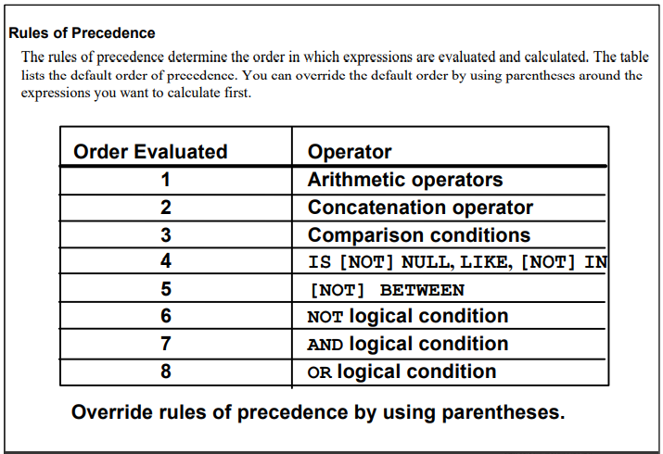

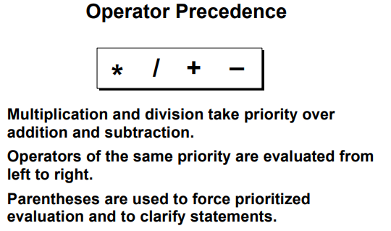

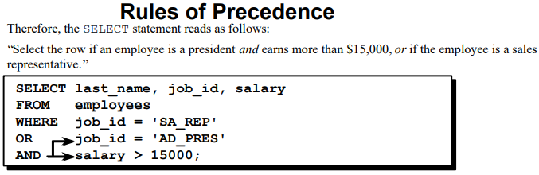

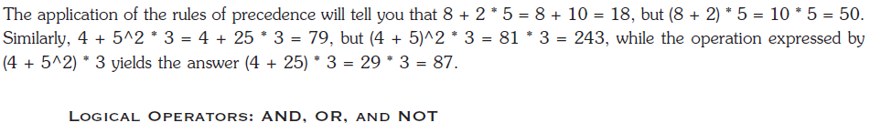

**Subquery Concept**

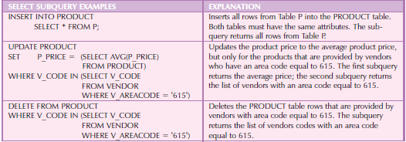

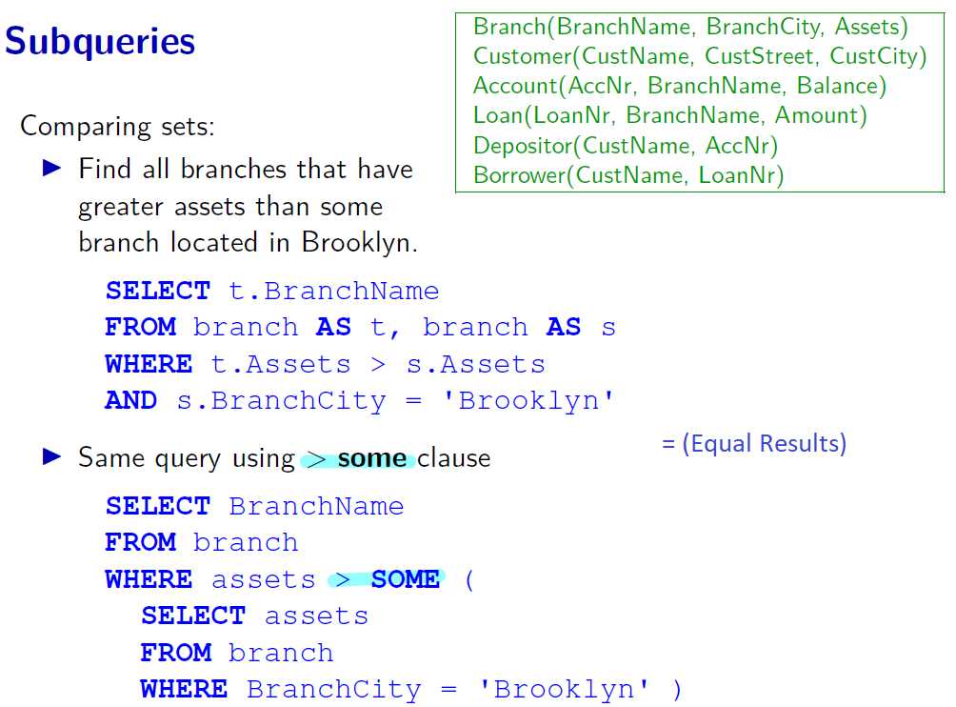

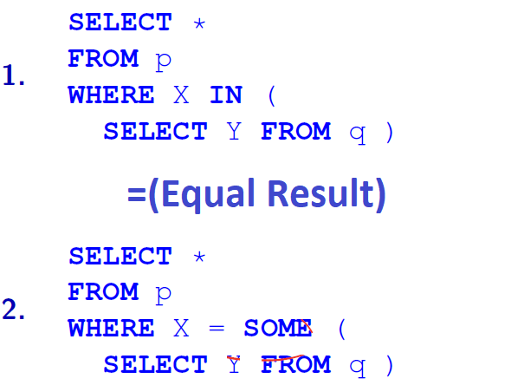

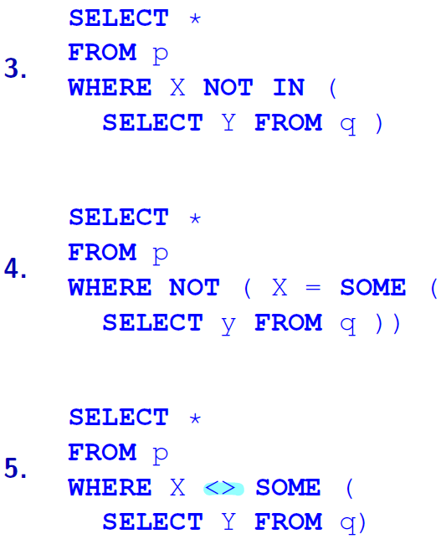

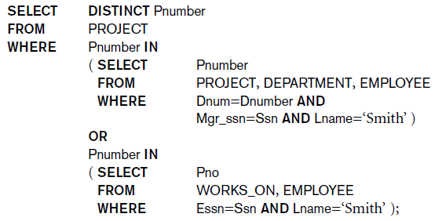

END

**CHAPTER 3 DATA MODELS, ITS TYPES, AND MAPPING TECHNIQUES**

**Overview of data modeling in DBMS**

The semantic data model is a method of structuring data to represent it in a specific logical way.

**Types of Data Models in history:**

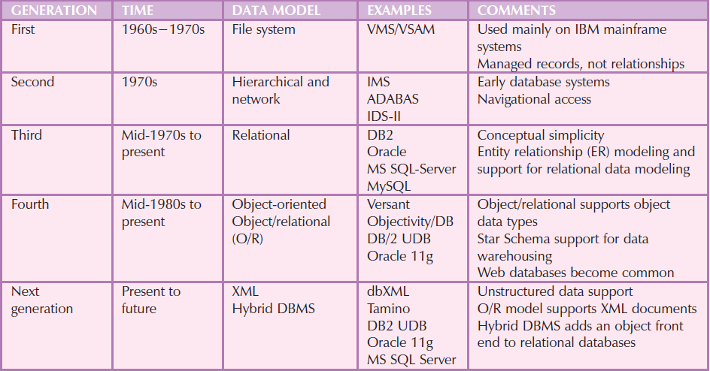

**Data abstraction** Process of hiding (suppressing) unnecessary details so that the high-level concept can be made more visible. A data model is a relatively simple representation, usually graphical, of more complex real-world data structures.

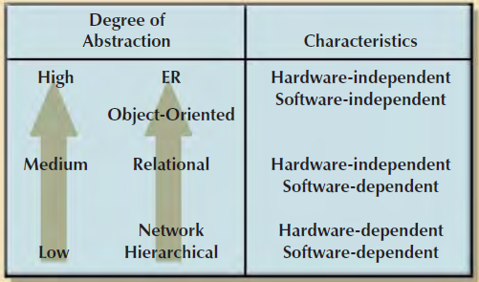

**Data model Schema and Instance**

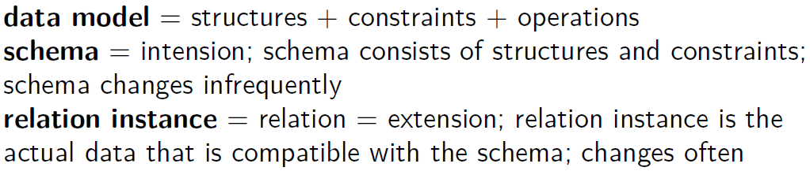

**Database Instance** is thedata which is stored in the database at a particular moment is called an instance of the database. Also called database state (or occurrence or snapshot). The content of the database, instance is also called an **extension**.

The term instance is also applied to individual database components,

E.g., record instance, table instance, entity instance

Types of Instances

**Initial Database Instance**: Refers to the database instance that is initially loaded into the system.

**Valid Database Instance**: An instance that satisfies the structure and constraints of the database.

The database instance changes every time the database is updated.

D**atabase Schema** is the overall design or skeleton structure of the database. It represents the logical view, visual diagram having relationals of objects of the entire database.

A database schema can be represented by using a visual diagram. That diagram shows the database objects and their relationship with each other. A schema contains schema objects like table, foreign key, primary key, views, columns, data types, stored procedure, etc.

A database schema is designed by the database designers to help programmers whose software will interact with the database. The process of database creation is called data modeling.

**Relational Schema definition**

Relational schema refers to the meta-data that describes the structure of data within a certain domain . It is the blueprint of a database that outlines the way any database will have some number of constraints that must be applied to ensure correct data (valid states).

**Database Schema definition**

A relational schema may also refer to as a database schema. A database schema is the collection of relation schemas for a whole database. A relational or Database schema is a collection of meta-data. Database schema describes the structure and constraints of data represented in a particular domain . A Relational schema can be described as a blueprint of a database that outlines the way data is organized into tables. This blueprint will not contain any type of data. In a relational schema, each tuple is divided into fields called Domain.

Other definitions: The overall design of the database.Structure of database, Schema is also called **intension**.

**Types of Schemas w.r.t Database**

**DBMS Schemas:** Logical/Conceptual/physical schema/external schema

**Data warehouse/multi-dimensional schemas:** Snowflake/star

**OLAP Schemas:** Fact constellation schema/galaxy

**ANSI-SPARC schema architecture**

**External Level: V**iew level, user level, external schema, Client level.

**Conceptual Level:** Community view, ERD Model, conceptual schema, server level, Conceptual (high-level, semantic) data models, entity-based or object-based data models, what data is stored .and relationships, it’s deal Logical data independence (External/conceptual mapping)

**logical schema: I**t is sometimes called conceptual schema too (server level), Implementation (representational) data models. Specific DBMS level modeling.

**Internal Level:** Physical representation, Internal schema, Database level, Low level. It deals with how data is stored in the database and Physical data independence (Conceptual/internal mapping)

**Physical data level:** Physical storage, physical schema, some-time deals with internal schema. It is detailed in administration manuals.

**Data independence**

IT is the ability to make changes in either the logical or physical structure of the database without requiring reprogramming of application programs.

**Data Independence types**

**Logical data independence=>**Immunity of external schemas to changes in the conceptual schema

**Physical data independence**=>Immunity of the conceptual schema to changes in the internal schema.

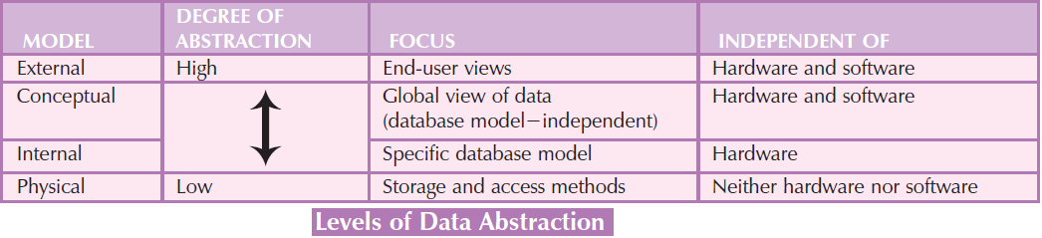

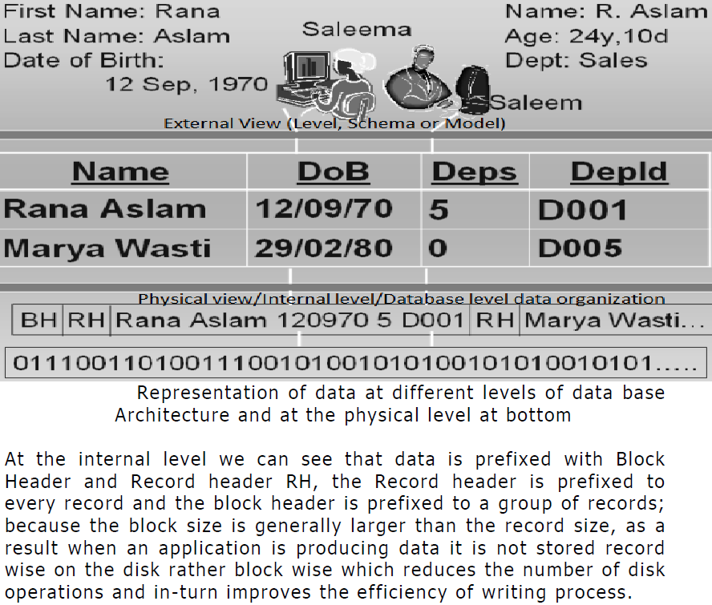

**There are two types of mapping in the database architecture**

**Conceptual/ Internal Mapping**

The Conceptual/ Internal Mapping lies between the conceptual level and the internal level. Its role is to define the correspondence between the records and fields of the conceptual level and files and data structures of the internal level.

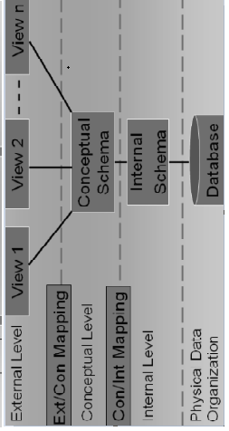

**External/Conceptual Mapping**

The external/Conceptual Mapping lies between the external level and the Conceptual level. Its role is to define the correspondence between a particular external and conceptual view.

**Detail description**

When a schema at a lower level is changed, only the mappings.

between this schema and higher-level schemas need to be changed in a DBMS that fully supports data independence.

The higher-level schemas themselves are unchanged.

Hence, the application programs need not be changed since they refer to the external schemas.

For example, the internal schema may be changed when certain file structures are reorganized or new indexes are created to improve database performance.

**Data abstraction**

Data abstraction makes complex systems more user-friendly by removing the specifics of the system mechanics.

The conceptual data model has been most successful as a tool for communication between the designer and the end user during the requirements analysis and logical design phases. Its success is because the model, using either ER or UML, is easy to understand and convenient to represent. Another reason for its effectiveness is that it is a top-down approach using the concept of abstraction. In addition, abstraction techniques such as generalization provide useful tools for integrating end user views to define a global conceptual schema.

These differences show up in conceptual data models as different levels of abstraction; connectivity of relationships (one-to-many, many-to-many, and so on); or as the same concept being modeled as an entity, attribute, or relationship, depending on the user’s perspective.

Techniques used for view integration include abstraction, such as generalization and aggregation to create new supertypes or subtypes, or even the introduction of new relationships. The higher-level abstraction, the entity cluster, must maintain the same relationships between entities inside and outside the entity cluster as those that occur between the same entities in the lower-level diagram.

ERD, EER terminology is not only used in conceptual data modeling but also in artificial intelligence literature when discussing knowledge representation (KR).

The goal of KR techniques is to develop concepts for accurately modeling some domain of knowledge by creating an ontology.

**Ontology** is the fundamental part of Semantic Web. The goal of World Wide Web Consortium (W3C) is to bring the web into (its full potential) a semantic web with reusing previous systems and artifacts. Most legacy systems have been documented in structural analysis and structured design (SASD), especially in simple or Extended ER Diagram (ERD). Such systems need up-gradation to become the part of semantic web. In this paper, we present ERD to OWL-DL ontology transformation rules at concrete level. These rules facilitate an easy and understandable transformation from ERD to OWL. Ontology engineering is an important aspect of semantic web vision to attain the meaningful representation of data. Although various techniques exist for the creation of ontology, most of the methods involve the number of complex phases, scenario-dependent ontology development, and poor validation of ontology. This research work presents a lightweight approach to build domain ontology using Entity Relationship (ER) model.

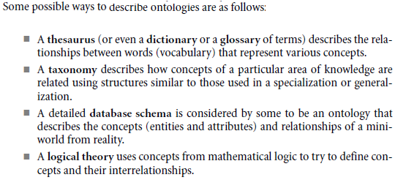

We now discuss four abstraction concepts that are used in semantic data models, such as the EER model as well as in KR schemes: (1) classification and instantiation, (2) identification, (3) specialization and generalization, and (4) aggregation and association.

One ongoing project that is attempting to allow information exchange among computers on the Web is called the Semantic Web, which attempts to create knowledge representation models that are quite general in order to allow meaningful information exchange and search among machines.

One commonly used definition of ontology is a specification of a conceptualization. In this definition, a conceptualization is the set of concepts that are used to represent the part of reality or knowledge that is of interest to a community of users.

**Types of Abstractions**

**Classification:** A is a member of class B

**Aggregation:** B, C, D Are Aggregated Into A, A Is Made Of/Composed Of B, C, D, Is-Made-Of, Is- Associated-With, Is-Part-Of, Is-Component-Of. Aggregation is an abstraction through which relationships are treated as higher-level entities.

**Generalization:** B,C,D can be generalized into a, b **is-a/is-an** a, is-as-like, is-kind-of.

**Category or Union:** A category represents a single superclass or subclass relationship with more than one superclass.

**Specialization:** A can be specialized into B, C, DB, C, or D (special cases of A) **Has-a, Has-A, Has An, Has-An** approach is used in the specialization

**Composition**: IS-MADE-OF (like aggregation)

**Identification**: IS-IDENTIFIED-BY

**UML Diagrams Notations**

UML stands for Unified Modeling Language. ERD stands for Entity Relationship Diagram. UML is a popular and standardized modeling language that is primarily used for object-oriented software. Entity-Relationship diagrams are used in structured analysis and conceptual modeling.

Object-oriented data models are typically depicted using Unified Modeling Language (UML) class diagrams. Unified Modeling Language (UML) is a language based on OO concepts that describes a set of diagrams and symbols that can be used to graphically model a system. UML class diagrams are used to represent data and their relationships within the larger UML object-oriented system’s modeling language.

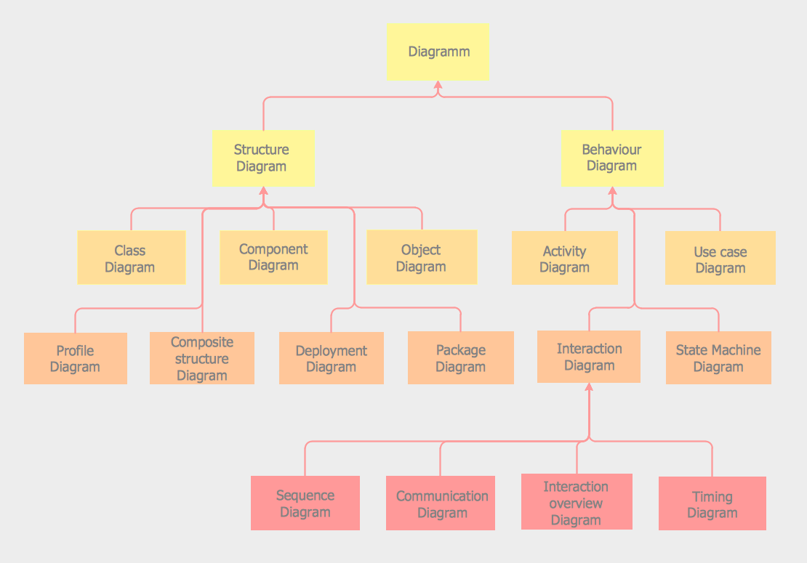

**Associations**

UML uses Boolean attributes instead of unary relationships but allows relationships of all other entities. Optionally, each association may be given at most one name. Association names normally start with a capital letter. Binary associations are depicted as lines between classes. Association lines may include elbows to assist with layout or when needed (e.g., for ring relationships).

**ER Diagram and Class Diagram Synchronization Sample**

Supporting the synchronization between ERD and Class Diagram. You can transform the system design from the data model to the Class model and vice versa, without losing its persistent logic.

**Conversions of Terminology of UML and ERD**

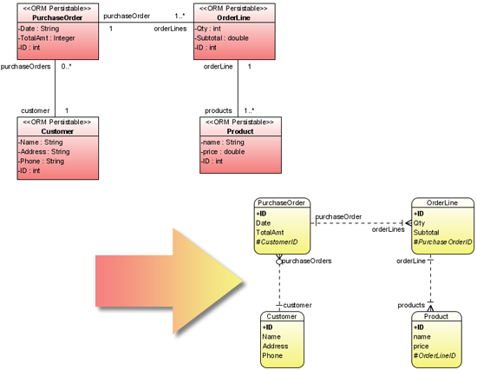

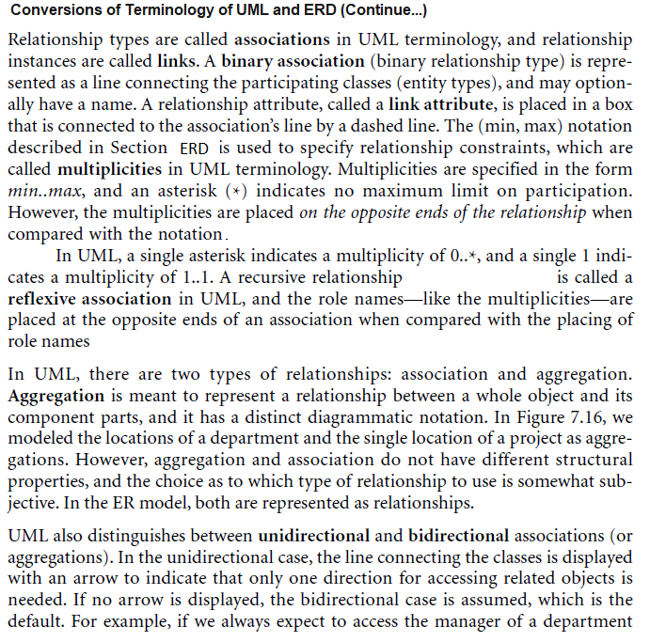

**Relational Data Model and its Main Evolution**

Inclusion ER Model is the Class diagram of the UML Series. 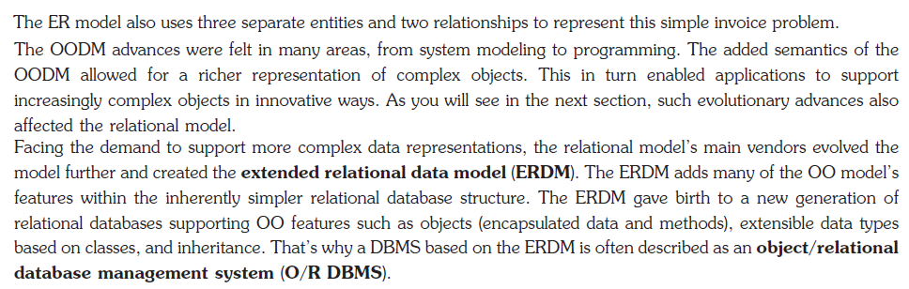

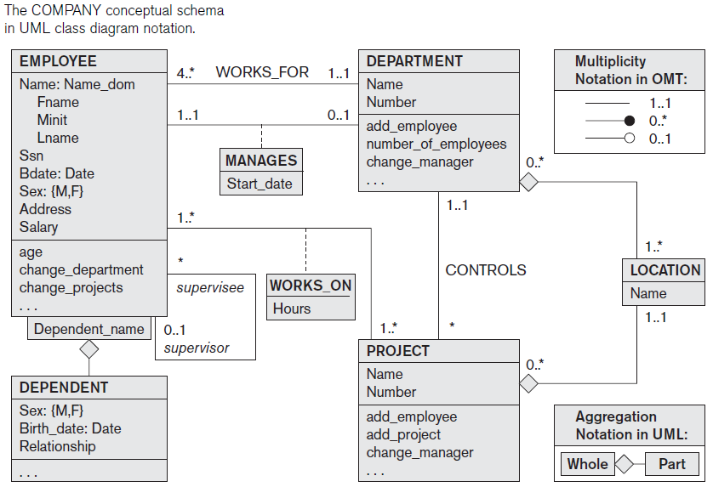

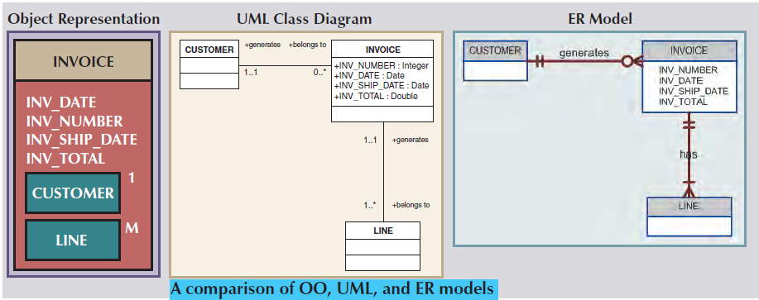

**ER Notation Comparison with UML and Their relationship**

**ER Construct Notation Relationships**

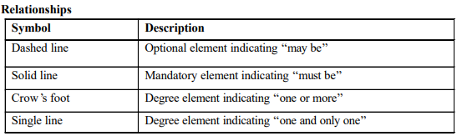

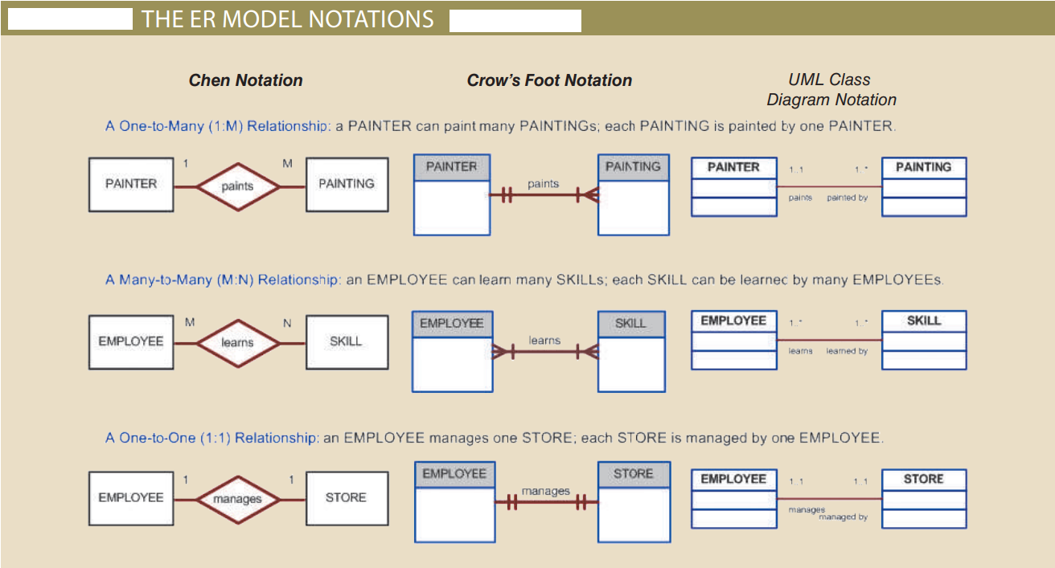

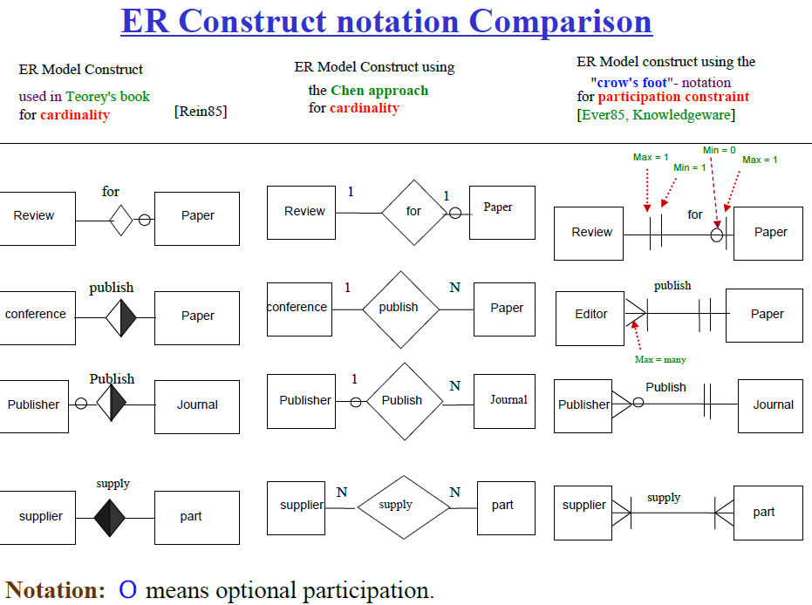

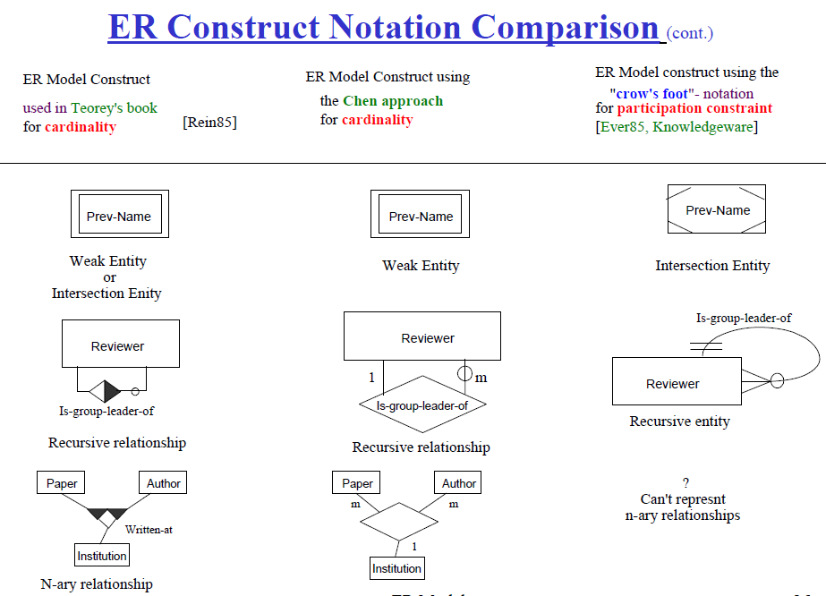

* **Rest ER Construct Notation Comparison**

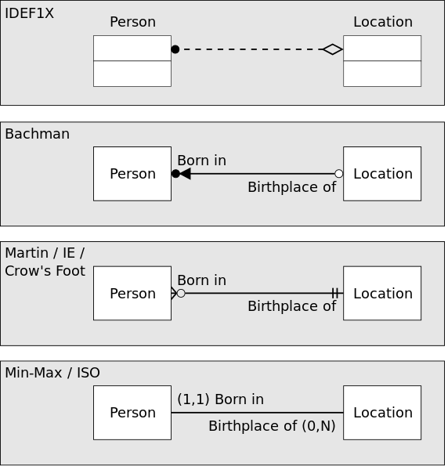

**Appropriate Er Model Design Naming Conventions**

**Guideline 1**

**Nouns =>** Entity, object, relation, table_name.

**Verbs =>** Indicate relationship_types.

**Common Nouns=>** A common noun (such as student and employee) in English corresponds to an entity type in an ER diagram:

**Proper Nouns=>** Proper nouns are entities. e.g. John, Singapore, New York City.

**Note: A relational database uses relations or two-dimensional tables to store information.**

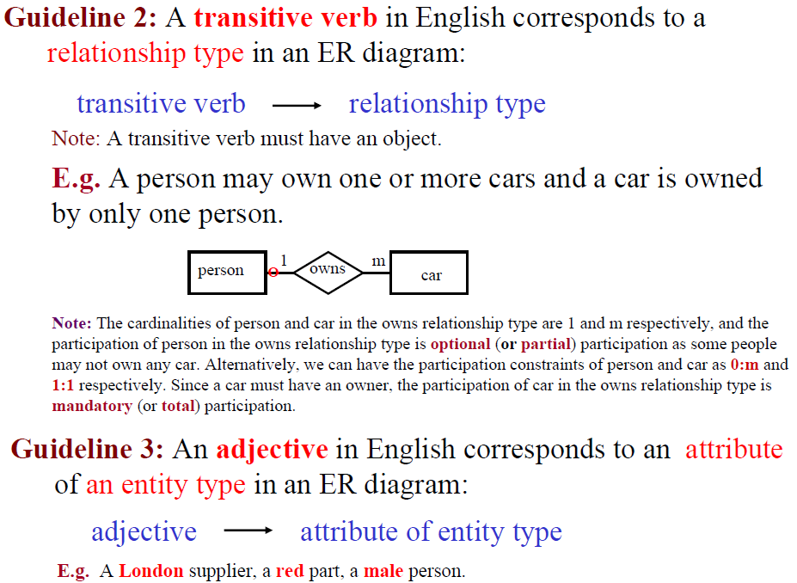

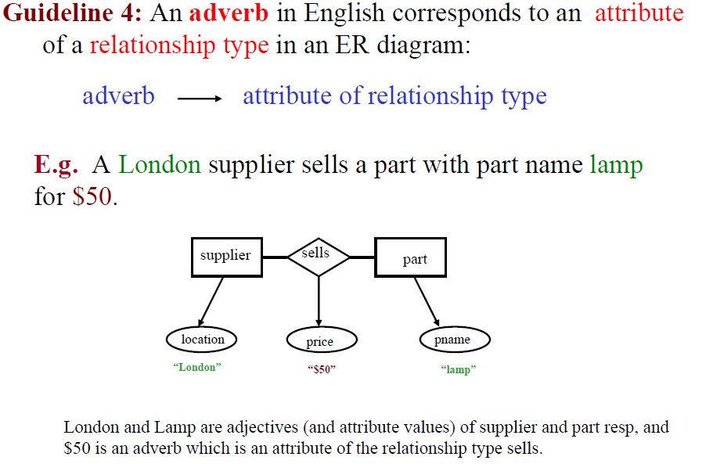

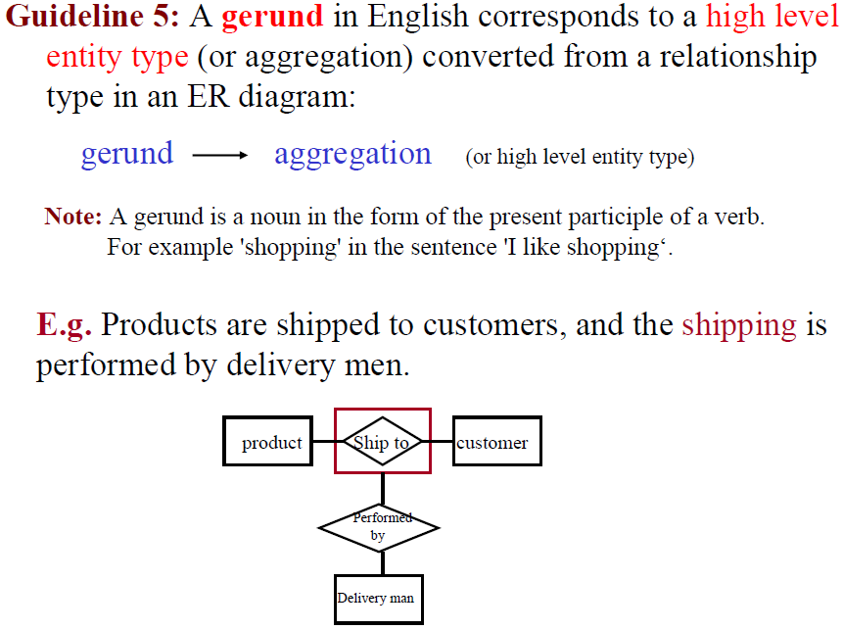

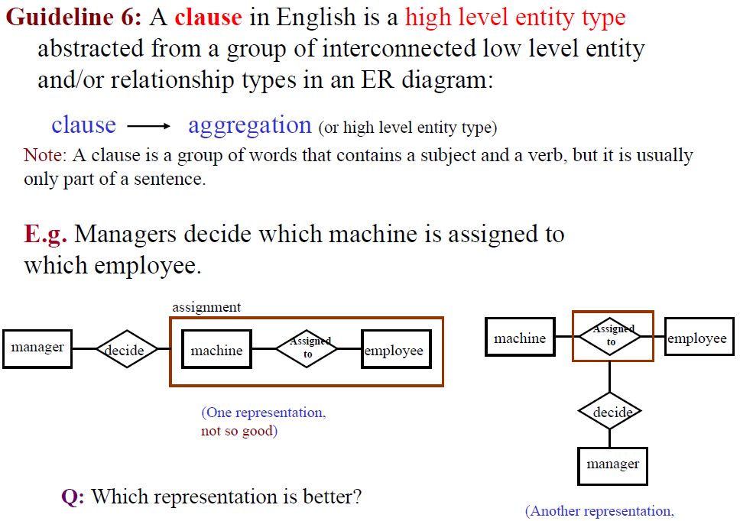

**Types of Attributes-**

In ER diagram, attributes associated with an entity set may be of the following types-

1. Simple attributes/atomic attributes/Static attributes
2. Key attribute
3. Unique attributes
4. Stored attributes
5. Prime attributes
6. Derived attributes (DOB, AGE, Oval is a derived attribute)
7. Composite attribute (Address (street, door#, city, town, country))
8. The multivalued attribute (double ellipse (Phone#, Hobby, Degrees))
9. Dynamic Attributes
10. Boolean attributes

The fundamental new idea in the MOST model is the so-called **dynamic attributes.** Each attribute of an object class is classified to be either static or dynamic. A **static attribute** is as usual. A dynamic attribute changes its value with time automatically.

Attributes of the database tables which are candidate keys of the database tables are called **prime attributes**.

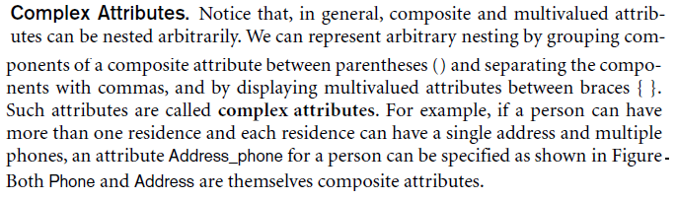

**Symbols of Attributes:**

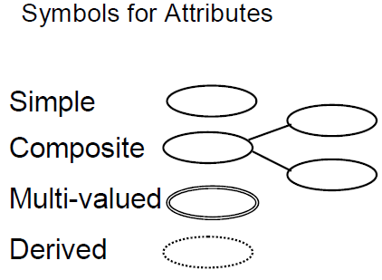

**The Entity**

The entity is the basic building block of the E-R data model. The term entity is used in three different meanings or for three different terms and are:

Entity type

Entity instance

Entity set

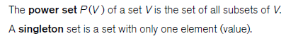

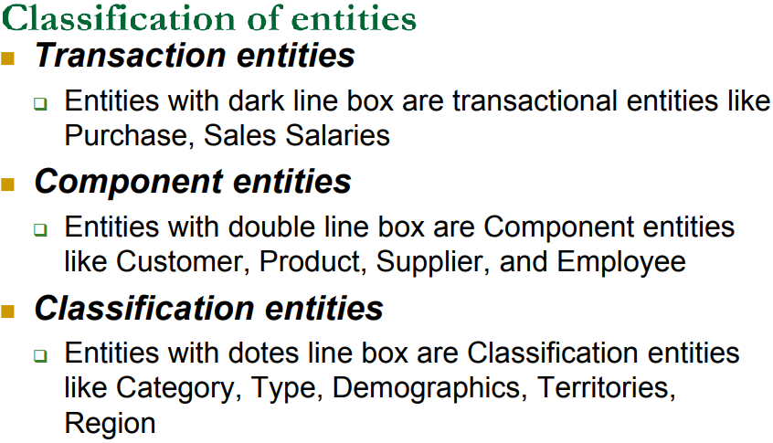

**Technical Types of Entity:**

* **Tangible Entity:**

Tangible Entities are those entities that exist in the real world physically. Example: Person, car, etc.

* **Intangible Entity:**

Intangible (Concepts) Entities are those entities that exist only logically and have no physical existence. Example: Bank Account, etc.

**Major of entity types**

1. Strong Entity Type
2. Weak Entity Type
3. Naming Entity
4. Characteristic entities
5. Dependent entities
6. Independent entities

**Details of entity types**

An entity type whose instances can exist independently, that is, without being linked to the instances of any other entity type is called a strong entity type.

A weak entity can be identified uniquely only by considering the primary key of another (owner) entity.

The owner entity set and weak entity set must participate in a one-to-many relationship set (one owner, many weak entities).

The weak entity set must have total participation in this *identifying relationship* set.

Weak entities have only a “partial key” (dashed underline), When the owner entity is deleted, all owned weak entities must also be deleted

**Types Following are some recommendations for naming entity types.**

* Singular nouns are recommended, but still, plurals can also be used
* Organization-specific names, like a customer, client, owner anything will work
* Write in capitals, yes, this is something that is generally followed, otherwise will also work.
* Abbreviations can be used, be consistent. Avoid using confusing abbreviations, if they are confusing for others today, tomorrow they will confuse you too.

**Database Design Tools**

Some commercial products are aimed at providing environments to support the DBA in performing database design. These environments are provided by database design tools, or sometimes as part of a more general class of products known as computer-aided software engineering (CASE) tools. Such tools usually have some components, choose from the following kinds. It would be rare for a single product to offer all these capabilities.

1. ER Design Editor
2. ER to Relational Design Transformer
3. FD to ER Design Transformer
4. Design Analyzers

**ER Modeling Rules to design database**

**Three components:**

1. Structural part - set of rules applied to the construction of the database
2. Manipulative part - defines the types of operations allowed on the data
3. Integrity rules - ensure the accuracy of the data

**Step1: DFD Data Flow Model**

Data flow diagrams: the most common tool used for designing database systems is a data flow diagram. It is used to design systems graphically and expresses different system detail at different DFD levels.

**Characteristics**

* DFDs show the flow of data between different processes or a specific system.
* DFDs are simple and hide complexities.
* DFDs are descriptive and links between processes describe the information flow.
* DFDs are focused on the flow of information only.
* Data flows are pipelines through which packets of information flow.
* DBMS applications store data as a file. RDBMS applications store data in a tabular form.
* In the file system approach, there is no concept of data models exists. It mostly consists of different types of files like mp3, mp4, txt, doc, etc. that are grouped into directories on a hard drive.
* Collection of logical constructs used to represent data structure and relationships within the database.
* A data flow diagram shows the way information flows through a process or system. It includes data inputs and outputs, data stores, and the various subprocesses the data moves through.

**Symbols used in DFD**

Dataflow **=>** Arrow symbol

Data store **=>** It is expressed with a rectangle open on the right width and the left width of the rectangle drawn with double lines.

Processes **=>** Circle or near squire rectangle

DFD-process **=>** Numbered DFD processes circle and rectangle by passing a line above the center of the circle or rectangle

**To create DFD following steps:**

1. Create a list of activities
2. Construct Context Level DFD (external entities, processes)
3. Construct Level 0 DFD (manageable sub-process)
4. Construct Level 1- n DFD (actual data flows and data stores)

**Types of DFD**

1. **Context diagram**
2. **Level 0,1,2 diagrams**
3. **Detailed diagram**
4. **Logical DFD**
5. **Physical DFD**

**Context diagrams** are the most basic data flow diagrams. They provide a broad view that is easily digestible but offers little detail. They always consist of a single process and describe a single system. The only process displayed in the CDFDs is the process/system being analyzed. The name of the CDFDs is generally a Noun Phrase.

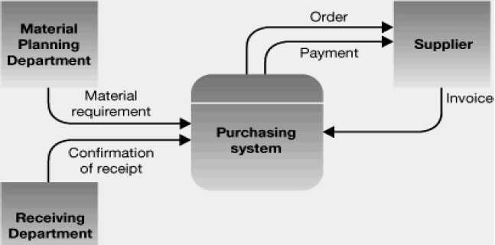

Example Context DFD Diagram

In the context level, DFDs no data stores are created.

**0-Level DFD** The level 0 Diagram in the DFD is used to describe the working of the whole system. Once a context DFD has been created the level zero diagram or level ‘not’ diagram is created. The level zero diagram contains all the apparent details of the system. It shows the interaction between some processes and may include a large number of external entities. At this level, the designer must keep a balance in describing the system using the level 0 diagram. Balance means that he should give proper depth to the level 0 diagram processes.

**1-level DFD** In 1-level DFD, the context diagram is decomposed into multiple bubbles/processes. In this level, we highlight the main functions of the system and breakdown the high-level process of 0-level DFD into subprocesses.

**2-level DFD** In 2-level DFD goes one step deeper into parts of 1-level DFD. It can be used to plan or record the specific/necessary detail about the system’s functioning.

**Detailed DFDs** are detailed enough that it doesn’t usually make sense to break them down further.

Logical data flow diagrams focus on what happens in a particular information flow: what information is being transmitted, what entities are receiving that info, what general processes occur, etc. It describes the functionality of the processes that we showed briefly in the Level 0 Diagram. It means that generally detailed DFDS is expressed as the successive details of those processes for which we do not or could not provide enough details.

**Logical DFD**

Logical data flow diagram mainly focuses on the system process. It illustrates how data flows in the system. Logical DFD is used in various organizations for the smooth running of system. Like in a Banking software system, it is used to describe how data is moved from one entity to another.

**Physical DFD**

Physical data flow diagram shows how the data flow is actually implemented in the system. Physical DFD is more specific and closer to implementation.

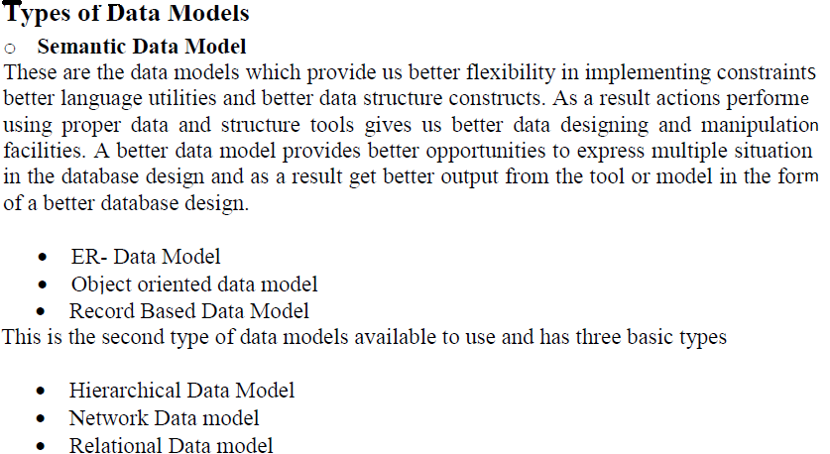

* Conceptual models are (Entity-relationship database model (ERDBD), Object-oriented model (OODBM), Record-based data model)
* Implementation models (Types of Record-based logical Models are (Hierarchical database model (HDBM), Network database model (NDBM), Relational database model (RDBM)
* Semi-structured Data Model **(**The semi-structured data model allows the data specifications at places where the individual data items of the same type may have different attribute sets. The Extensible Markup Language, also known as XML, is widely used for representing semi-structured data).

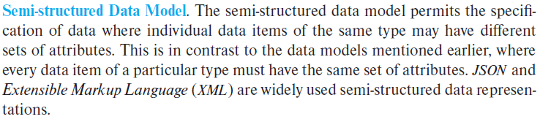

**Evolution Records of Data model and types**

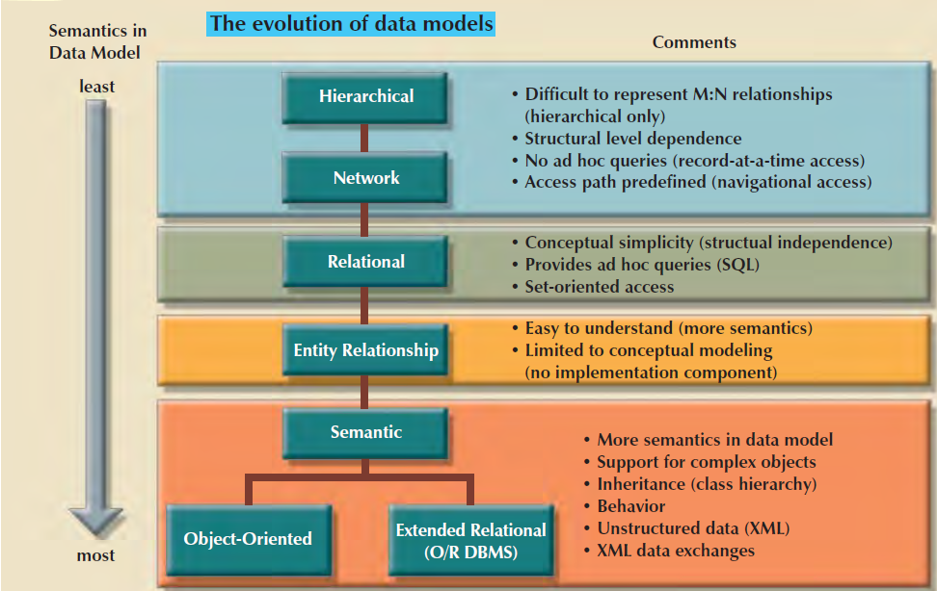

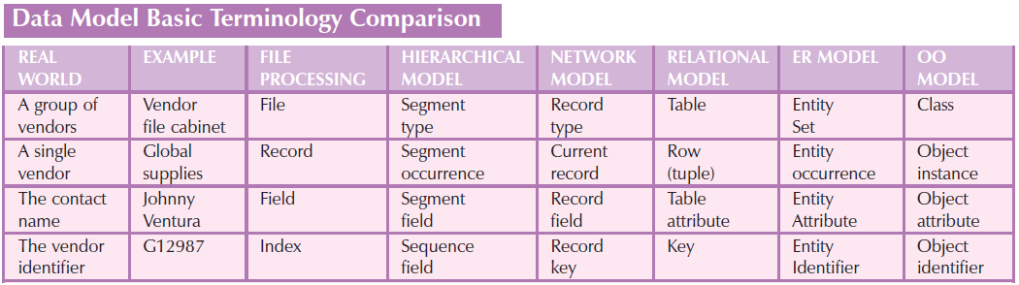

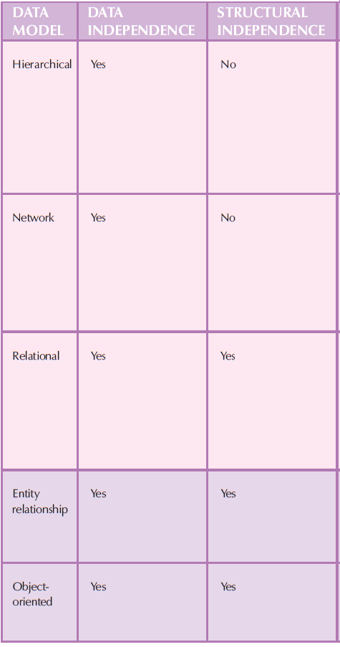

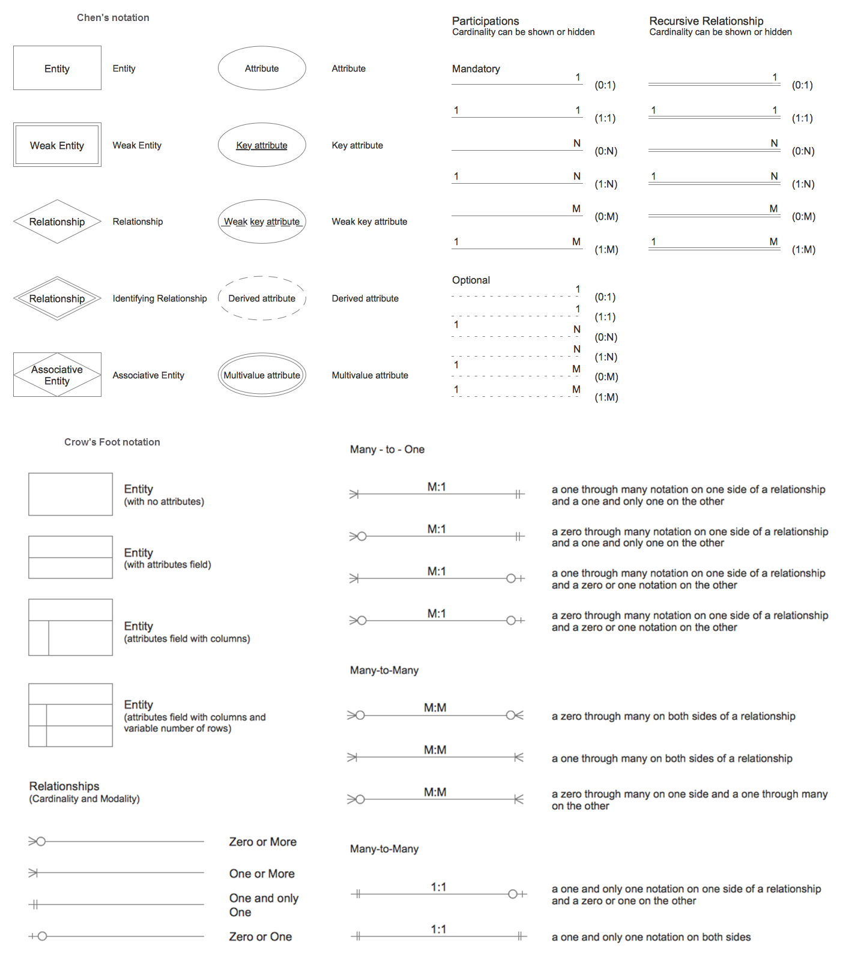

**ERD Modeling and Database table relationships**

**What is ERD:** structure or schema or logical design of database is called Entity-Relationship diagram.

**Category of relationships**

Optional relationship

Mandatory relationship

**Types of relationships concerning degree**

**Unary or self or recursive relationship**

A single entity, recursive, exists between occurrences of the same entity set

**Binary**

Two entities are associated in a relationship

**Ternary**

A ternary relationship is when three entities participate in the relationship.

A ternary relationship is a relationship type that involves many many relationships between three tables.

For Example:

The University might need to record which teachers taught which subjects in which courses.

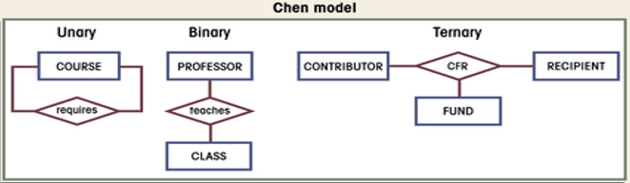

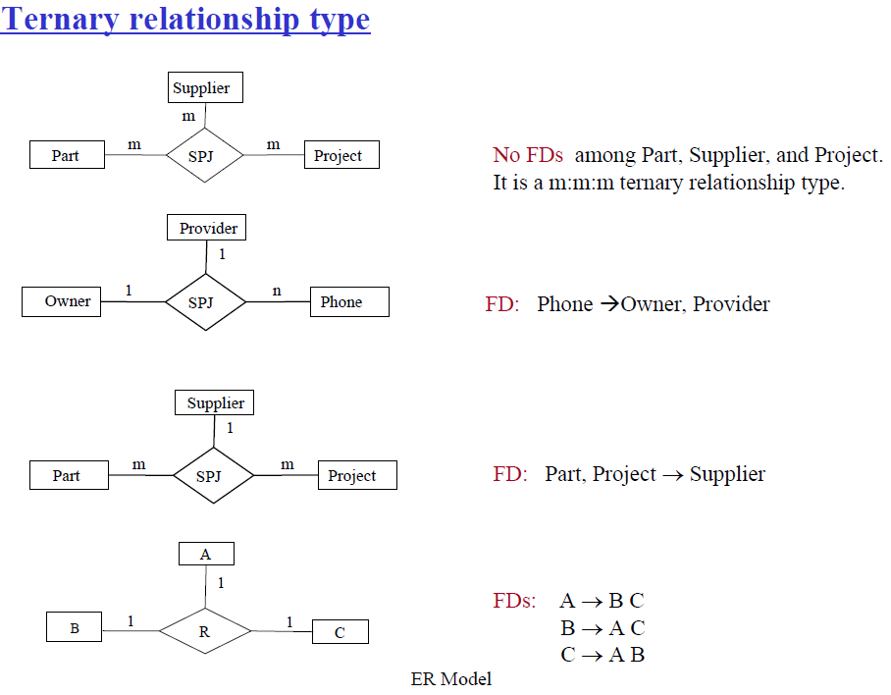

**N-ary**

N-ary (many entities involved in the relationship)

An N-ary relationship exists when there are n types of entities. There is one limitation of the N-ary any entities so it is very hard to convert into an entity, a rational table.

A relationship between more than two entities is called an n-ary relationship.

**Examples of relationships R between two entities E and F**

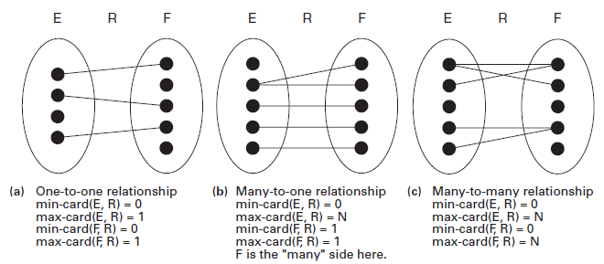

**Relationship Notations with entities:**

Because it uses diamonds for relationships, Chen notation takes up more space than Crow’s Foot notation. Chen's notation also requires symbols. Crow’s Foot has a slight learning curve.

Chen notation has the following possible cardinality:

**One-to-One, Many-to-Many, and Many-to-One Relationships**

One-to-one (1:1) – both entities are associated with only one attribute of another entity

One-to-many (1:N) – one entity can be associated with multiple values of another entity

Many-to-one (N:1) – many entities are associated with only one attribute of another entity

Many-to-many (M: N) – multiple entities can be associated with multiple attributes of another entity

**ER Design Issues**

Here, we will discuss the basic design issues of an ER database schema in the following points:

1) Use of Entity Set vs Attributes

The use of an entity set or attribute depends on the structure of the real-world enterprise that is being modeled and the semantics associated with its attributes.

2) Use of Entity Set vs. Relationship Sets

It is difficult to examine if an object can be best expressed by an entity set or relationship set.

3) Use of Binary vs n-ary Relationship Sets

Generally, the relationships described in the databases are binary relationships. However, non-binary relationships can be represented by several binary relationships.

**Transforming Entities and Attributes to Relations**

Our ultimate aim is to transform the ER design into a set of definitions for relational

tables in a computerized database, which we do through a set of transformation

rules.

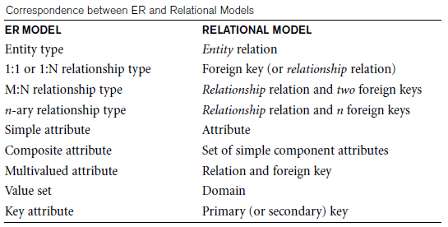

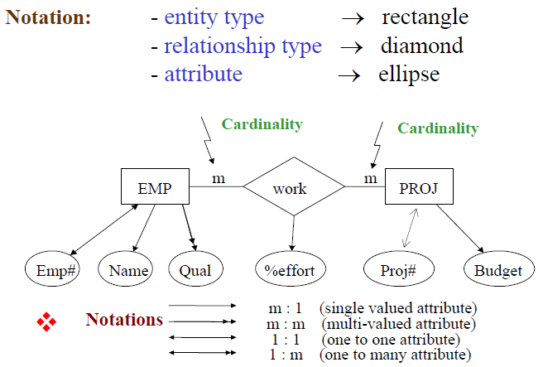

**The first step is to design a rough schema by analyzing of requirements**

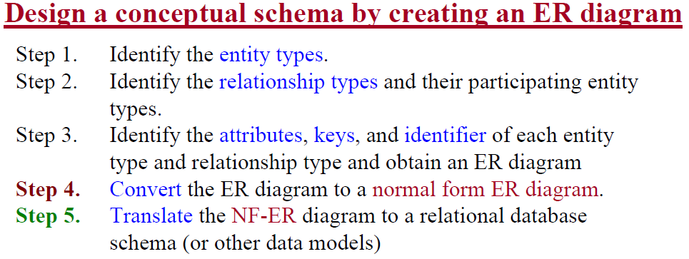

**Normalize the ERD and remove FD from Entities to enter the final steps**

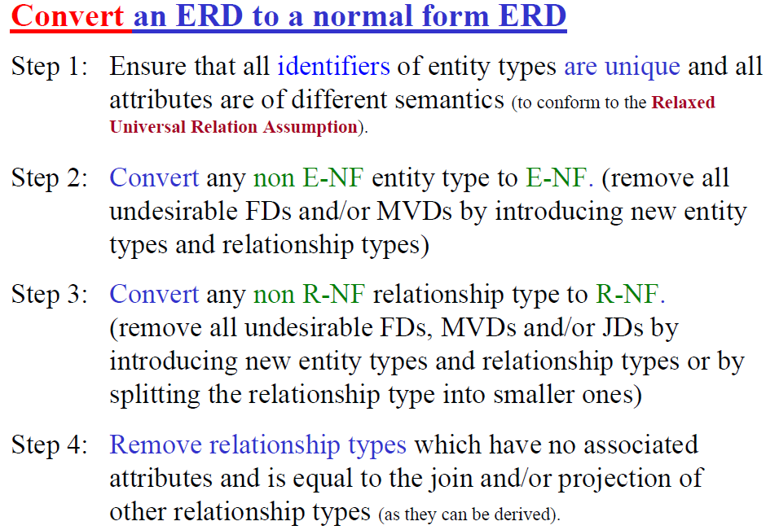

**Transformation Rule 1.** Each entity in an ER diagram is mapped to a single table in a relational database;

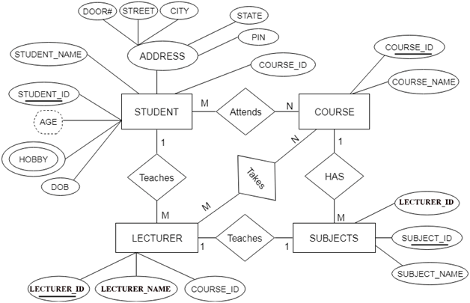

**Transformation Rule 2.** A key attribute of the entity type is represented by the primary key.

All single-valued attribute becomes a column for the table

**Transformation Rule 3.** Given an entity E with primary identify, a multivalued attributed attached to E in an ER diagram is mapped to a table of its own;

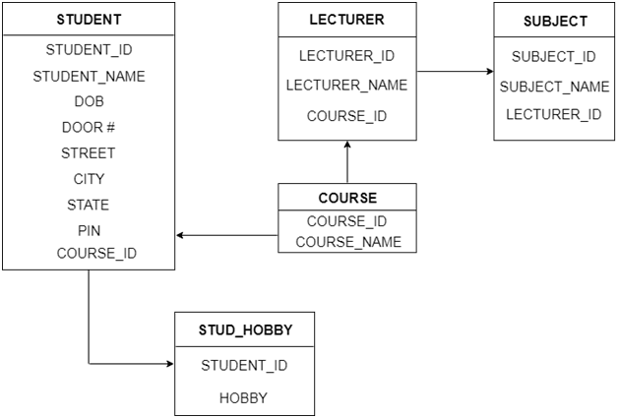

**Transforming Binary Relationships to Relations**

We are now prepared to give the transformation rule for a binary many-to-many relationship.

**Transformation Rule 3.5**. N – N Relationships: When two entities E and F take part in a many-to-many binary relationship R, the relationship is mapped to a representative table T in the related relational database design. The table contains columns for all attributes in the primary keys of both tables transformed from entities E and F, and this set of columns form the primary key for table T.

Table T also contains columns for all attributes attached to the relationship. Relationship occurrences are represented by rows of the table, with the related entity instances uniquely identified by their primary key values as rows.

Case 1: Binary Relationship with 1:1 cardinality with the total participation of an entity

Total participation, i.e. min occur is 1 with double lines in total.

A person has 0 or 1 passport number and the Passport is always owned by 1 person. So it is 1:1 cardinality with full participation constraint from Passport.  First Convert each entity and relationship to tables.

Case 2: Binary Relationship with 1:1 cardinality and partial participation of both entities

A male marries 0 or 1 female and vice versa as well. So it is a 1:1 cardinality with partial participation constraint from both. First Convert each entity and relationship to tables. Male table corresponds to Male Entity with key as M-Id. Similarly, the Female table corresponds to Female Entity with the key as F-Id. Marry Table represents the relationship between Male and Female (Which Male marries which female). So it will take attribute M-Id from Male and F-Id from Female.

Case 3: Binary Relationship with n: 1 cardinality

Case 4: Binary Relationship with m: n cardinality

Case 5: Binary Relationship with weak entity

In this scenario, an employee can have many dependents and one dependent can depend on one employee. A dependent does not have any existence without an employee (e.g; you as a child can be dependent on your father in his company). So it will be a weak entity and its participation will always be total.

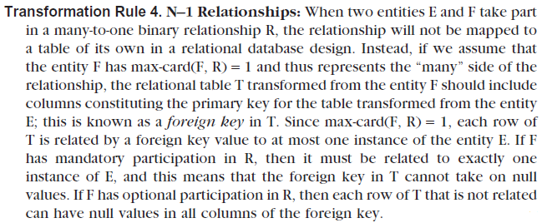

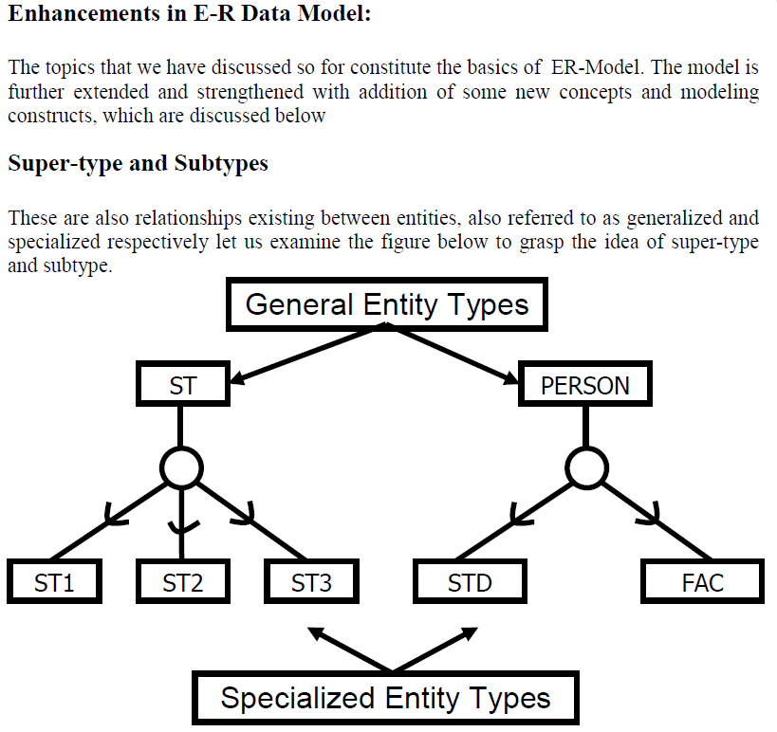

**EERD design approaches**

Generalization is the concept that some entities are the subtypes of other more general entities. They are represented by an "is a" relationship. Faculty (**ISA OR IS-A OR IS A**) subtype of the employee. One method of representing subtype relationships shown below is also known as the top-down approach.

**Exclusive Subtype**

If subtypes are exclusive, one supertype relates to at most one subtype.

**Inclusive Subtype**

If subtypes are inclusive, one supertype can relate to one or more subtypes

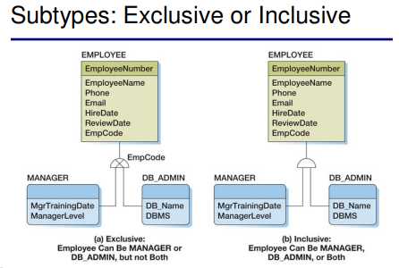

**Data abstraction in EERD levels**

Concepts of total and partial, subclasses and superclasses, specializations and generalizations.

View level: The highest level of data abstraction like EERD.

Middle level: Middle level of data abstraction like ERD

The lowest level of data abstraction like Physical/internal data stored at disk/bottom level

**Specialization**

Subgrouping into subclasses (top-down approach)( **HASA, HAS-A, HAS AN, HAS-AN**)

Inheritance – Inherit attributes and relationships from the superclass (Name, Birthdate, etc.)

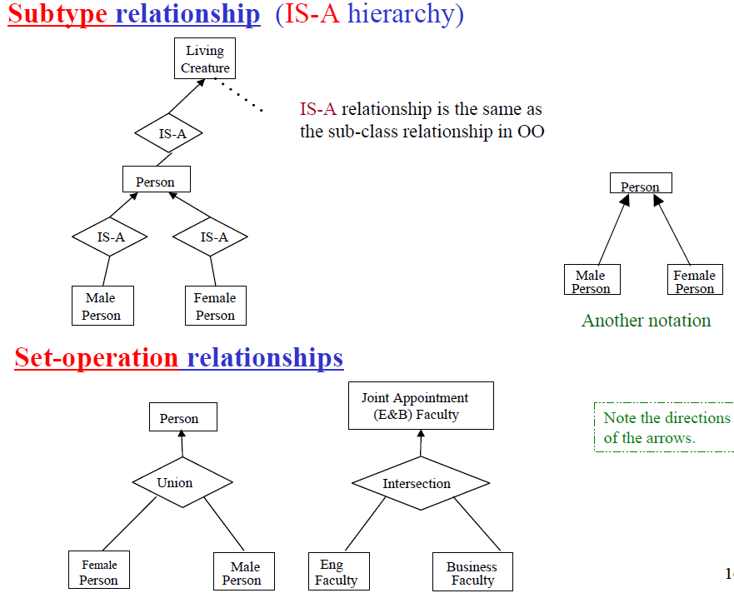

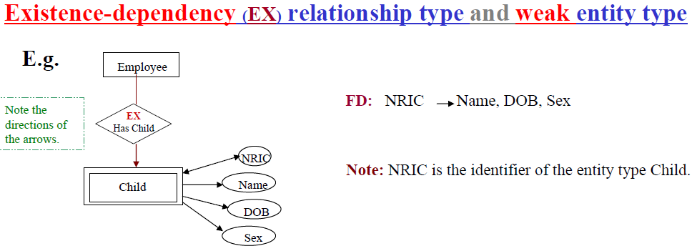

**Generalization**

Reverse processes of defining subclasses (bottom-up approach). Bring together common attributes in entities (**ISA, IS-A, IS AN, IS-AN**)

**Union**

Models a class/subclass with more than one superclass of distinct entity types. Attribute inheritance is selective.

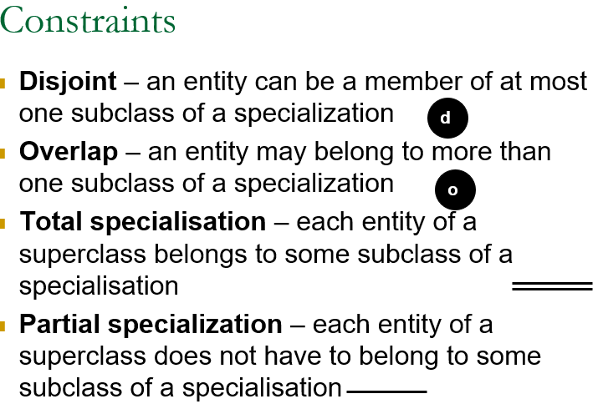

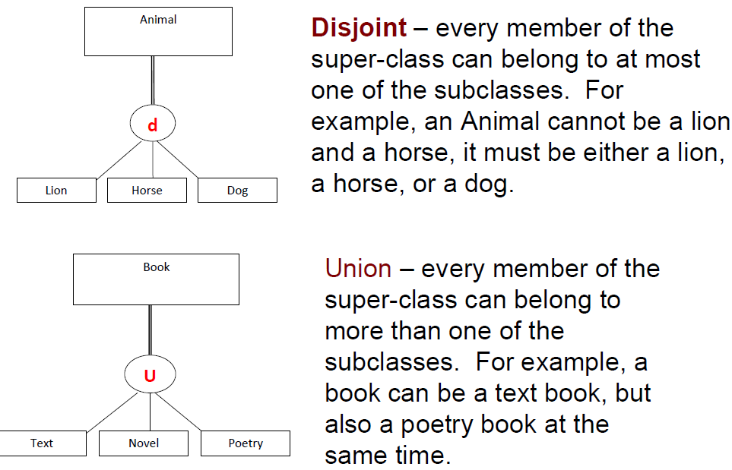

**Constraints on Specialization and Generalization**

We have four types of specialization/generalization constraints:

**Disjoint**, total

**Disjoint**, partial

**Overlapping**, total

**Overlapping**, partial

**Multiplicity** (relationship constraint)

**Covering** constraints whether the entities in the subclasses collectively include all entities in the superclass

Note: Generalization usually is total because the superclass is derived from the subclasses.

The term **Cardinality** has two different meanings based on the context you use.

**Relationship Constraints types**

Cardinality ratio

Specifies the maximum number of relationship instances in which each entity can participate

Types 1:1, 1:N, or M:N

**Participation constraint**

Specifies whether the existence of an entity depends on its being related to another entity

**Types: total and partial**

Thus the minimum number of relationship instances in which entities can participate: thus1 for total participation, 0 for partial

Diagrammatically, use a double line from relationship type to entity type

**There are two types of participation constraints:**

Total participation, i.e. min occur is 1 with double lines in total. DottedOval is a derived attribute

1. Partial Participation
2. Total Participation

When we require all entities to participate in the relationship (total participation), we use double lines to specify. (Every loan has to have at least one customer)

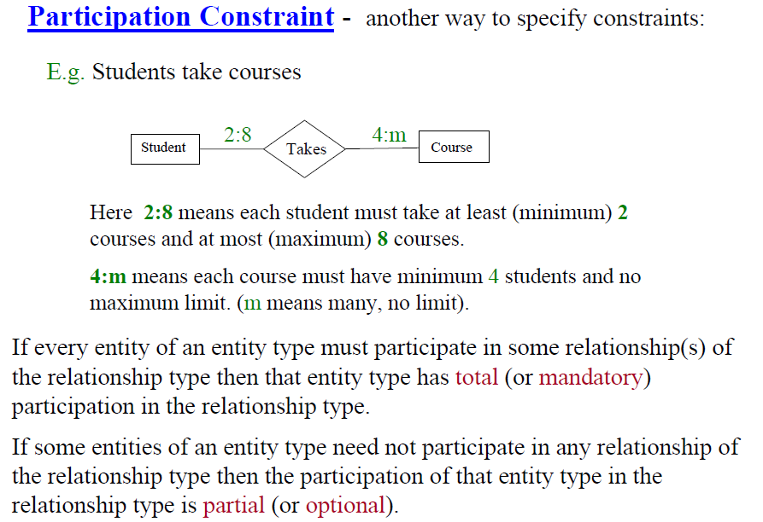

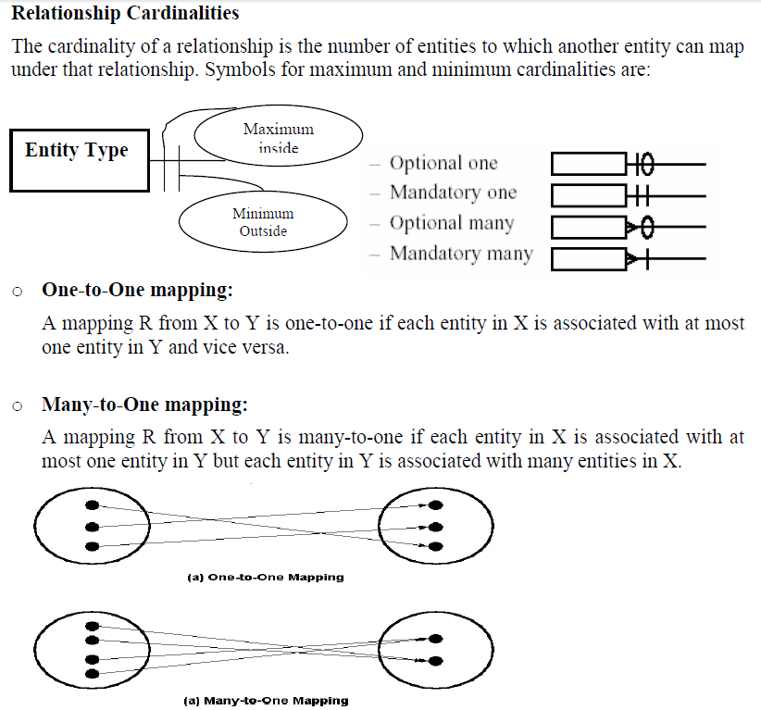

Itexpresses some entity occurrences associated with one occurrence of the related entity=>The specific.

The cardinality of a relationship is the number of instances of entity B that can be associated with entity A. There is a minimum cardinality and a maximum cardinality for each relationship, with an unspecified maximum cardinality being shown as N. Cardinality limits are usually derived from the organization's policies or external constraints.

**For Example:**

At the University, each Teacher can teach an unspecified maximum number of subjects as long as his/her weekly hours do not exceed 24 (this is an external constraint set by an industrial award). Teachers may teach 0 subjects if they are involved in non-teaching projects. Therefore, the cardinality limits for TEACHER are (O, N).

The University's policies state that each Subject is taught by only one teacher, but it is possible to have Subjects that have not yet been assigned a teacher. Therefore, the cardinality limits for SUBJECT are (0,1). Teacher and subject have M: N relationship connectivity. And they are binary (two) ternary too if we break this relationship. Such situations are modeled using a composite entity (or gerund)

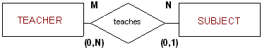

**Cardinality Constraint:** Quantification of the relationship between two concepts or classes (a constraint on aggregation)

Remember cardinality is always a relationship to another thing.

Max Cardinality(Cardinality) Always 1 or Many. Class A has a relationship to Package B with a cardinality of one, which means at most there can be one occurrence of this class in the package. The opposite could be a Package that has a Max Cardinality of N, which would mean there can be N number of classes

Min Cardinality(Optionality) Simply means "required." Its always 0 or 1. 0 would mean 0 or more, 1 or more

The three types of cardinality you can define for a relationship are as follows:

Minimum Cardinality. Governs whether or not selecting items from this relationship is optional or required. If you set the minimum cardinality to 0, selecting items is optional. If you set the minimum cardinality to greater than 0, the user must select that number of items from the relationship.

Optional to Mandatory, Optional to Optional, Mandatory to Optional, Mandatory to Mandatory

Summary Of ER Diagram Symbols

Maximum Cardinality. Sets the maximum number of items that the user can select from a relationship. If you set the minimum cardinality to greater than 0, you must set the maximum cardinality to a number at least as large If you do not enter a maximum cardinality, the default is 999.

Type of Max Cardinality: 1 to 1, 1 to many, many to many, many to 1

Default Cardinality. Specifies what quantity of the default product is automatically added to the initial solution that the user sees. Default cardinality must be equal to or greater than the minimum cardinality and must be less than or equal to the maximum cardinality.

Replaces cardinality ratio numerals and single/double line notation

Associate a pair of integer numbers (min, max) with each participant of an entity type E in a relationship type R, where 0 ≤ min ≤ max and max ≥ 1 max=N => finite, but unbounded

Relationship types can also have attributes

Attributes of 1:1 or 1:N relationship types can be migrated to one of the participating entity types

For a 1:N relationship type, the relationship attribute can be migrated only to the entity type on the N-side of the relationship

Attributes on M: N relationship types must be specified as relationship attributes

In the case of Data Modelling, Cardinality defines the number of attributes in one entity set, which can be associated with the number of attributes of other sets via a relationship set. In simple words, it refers to the relationship one table can have with the other table. They can be One-to-one, One-to-many, Many-to-one, or Many-to-many. And third may be the number of tuples in a relation.

In the case of SQL, Cardinality refers to a number. It gives the number of unique values that appear in the table for a particular column. For eg: you have a table called Person with the column Gender. Gender column can have values either 'Male' or 'Female''.

cardinality is the number of tuples in a relation (number of rows).

The **Multiplicity** of an association indicates how many objects the opposing class of an object can be instantiated. When this number is variable then the.

Multiplicity Cardinality + Participation dictionary definition of cardinality is the number of elements in a particular set or other.

Multiplicity can be set for attribute operations and associations in a UML class diagram (Equivalent to ERD) and associations in a use case diagram.

A cardinality is how many elements are in a set. Thus, a multiplicity tells you the minimum and maximum allowed members of the set. They are not synonymous.

**Given the example below:**

0-1 ---------- 1-

Multiplicities:

The first multiplicity, for the left entity: 0-1

The second multiplicity, for the right entity: 1-

Cardinalities for the first multiplicity:

Lower cardinality: 0

Upper cardinality: 1

Cardinalities for the second multiplicity:

Lower cardinality: 1

Upper cardinality:

Multiplicity is the constraint on the collection of the association objects whereas Cardinality is the count of the objects that are in the collection. The multiplicity is the cardinality constraint.

A multiplicity of an event = Participation of an element + cardinality of an element.

UML uses the term Multiplicity, whereas Data Modelling uses the term Cardinality. They are for all intents and purposes, the same.

Cardinality (sometimes referred to as Ordinality) is what is used in ER modeling to "describe" a relationship between two Entities.

**Cardinality and Modality**

The maindifference between cardinality and modality is that cardinality is defined as the metric used to specify the number of occurrences of one object related to the number of occurrences of another object. On the contrary, modality signifies whether a certain data object must participate in the relationship or not.

Cardinality refers to the maximum number of times an instance in one entity can be associated with instances in the related entity. Modality refers to the minimum number of times an instance in one entity can be associated with an instance in the related entity.

Cardinality can be 1 or Many and the symbol is placed on the outside ends of the relationship line, closest to the entity, Modality can be 1 or 0 and the symbol is placed on the inside, next to the cardinality symbol. For a cardinality of 1, a straight line is drawn. For a cardinality of Many a foot with three toes is drawn. For a modality of 1, a straight line is drawn. For a modality of 0, a circle is drawn.

zero or more

1 or more 

1 and only 1 (exactly 1)

**Multiplicity = Cardinality + Participation**

Cardinality: Denotes the maximum number of possible relationship occurrences in which a certain entity can participate (in simple terms: at most).

Note: Connectivity and Modality/ multiplicity/ Cardinality and Relationship are same terms.

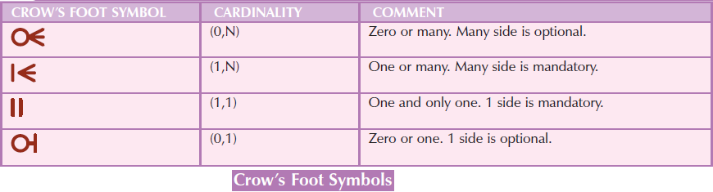

Participation: Denotes if all or only some entity occurrences participate in a relationship (in simple terms: at least). 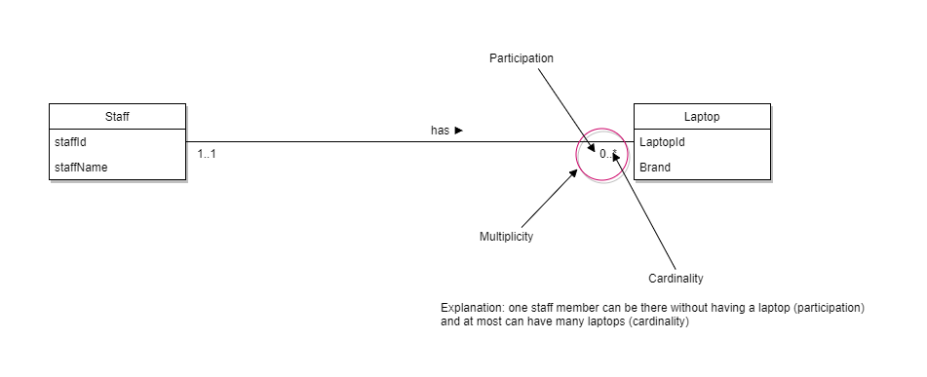

| BASIS FOR COMPARISON | CARDINALITY | MODALITY |
| --- | --- | --- |
| Basic | A maximum number of associations between the table rows. | A minimum number of row associations. |
| Types | One-to-one, one-to-many, many-to-many. | Nullable and not nullable. |

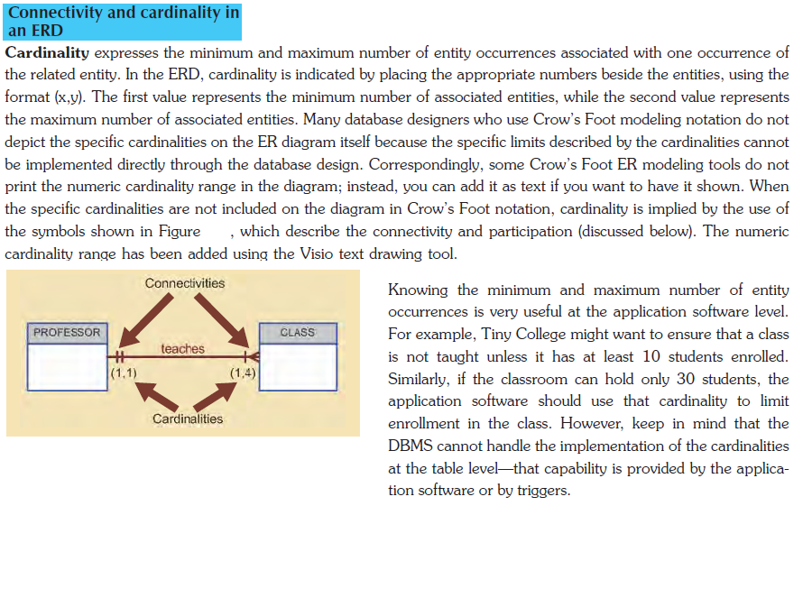

**Generalization** is like a bottom-up approach in which two or more entities of lower levels combine to form a higher level entity if they have some attributes in common.

Generalization is more like a subclass and superclass system, but the only difference is the approach. Generalization uses the bottom-up approach. Like subclasses are combined to make a superclass. **IS-A, ISA, IS A, IS AN, IS-AN** Approach is used in generalization

Generalization is the result of taking the union of two or more (lower level) entity types to produce a higher level entity type.

Generalization is the same as UNION. Specialization is the same as ISA.

**A specialization** is a top-down approach, and it is the opposite of Generalization. In specialization, one higher-level entity can be broken down into two lower-level entities. Specialization is the result of taking a subset of a higher-level entity type to form a lower-level entity type.

Normally, the superclass is defined first, the subclass and its related attributes are defined next, and the relationship set is then added. **HASA, HAS-A, HAS AN, HAS-AN.**

**UML to EER specialization or generalization comes in the form of hierarchical entity set:**

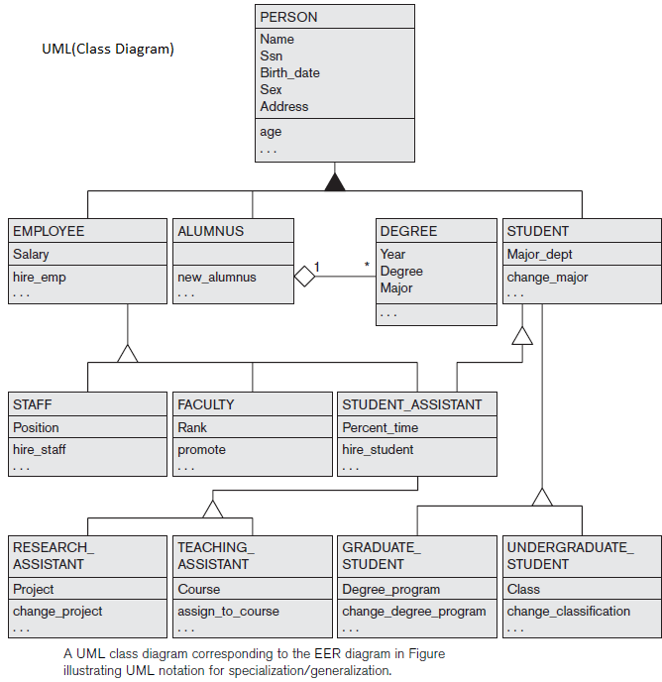

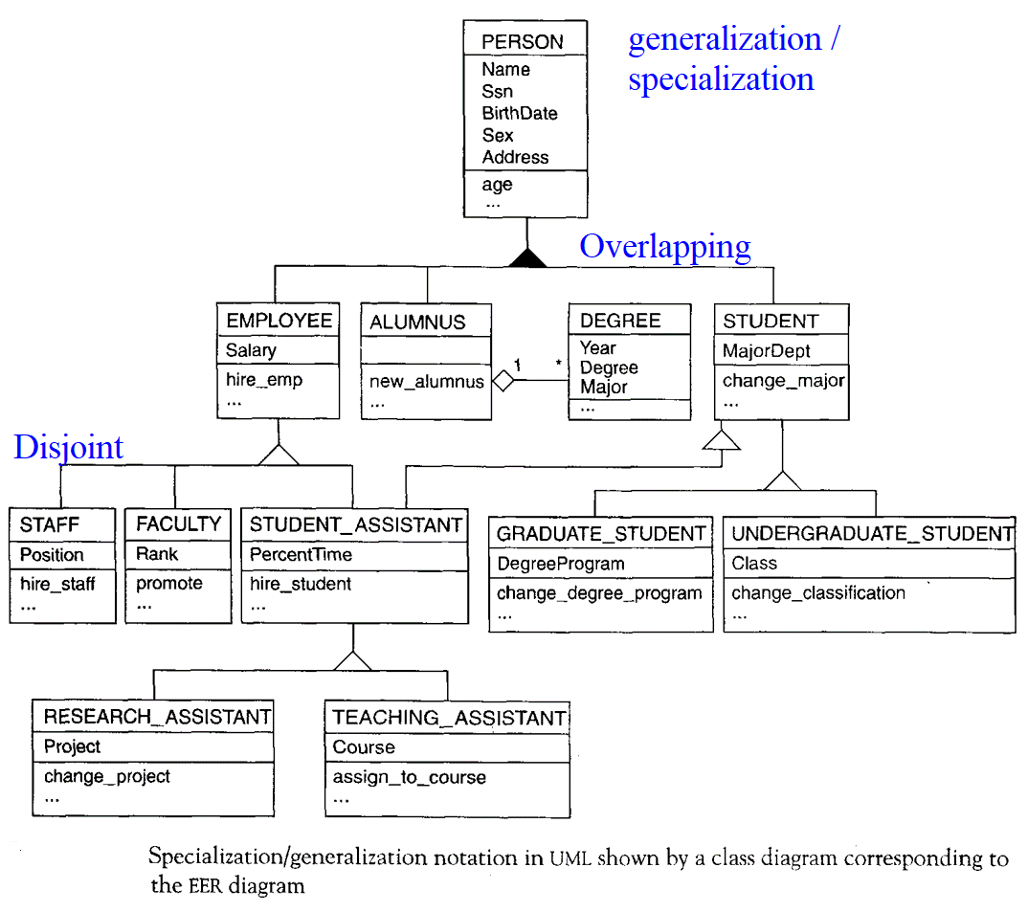

**Transforming EERD to Relational Database Model**

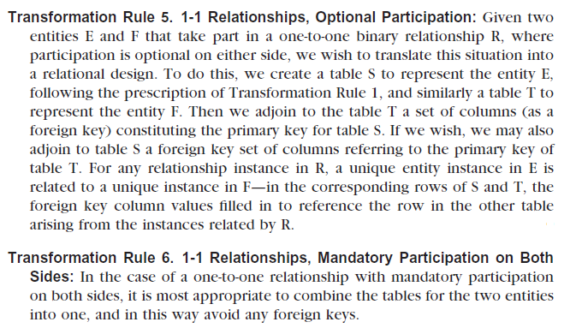

**Specialization / Generalization Lattice Example (UNIVERSITY) EERD TO Relational Model**

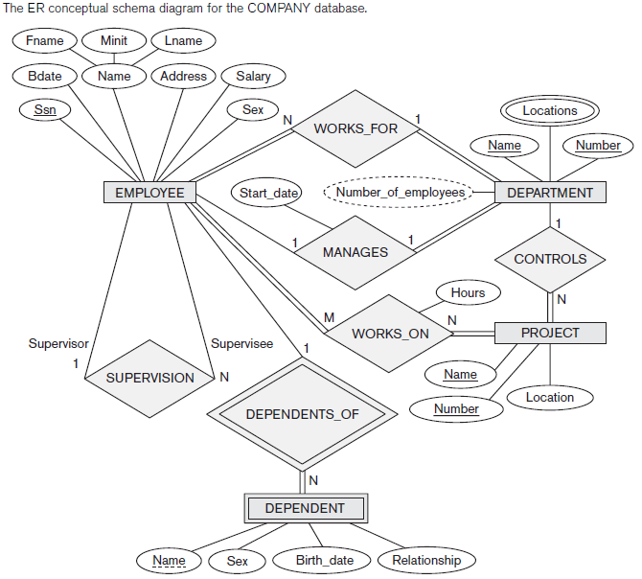

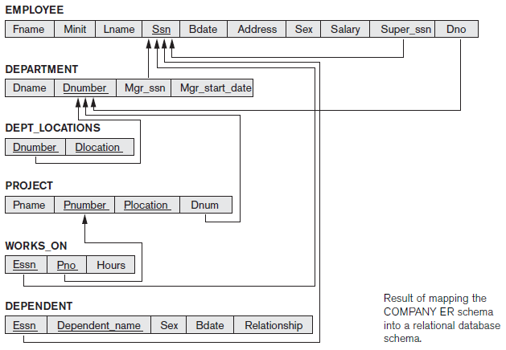

**Mapping Process**

1. Create tables for all higher-level entities.
2. Create tables for lower-level entities.
3. Add primary keys of higher-level entities in the table of lower-level entities.
4. In lower-level tables, add all other attributes of lower-level entities.
5. Declare the primary key of the higher-level table and the primary key of the lower-level table.
6. Declare foreign key constraints.

This section presents the concept of entity clustering, which abstracts the ER schema to such a degree that the entire schema can appear on a single sheet of paper or a single computer screen.

END

**CHAPTER 4 DISCOVERING BUSINESS RULES AND DATABASE CONSTRAINTS**

**Overview of Database Constraints**

Definition of Data integrity Constraints placed on the set of values allowed for the attributes of relation as relational Integrity.

**Constraints**– These are special restrictions on allowable values.

For example, the Passing marks for a student must always be greater than 50%.

**Categories of Constraints**

Constraints on databases can generally be divided into three main categories:

1. Constraints that are inherent in the data model. We call these inherent **model-based constraints or implicit constraints.**
2. Constraints that can be directly expressed in schemas of the data model, typically by specifying them in the DDL (data definition language, we call these **schema-based constraints or explicit constraints**.
3. Constraints that cannot be directly expressed in the schemas of the data model, and hence must be expressed and enforced by the application programs. We call these **application-based or semantic constraints or business rules.**

**Types of data integrity**

1. Physical Integrity

Physical integrity is the process of ensuring the wholeness, correctness, and accuracy of data when data is stored and retrieved.

1. Logical integrity

Logical integrity refers to the accuracy and consistency of the data itself. Logical integrity ensures that the data makes sense in its context.

**Types of logical integrity**

1. Entity integrity
2. Domain integrity

**The model-based constraints or implicit** include domain constraints, key constraints, entity integrity constraints, and referential integrity constraints.

Domain constraints can be violated if an attribute value is given that does not appear in the corresponding domain or is not of the appropriate data type. Key constraints can be violated if a key value in the new tuple already exists in another tuple in the relation r(R). Entity integrity can be violated if any part of the primary key of the new tuple t is NULL. Referential integrity can be violated if the value of any foreign key in t refers to a tuple that does not exist in the referenced relation.

**Note**: Insertions Constraints and constraints on NULLs are called explicit. Insert can violate any of the four types of constraints discussed in the implicit constraints.

1. **Business Rule or default relation constraints**

These rules are applied to data before (first) the data is inserted into the table columns. For example, Unique, Not NULL, Default constraints.

1. The primary key value can’t be null.
2. Not null (absence of any value (i.e., unknown or nonapplicable to a tuple)
3. Unique
4. Primary key
5. Foreign key
6. Check
7. Default
8. **Null Constraints**

Comparisons Involving NULL and Three-Valued Logic:

SQL has various rules for dealing with NULL values. Recall from Section 3.1.2 that NULL is used to represent a missing value, but that it usually has one of three different interpretations—value unknown (exists but is not known), value not available (exists but is purposely withheld), or value not applicable (the attribute is undefined for this tuple). Consider the following examples to illustrate each of the meanings of NULL.

1. **Unknownalue**. A person’s date of birth is not known, so it is represented by NULL in the database.
2. **Unavailable** or withheld value. A person has a home phone but does not want it to be listed, so it is withheld and represented as NULL in the database.
3. **Not applicable attribute**. An attribute Last_College_Degree would be NULL for a person who has no college degrees because it does not apply to that person.

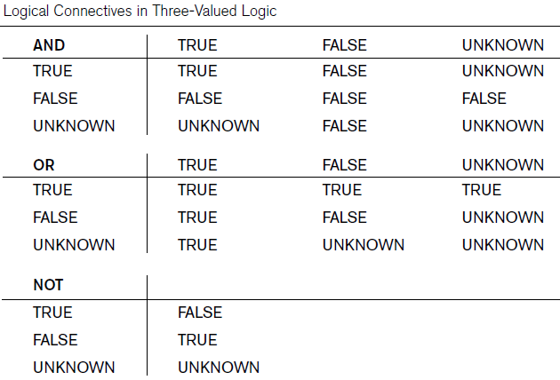

1. **Enterprise Constraints**

Enterprise constraints – sometimes referred to as semantic constraints – are additional rules specified by users or database administrators and can be based on multiple tables.

Here are some examples.

A class can have a maximum of 30 students.

A teacher can teach a maximum of four classes per semester.

An employee cannot take part in more than five projects.

The salary of an employee cannot exceed the salary of the employee’s manager.

1. **Key Constraints or Uniqueness Constraints :**

These are called uniqueness constraints since it ensures that every tuple in the relation should be unique.

A relation can have multiple keys or candidate keys(minimal superkey), out of which we choose one of the keys as primary key, we don’t have any restriction on choosing the primary key out of candidate keys, but it is suggested to go with the candidate key with less number of attributes.

Null values are not allowed in the primary key, hence Not Null constraint is also a part of key constraint.

1. **Domain, Field, Row integrity Constraints**

**Domain Integrity:**

A domain of possible values must be associated with every attribute (for example, integer types, character types, date/time types). Declaring an attribute to be of a particular domain act as the constraint on the values that it can take. Domain Integrity rules govern the values.

In the specific field/cell values must be with in column domain and represent a specific location within at table

In a database system, the domain integrity is defined by:

1. The datatype and the length
2. The NULL value acceptance
3. The allowable values, through techniques like constraints or rules the default value.

**Some examples of Domain Level Integrity are mentioned below;**

* **Data Type–** For example integer, characters, etc.
* **Date Format–** For example dd/mm/yy or mm/dd/yyyy or yy/mm/dd.
* **Null support–** Indicates whether the attribute can have null values.
* **Length**– Represents the length of characters in a value.
* **Range**– The range specifies the lower and upper boundaries of the values the attribute may legally have.

**Entity integrity:**

No attribute of a primary key can be null (every tuple must be uniquely identified)

1. **Referential Integrity Constraints**

A referential integrity constraint is famous as a foreign key constraint. The value of foreign key values is derived from the Primary key of another table. Similar options exist to deal with referential integrity violations caused by Update as those options discussed for the Delete operation.

**There are two types of referential integrity constraints:**

* Insert Constraint: We can’t inert value in CHILD Table if the value is not stored in MASTER Table
* Delete Constraint: We can’t delete a value from MASTER Table if the value is existing in CHILD Table

**The three rules that referential integrity enforces are:**

1. A foreign key must have a corresponding primary key. (“No orphans” rule.)
2. When a record in a primary table is deleted, all related records referencing the primary key must also be deleted, which is typically accomplished by using cascade delete.
3. If the primary key for record changes, all corresponding records in other tables using the primary key as a foreign key must also be modified. This can be accomplished by using a cascade update.
4. **Assertions constraints**

An assertion is any condition that the database must always satisfy. Domain constraints and Integrity constraints are special forms of assertions.

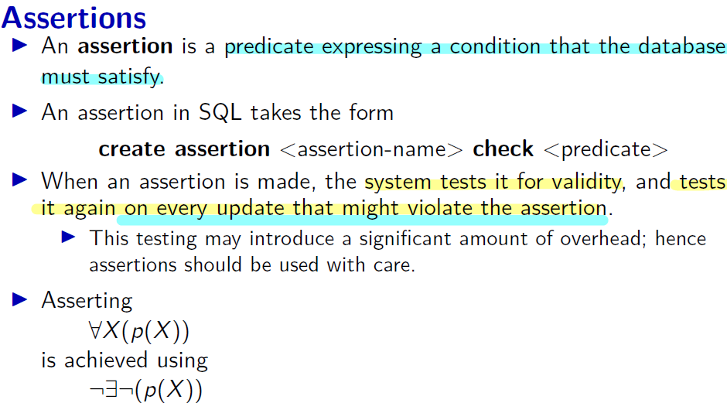

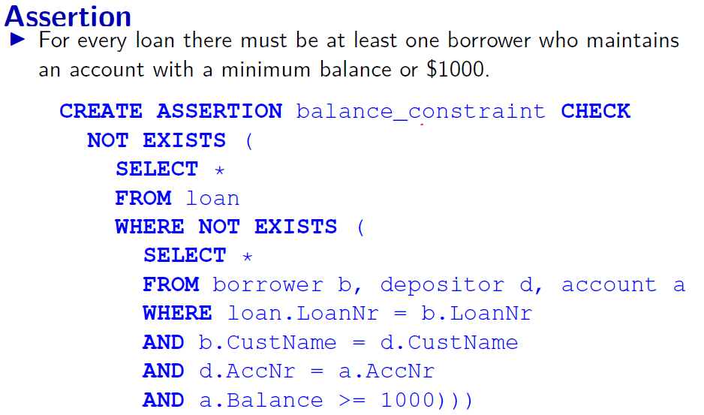

1. **Authorization constraints**

We may want to differentiate among the users as far as the type of access they are permitted to various data values in the database. This differentiation is expressed in terms of Authorization.

**The most common being:**

Read authorization – which allows reading but not the modification of data;

Insert authorization – which allows the insertion of new data but not the modification of existing data

Update authorization – which allows modification, but not deletion.

1. **Preceding integrity constraints**

**Preceding integrity constraints** are included in the data definition language because they occur in most

database applications. However, they do not include a large class of general constraints, sometimes called semantic integrity constraints, which may have to be specified and enforced on a relational database.

The types of constraints we discussed so far may be called **state constraints** because they define the constraints that a valid state of the database must satisfy. Another type of constraint, called **transition constraints**, can be defined to deal with state changes in the database. An example of a transition constraint is: “the salary of an employee can only increase.”

**What is the use of data constraints?**

Constraints are used to:

Avoid bad data being entered into tables.

At the database level, it helps to enforce business logic.

Improves database performance.

Enforces uniqueness and avoid redundant data to the database.

END

**CHAPTER 5 DATABASE DESIGN STEPS AND IMPLEMENTATIONS**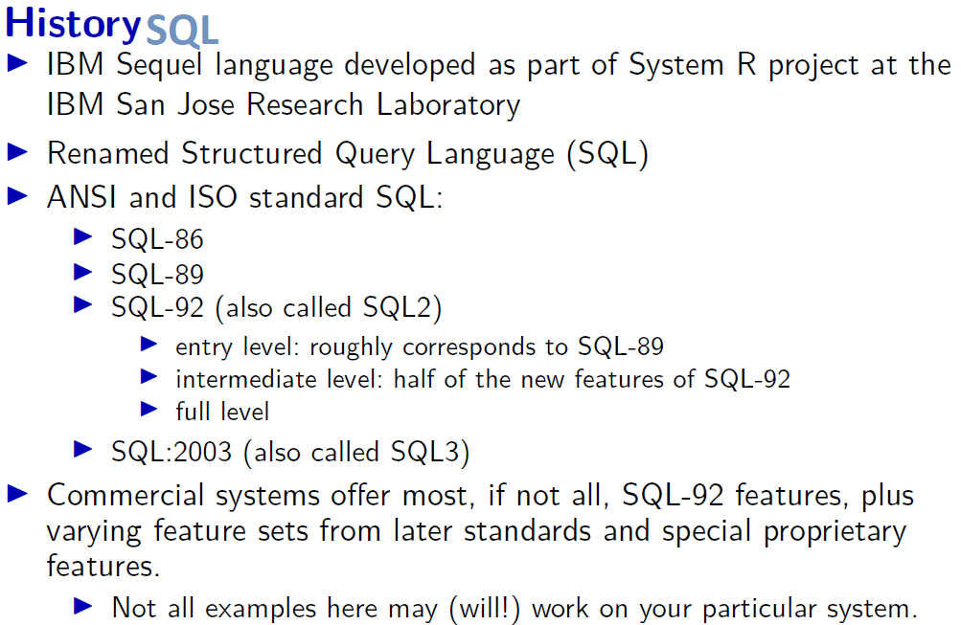

**SQL version:**

* 1970 – Dr. Edgar F. “Ted” Codd described a relational model for databases.
* 1974 – Structured Query Language appeared.
* 1978 – IBM released a product called System/R.
* 1986 – SQL1 IBM developed the prototype of a relational database, which is standardized by ANSI.
* 1989- First minor changes but not standards changed
* 1992 – SQL2 launched with features like triggers, object orientation, etc.
* SQL1999 to 2003- SQL3 launched
* SQL2006- Support for XML Query Language
* SQL2011-improved support for temporal databases
* SQL-86 in 1986, the most recent version in 2011 (SQL:2016).

**SQL-86**

The first SQL standard was SQL-86. It was published in 1986 as ANSI standard and in 1987 as International Organization for Standardization (ISO) standard. The starting point for the ISO standard was IBM’s SQL standard implementation. This version of the SQL standard is also known as SQL 1.

**SQL-89**

The next SQL standard was SQL-89, published in 1989. This was a minor revision of the earlier standard, a superset of SQL-86 that replaced SQL-86. The size of the standard did not change.

**SQL-92**

The next revision of the standard was SQL-92 – and it was a major revision. The language introduced by SQL-92 is sometimes referred to as SQL 2. The standard document grew from 120 to 579 pages. However, much of the growth was due to more precise specifications of existing features.

The most important new features were:

An explicit JOIN syntax and the introduction of outer joins: LEFT JOIN, RIGHT JOIN, FULL JOIN.

The introduction of NATURAL JOIN and CROSS JOIN

**SQL:1999**

SQL:1999 (also called SQL 3) was the fourth revision of the SQL standard. Starting with this version, the standard name used a colon instead of a hyphen to be consistent with the names of other ISO standards. This standard was published in multiple installments between 1999 and 2002.

In 1993, the ANSI and ISO development committees decided to split future SQL development into a multi-part standard.

The first installment of 1995 and SQL:1999 had many parts:

**Part 1:** SQL/Framework (100 pages) defined the fundamental concepts of SQL.

**Part 2:** SQL/Foundation (1050 pages) defined the fundamental syntax and operations of SQL: types, schemas, tables, views, query and update statements, expressions, and so forth. This part is the most important for regular SQL users.

**Part 3:** SQL/CLI (Call Level Interface) (514 pages) defined an application programming interface for SQL.

**Part 4:** SQL/PSM (Persistent Stored Modules) (193 pages) defined extensions that make SQL procedural.

**Part 5**: SQL/Bindings (270 pages) defined methods for embedding SQL statements in application programs written in a standard programming language. SQL/Bindings. The Dynamic SQL and Embedded SQL bindings are taken from SQL-92. No active new work at this time, although C++ and Java interfaces are under discussion.

**Part 6:** SQL/XA. An SQL specialization of the popular XA Interface developed by X/Open (see below).

**Part 7**: SQL/Temporal. A newly approved SQL subproject to develop enhanced facilities for temporal data management using SQL.

**Part 8:** SQL Multimedia (SQL/Mm)

A new ISO/IEC international standardization project for the development of an SQL class library for multimedia applications was approved in early 1993. This new standardization activity, named SQL Multimedia (SQL/MM), will specify packages of SQL abstract data type (ADT) definitions using the facilities for ADT specification and invocation provided in the emerging SQL3 specification.

SQL:2006 further specified how to use SQL with XML. It was not a revision of the complete SQL standard, just **Part 14**, which deals with SQL-XML interoperability.

The current SQL standard is **SQL:2019**. It added **Part 15**, which defines multidimensional array support in SQL.



**SQL:2003 and beyond**

In the 21st century, the SQL standard has been regularly updated.

The SQL:2003 standard was published on March 1, 2004. Its major addition was window functions, a powerful analytical feature that allows you to compute summary statistics without collapsing rows. Window functions significantly increased the expressive power of SQL. They are extremely useful in preparing all kinds of business reports, analyzing time series data, and analyzing trends. The addition of window functions to the standard coincided with the popularity of OLAP and data warehouses. People started using databases to make data-driven business decisions. This trend is only gaining momentum, thanks to the growing amount of data that all businesses collect. You can learn window functions with our Window Functions course. (Read about the course or why it’s worth learning SQL window functions here.) SQL:2003 also introduced XML-related functions, sequence generators, and identity columns.

**Conformance with Standard SQL**

This section declares Oracle's conformance to the SQL standards established by these organizations:

1. American National Standards Institute (ANSI)
2. International Standards Organization (ISO)
3. United States Federal Government Federal Information Processing Standards (FIPS)

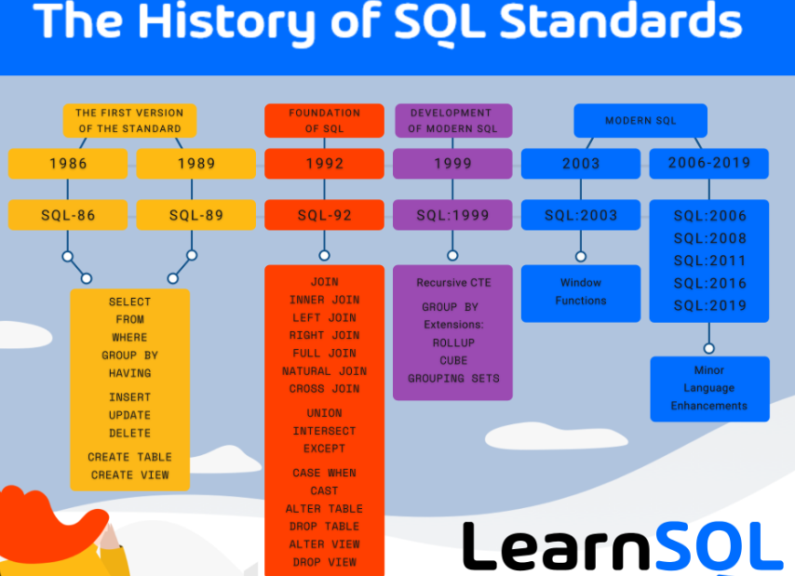

**Standard of SQL ANSI and ISO and FIPS**

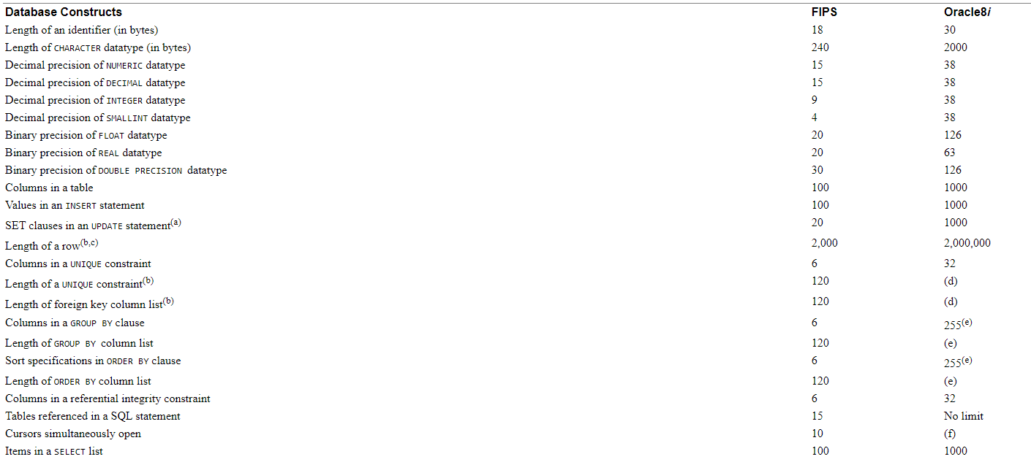

**Dynamic SQL or Extended SQL (Extended SQL called SQL3 OR SQL-99)**

ODBC, however, is a call level interface (CLI) that uses a different approach. Using a CLI, SQL statements are passed to the database management system (DBMS) within a parameter of a runtime API. Because the text of the SQL statement is never known until runtime, the optimization step must be performed each time an SQL statement is run. This approach commonly is referred to as dynamic SQL. The simplest way to execute a dynamic SQL statement is with an EXECUTE IMMEDIATE statement. This statement passes the SQL statement to the DBMS for compilation and execution.

**Static SQL or Embedded SQL**

Static or Embedded SQL are SQL statements in an application that do not change at runtime and, therefore, can be hard-coded into the application. This is a central idea of embedded SQL: placing SQL statements in a program written in a host programming language. The embedded SQL shown in Embedded SQL Example is known as static SQL.

Traditional SQL interfaces used an embedded SQL approach. SQL statements were placed directly in an application's source code, along with high-level language statements written in C, COBOL, RPG, and other programming languages. The source code then was precompiled, which translated the SQL statements into code that the subsequent compile step could process. This method is referred to as static SQL. One performance advantage to this approach is that SQL statements were optimized at the time the high-level program was compiled, rather than at runtime while the user was waiting. Static SQL statements in the same program are treated normally.

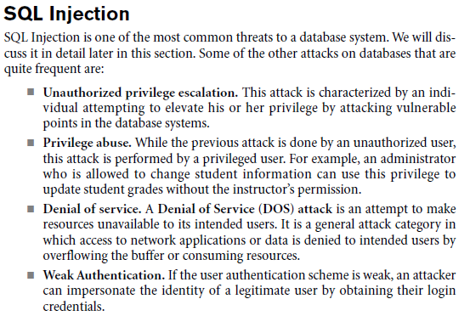

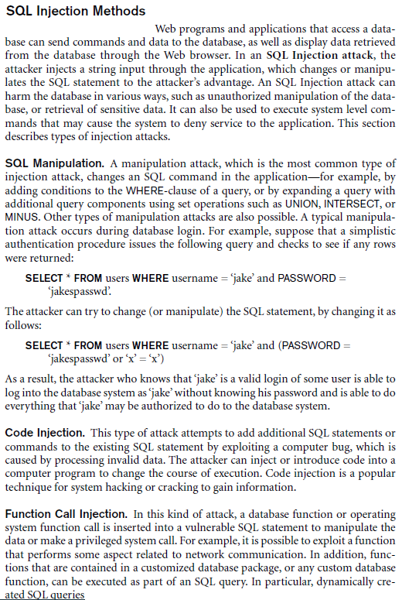

**Common Table Expressions (CTE)**

Common table expressions (CTEs) enable you to name subqueries temporarily for a result set. You then refer to these like normal tables elsewhere in your query. This can make your SQL easier to write and understand later. CTEs go in with the clause above the select statement.

**Recursive common table expression (CTE)**

RCTE is a CTE that references itself. By doing so, the CTE repeatedly executes, and returns subsets of data, until it returns the complete result set.

A recursive CTE is useful in querying hierarchical data such as organization charts where one employee reports to a manager or a multi-level bill of materials when a product consists of many components, and each component itself also consists of many other components.

**Query-By-Example (QBE)**

Query-By-Example (QBE) is the first interactive database query language to exploit such modes of HCI. In QBE, a query is constructed on an interactive terminal involving two-dimensional ‘drawings’ of one or more relations, visualized in tabular form, which are filled in selected columns with ‘examples’ of data items to be retrieved (thus the phrase query-by-example).

It is different from SQL, and from most other database query languages, in having a graphical user interface that allows users to write queries by creating example tables on the screen.

QBE, like SQL, was developed at IBM and QBE is an IBM trademark, but a number of other companies sell QBE-like interfaces, including Paradox.

A convenient shorthand notation is that if we want to print all fields in some relation, we can place P. under the name of the relation. This notation is like the SELECT * convention in SQL. It is equivalent to placing a P. in every field:

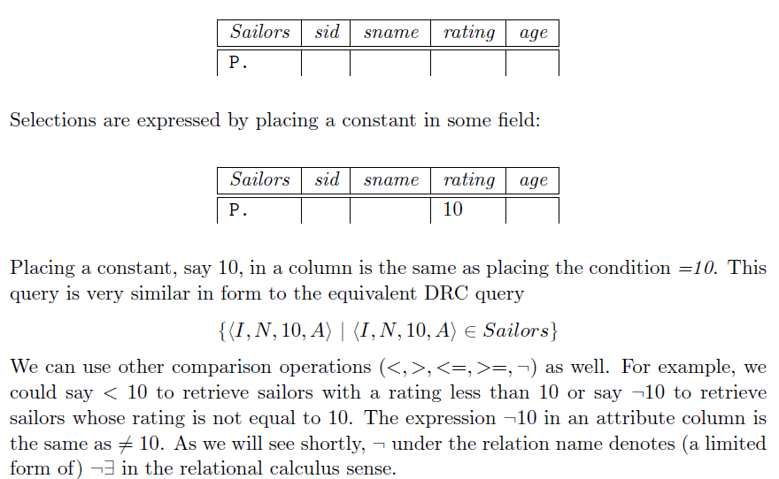

**Example of QBE:**

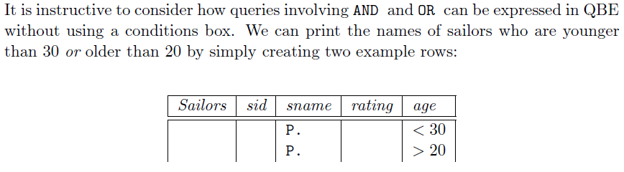

**AND, OR Conditions in QBE**

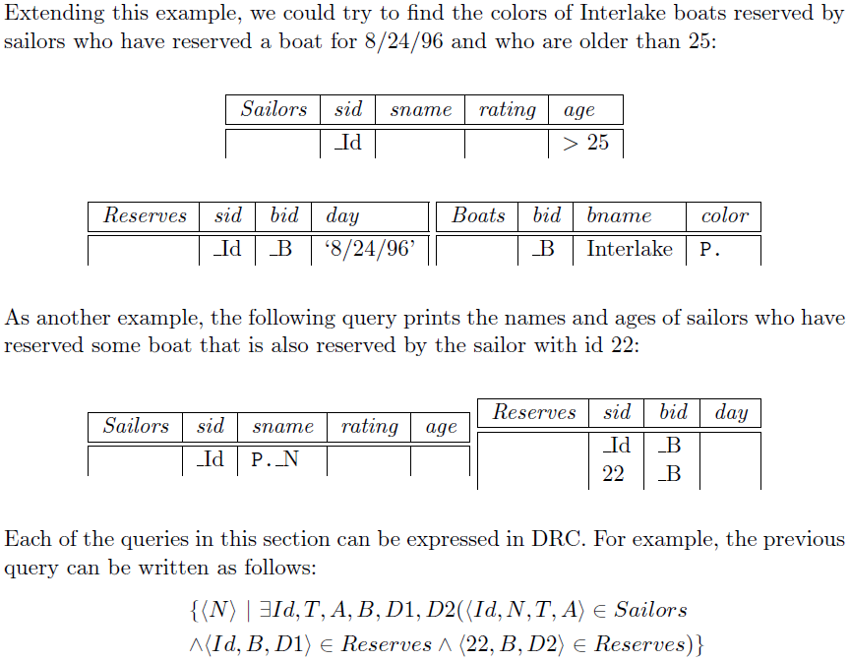

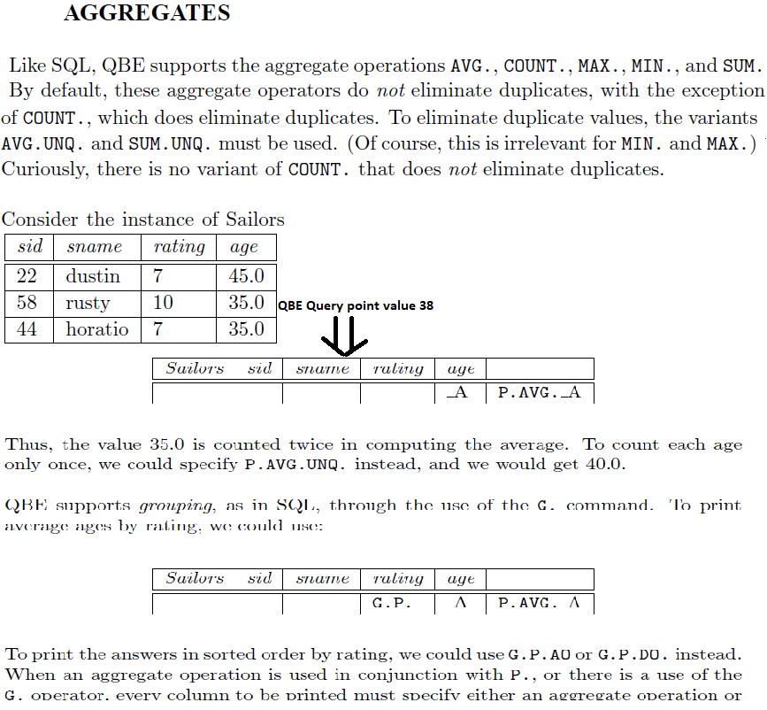

**Key characteristics of SQL**

* Set-oriented and declarative
* Free-form language
* Case insensitive
* Can be used both interactively from a command prompt or executed by a program

**Rules to write commands:**

* Table names cannot exceed 20 characters.
* The name of the table must be unique.
* Field names also must be unique.
* The field list and filed length must be enclosed in parentheses.
* The user must specify the field length and type.
* The field definitions must be separated with commas.
* SQL statements must end with a semicolon.

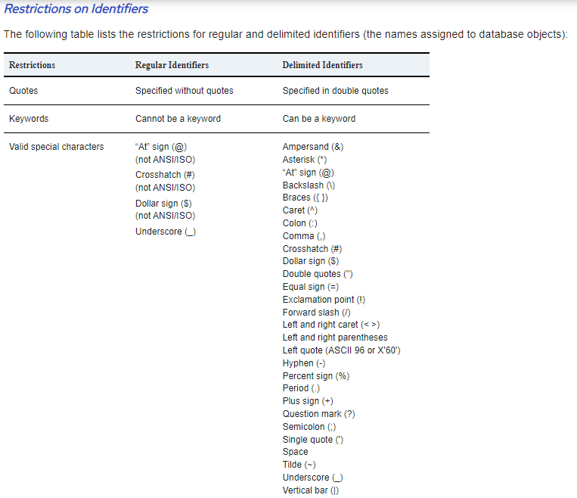

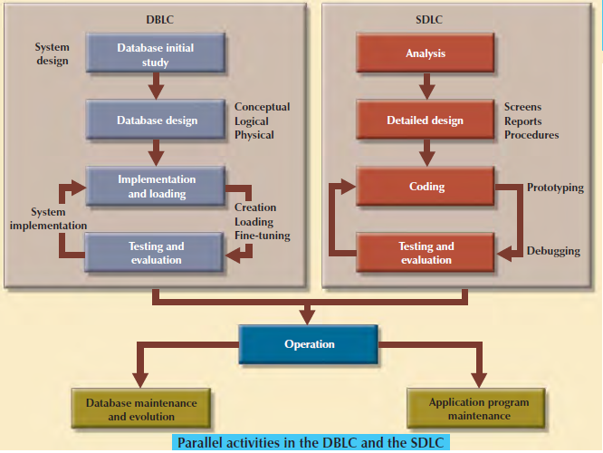

**Database Design Phases/Stages**

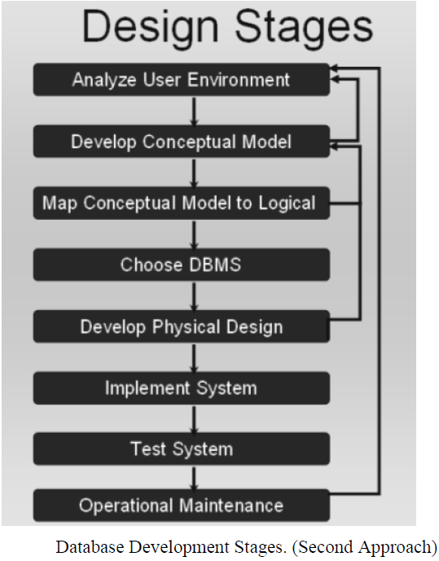

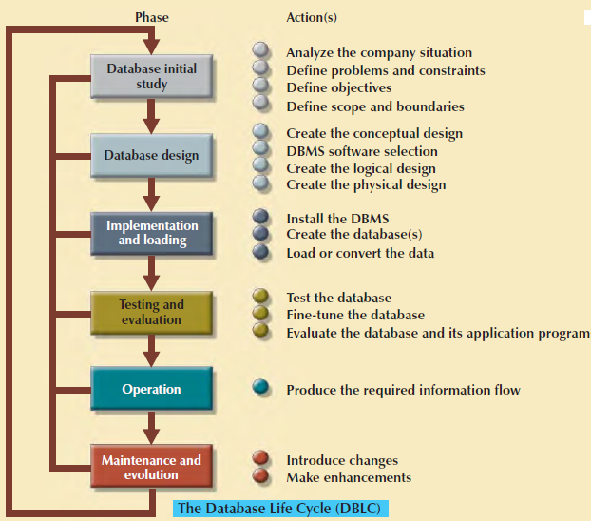

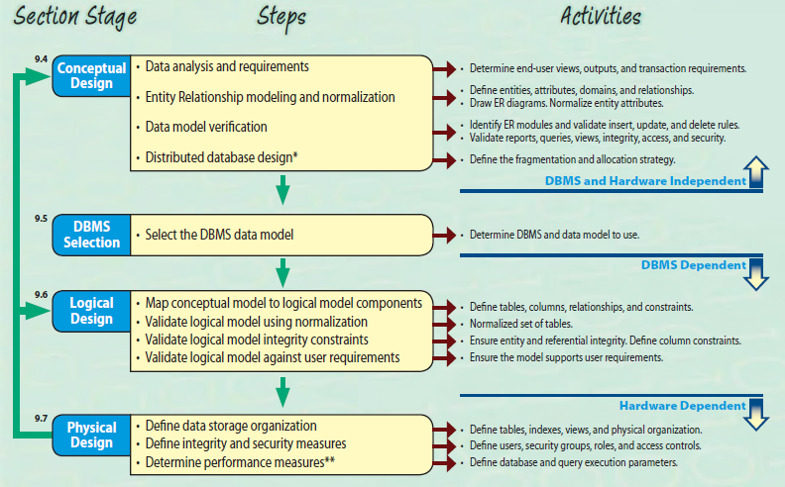

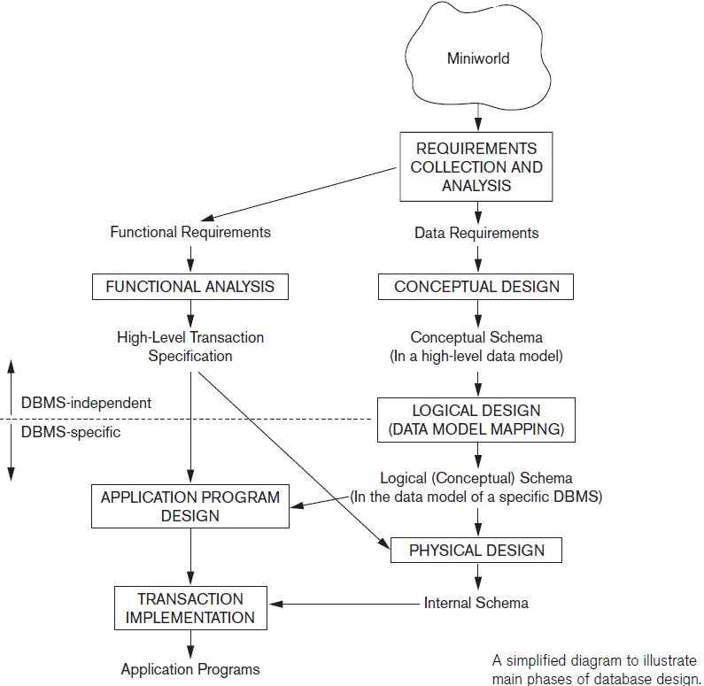

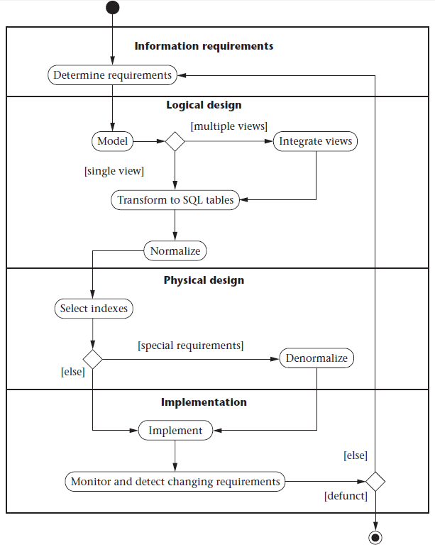

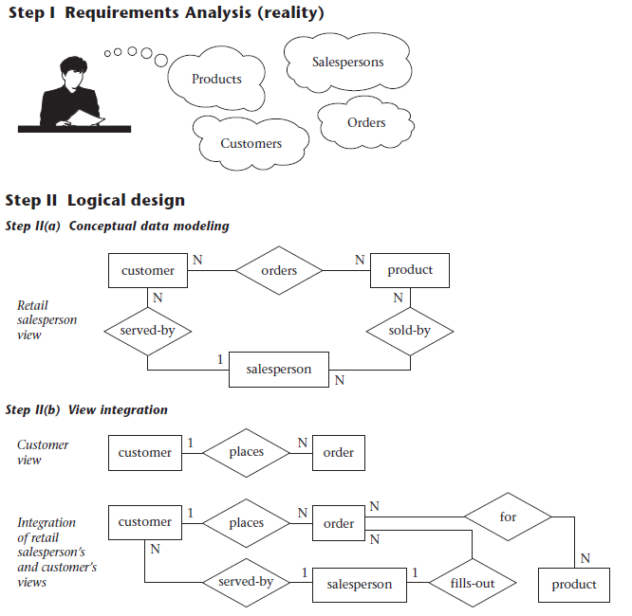

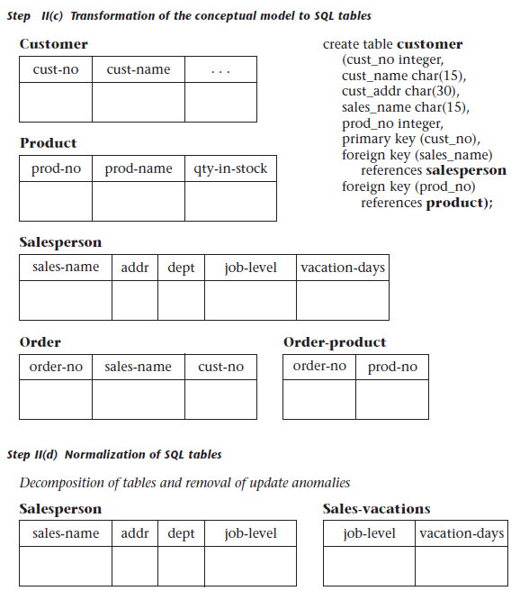

**III. Physical design.** The physical design step involves the selection of indexes (access methods), partitioning, and clustering of data. The logical design methodology in step II simplifies the approach to designing large relational databases by reducing the number of data dependencies that need to be analyzed. This is accomplished by inserting conceptual data modeling and integration steps (II(a) and II(b) of pictures into the traditional relational design

approach.

**IV. Database implementation, monitoring, and modification.**

Once thedesign is completed, and the database can be created through the implementation of the formal schema using the data definition language (DDL) of a DBMS.

**General Properties of Database Objects**

**Entity** Distinct object, Class, Table, Relation

**Entity Set** A collection of similar entities. E.g., all employees. All entities in an entity set have the same set of attributes.

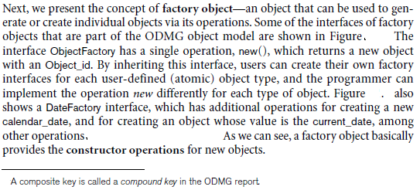

**Attribute** Describes some aspect of the entity/object, characteristics of object. An attribute is a data item that describes a property of an entity or a relationship

**Column or field** The column represents the set of values for a specific attribute. An attribute is for a model and a column is for a table, a column is a column in a database table whereas attribute(s) are externally visible facets of an object.

**A relation instance** is a finite set of tuples in the RDBMS system. Relation instances never have duplicate tuples.

**Relationship** Association between entities, connected entities are called participants, Connectivity describes the relationship (1-1, 1-M, M-N)

The degree of a relationship refers to the=> number of entities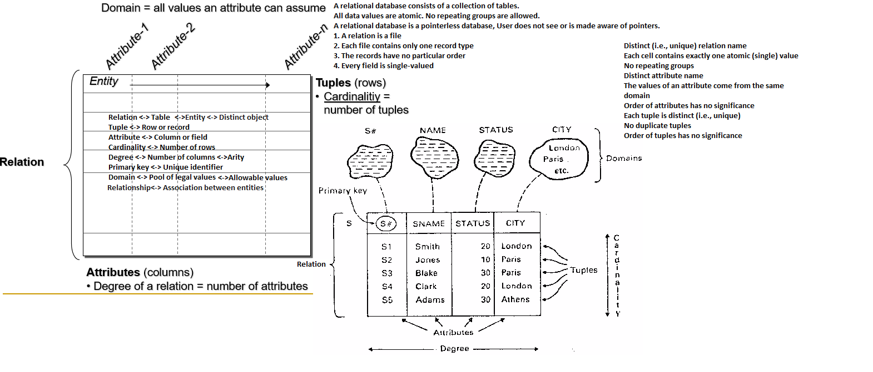

Following the relation in above image consist degree=4, 5=cardinality, data values/cells = 20.

**Characteristics of relation**

1. Distinct Relation/table name
2. Relations are unordered
3. Cells contain exactly one atomic (Single) value means Each cell (field) must contain a single value
4. No repeating groups
5. Distinct attributes name
6. Value of attribute comes from the same domain
7. Order of attribute has no significant
8. The attributes in R(A1, ...,An) and the values in t = <V1,V2, ..... , Vn> are ordered.
9. Each tuple is a distinct
10. order of tuples that has no significance.
11. tuples may be stored and retrieved in an arbitrary order
12. Tables manage attributes. This means they store information in form of attributes only
13. Tables contain rows. Each row is one record only
14. All rows in a table have the same columns. Columns are also called fields
15. Each field has a data type and a name
16. A relation must contain at least one attribute (column) that identifies each tuple (row) uniquely

**Database Table type**

**Temporary table**

Here are RDBMS, which supports temporary tables. Temporary Tables are a great feature that lets you store and process intermediate results by using the same selection, update, and join capabilities of tables.

Temporary tables store session-specific data. Only the session that adds the rows can see them. This can be handy to store working data.

In ANSI there are two types of temp tables. There are two types of temporary tables in the Oracle Database: global and private.

**Global Temporary Tables**

To create a global temporary table add the clause "global temporary" between create and table. For Example:

create global temporary table toys_gtt (

toy_name varchar2(100));

The global temp table is accessible to everyone. Global, you create this and it is registered in the data dictionary, it lives "forever". the global pertains to the schema definition

**Private/Local Temporary Tables**

Starting in Oracle Database 18c, you can create private temporary tables. These tables are only visible in your session. Other sessions can't see the table!

The temporary tables could be very useful in some cases to keep temporary data. Local, it is created "on the fly" and disappears after its use. you never see it in the data dictionary.

**Details of temp tables:**

A temporary table is owned by the person who created it and can only be accessed by that user.

A global temporary table is accessible to everyone and will contain data specific to the session using it;

multiple sessions can use the same global temporary table simultaneously. It is a global definition for a temporary table that all can benefit from.

Local temporary table – These tables are invisible when there is a connection and are deleted when it is closed.

**Clone Table** Temporary tables are available in MySQL version 3.23 onwards

There may be a situation when you need an exact copy of a table and the CREATE TABLE . or the SELECT. commands do not suit your purposes because the copy must include the same indexes, default values, and so forth.

There are **Magic Tables** (virtual tables) in SQL Server that hold the temporal information of recently inserted and recently deleted data in the virtual table.

The **INSERTED magic table** stores the before version of the row, and the DELETED table stores the after version of the row for any INSERT, UPDATE, or DELETE operations.

A record is a collection of data objects that are kept in fields, each having its name and datatype. A **Record** can be thought of as a variable that can store a table row or a set of columns from a table row. Table columns relate to the fields.

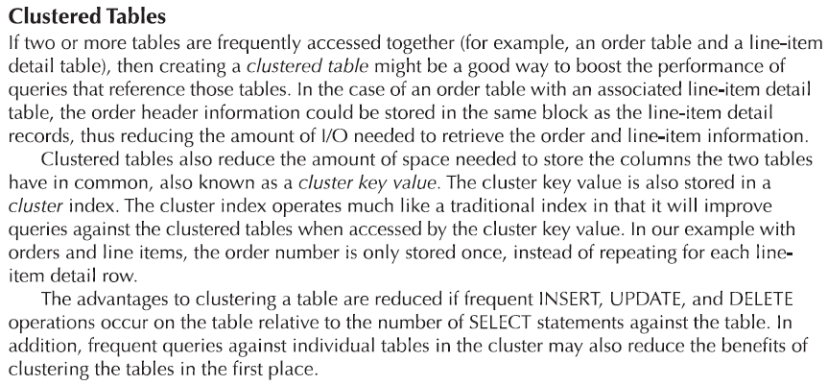

**External Tables**

An **external table** is a read-only table whose metadata is stored in the database but whose data is stored outside the database.

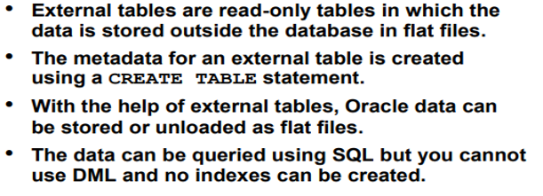

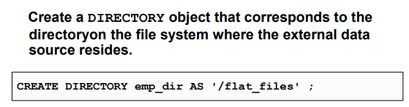

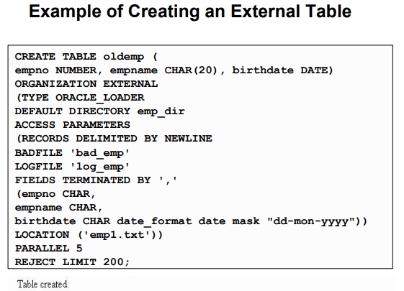

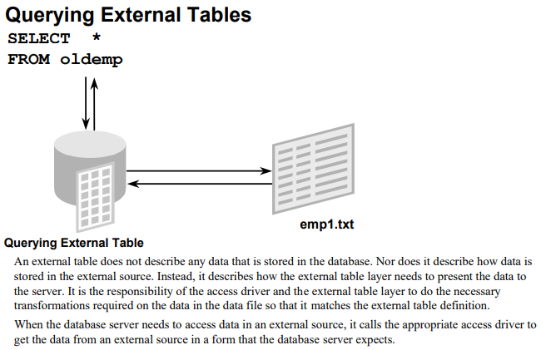

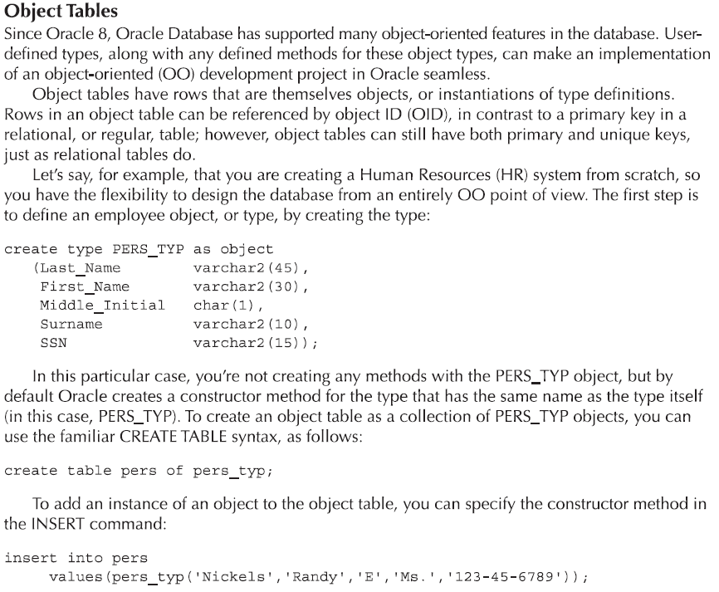

**Partitioning Tables and Table Splitting**

Partitioning logically splits up a table into smaller tables according to the partition column(s). So rows with the same partition key are stored in the same physical location.

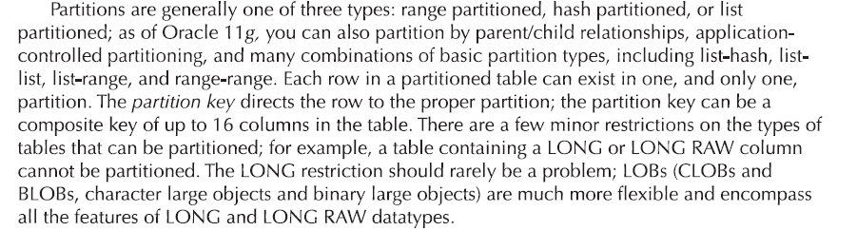

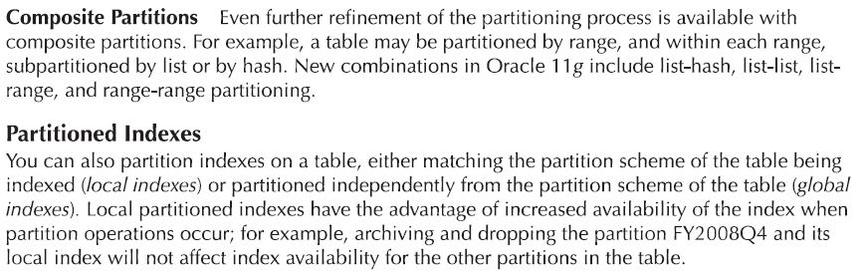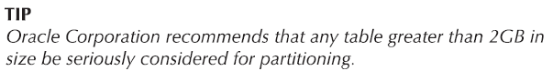

**Data Partitioning horizontal (Table rows)**

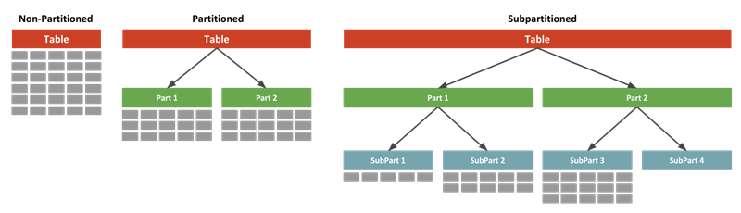

Horizontal partitioning divides a table into multiple tables that contain the same number of columns, but fewer rows.

**Table partitioning vertically (Table columns)**

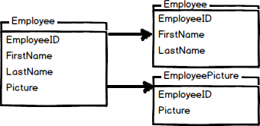

Vertical partitioning splits a table into two or more tables containing different columns.

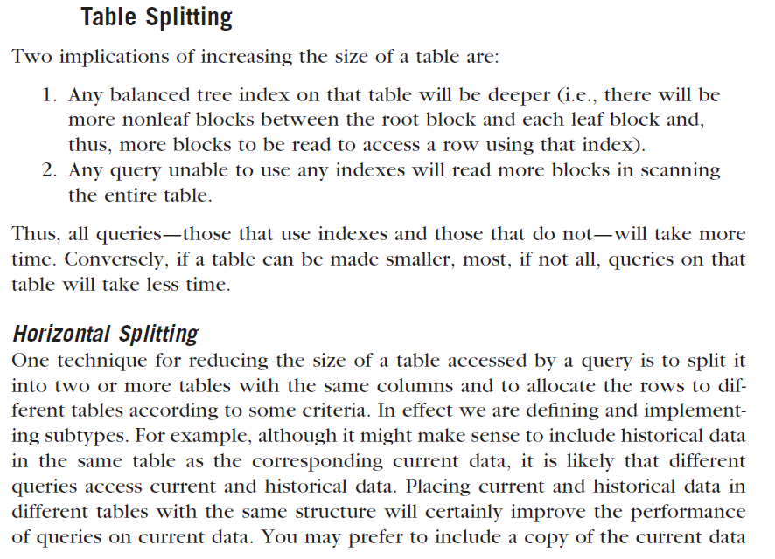

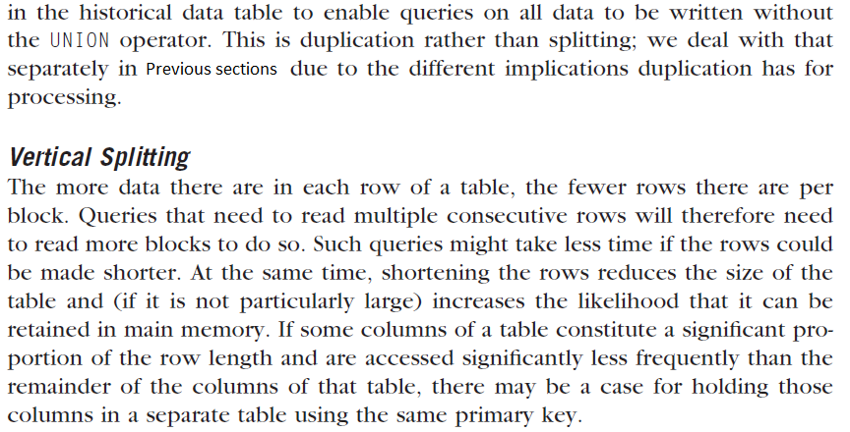

|  |  |
| --- | --- |
| **Collections** | **Records** |
| All items are of the same data type | All items are different data types |
| Same data type items are called elements | Different data type items are called fields |
| Syntax: *variable_name*(*index*) | Syntax: *variable_name.field_name* |
| For creating a collection variable you can use %TYPE | For creating a record variable you can use %ROWTYPE or %TYPE |
| Lists and arrays are examples | Tables and columns are examples |

**Correlated vs. Uncorrelated SQL Expressions**

A subquery is correlated when it joins to a table from the parent query. If you don't, then it's uncorrelated.

This leads to a difference between IN and EXISTS. EXISTS returns rows from the parent query, as long as the subquery finds at least one row.

So the following uncorrelated EXISTS returns all the rows in colors:

select from colors

where exists (

select null from bricks);

**Table Organizations**

Create a table in Oracle Database that has an organization clause. This defines how it physically stores rows in the table.

The options for this are:

1. Heap table organization (Some DBMS provide for tables to be created without indexes, and access data randomly)
2. Index table organization or Index Sequential table.
3. Hash table organization (Some DBMS provide an alternative to an index to access data by trees or hashing key or hashing function).

By default, tables are heap-organized. This means the database is free to store rows wherever there is space. You can add the "organization heap" clause if you want to be explicit.

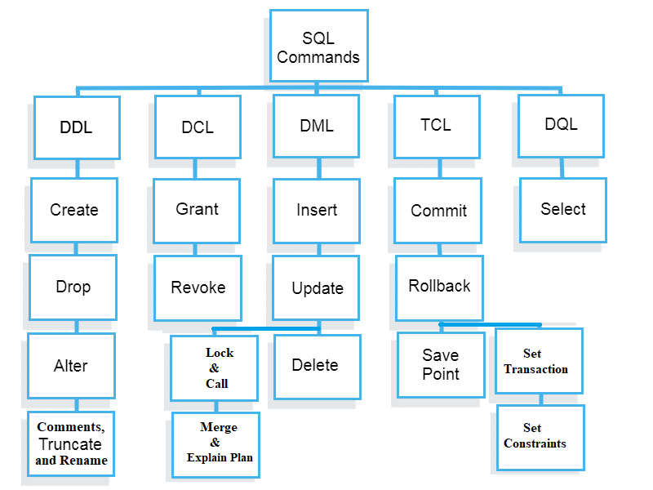

**Big picture of database languages and command types**

**Embedded DML are of two types**

**Low-level or Procedural DMLs:** require a user to specify what data are needed and how to get those data. PLSQL, Java, and Relational Algebra are the best examples. It can be used for query optimization.

**High-level or Declarative DMLs** (also referred to as non-procedural DMLs): require a user to specify what data are needed without specifying how to get those data. SQL or Google Search are the best examples. It is not suitable for query optimization. TRC and DRC are declarative languages.

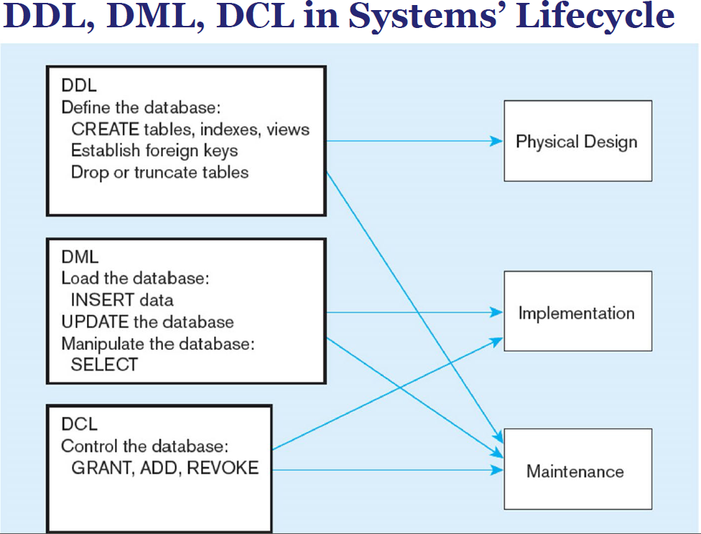

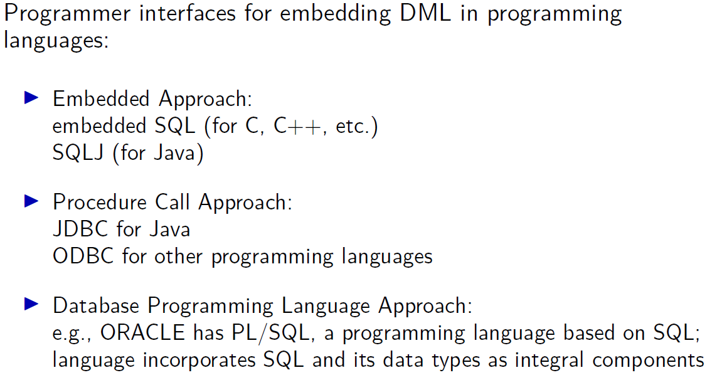



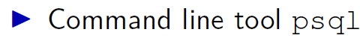

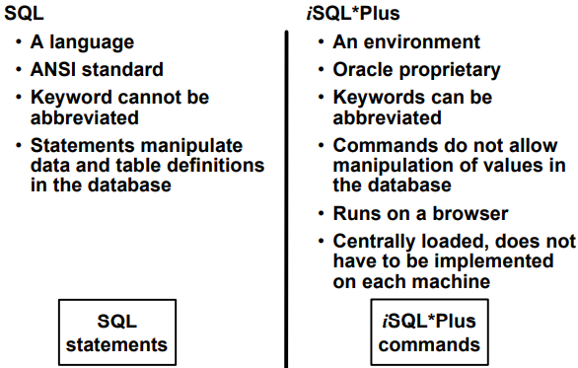

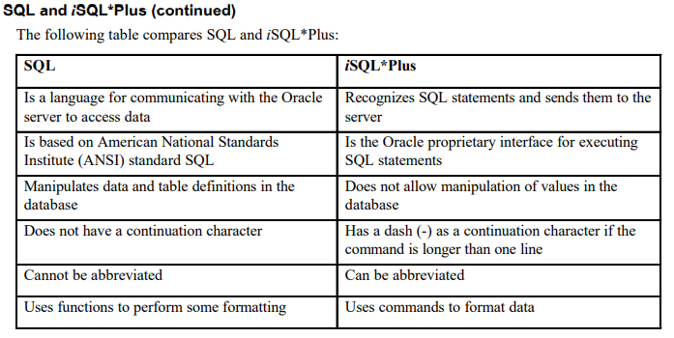

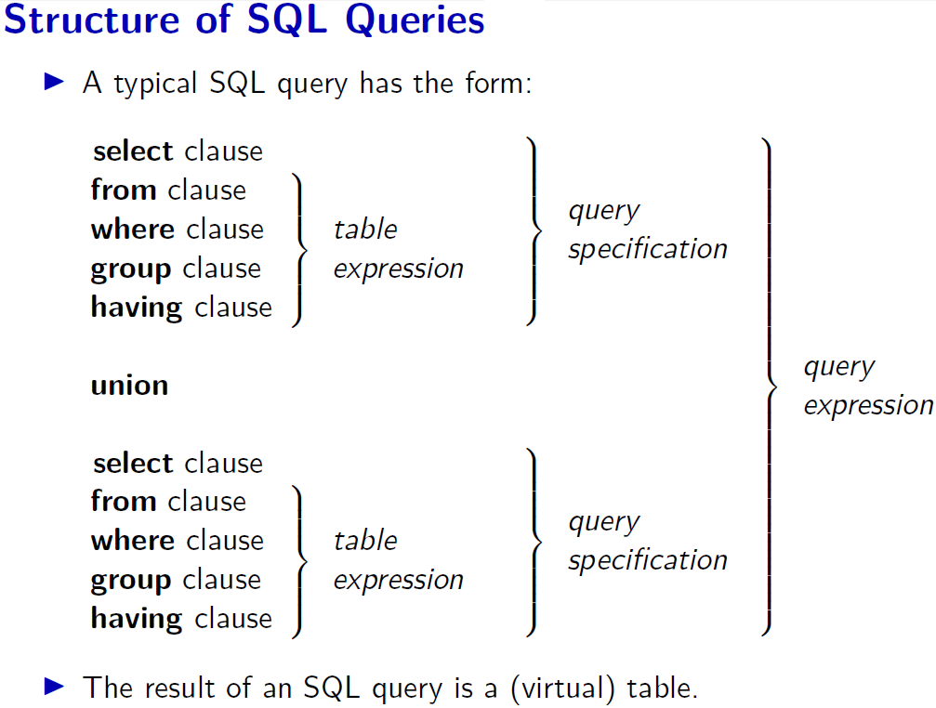

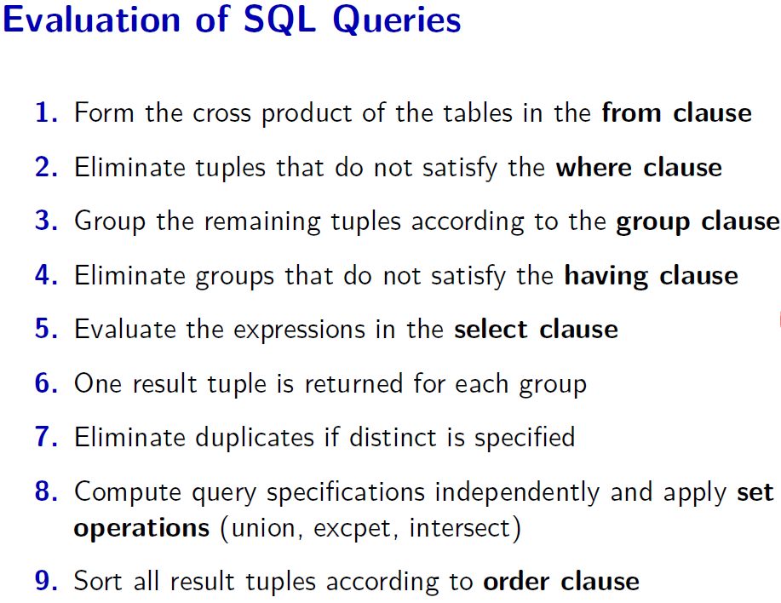

**Other SQL clauses used during Query evaluation**

* Windowing Clause When you use order by, the database adds a default windowing clause of range between unbounded preceding and current row.
* Sliding Windows As well as running totals so far, you can change the windowing clause to be a subset of the previous rows.

The following shows the total weight of:

1. The current row + the previous row
2. All rows with the same weight as the current + all rows with a weight one less than the current

**Strategies for Schema design in DBMS**

* Top-down strategy –
* Bottom-up strategy –
* Inside-Out Strategy –
* Mixed Strategy –

**Identifying correspondences and conflicts among the schema integration in DBMS**

* Naming conflict
* Type conflicts
* Domain conflicts
* Conflicts among constraints

**Process of SQL**

When we are executing the command of SQL on any Relational database management system, then the system automatically finds the best routine to carry out our request, and the SQL engine determines how to interpret that particular command.

Structured Query Language contains the following four components in its process:

1. Query Dispatcher
2. Optimization Engines
3. Classic Query Engine
4. SQL Query Engine, etc.

**SQL Programming**

**Approaches to Database Programming**

In this section, we briefly compare the three approaches for database programming

and discuss the advantages and disadvantages of each approach.

Several techniques exist for including database interactions in application programs.

The main approaches for database programming are the following:

1. **Embedding database commands** in a general-purpose programming language.

Embedded SQL Approach. The main advantage of this approach is that the query text is part of the program source code itself, and hence can be checked for syntax errors and validated against the database schema at compile time.

1. **Using a library of database functions.** A library of functions is made available to the

host programming language for database calls.

Library of Function Calls Approach. This approach provides more flexibility in that queries can be generated at runtime if needed.

1. **Designing a brand-new language.** A database programming language is designed from

scratch to be compatible with the database model and query language.

Database Programming Language Approach. This approach does not suffer from the impedance mismatch problem, as the programming language data types are the same as the database data types.

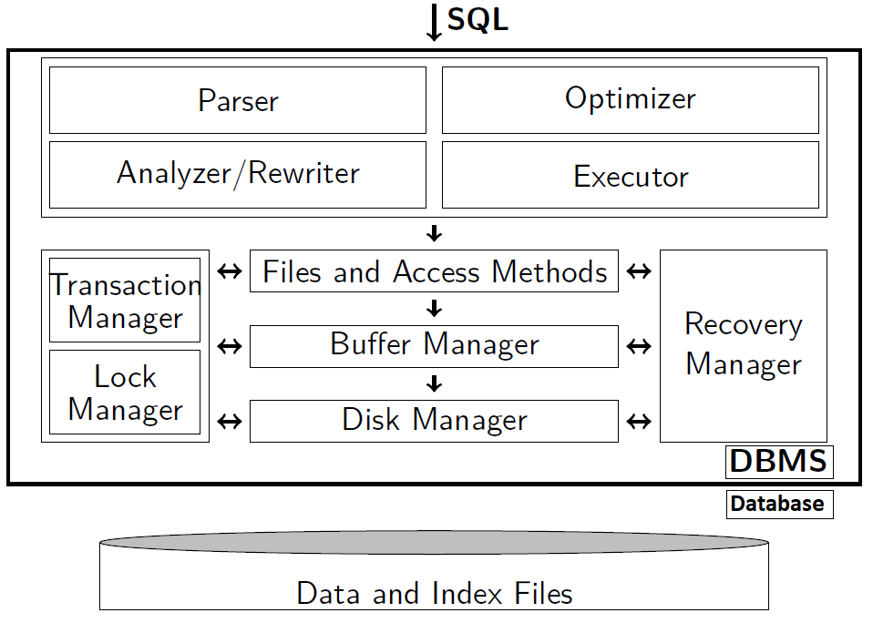

**Standard SQL order of execution** 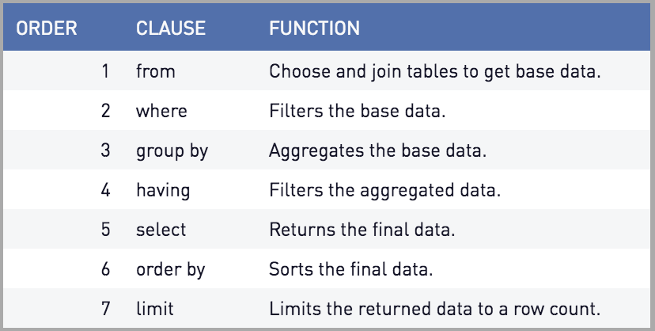

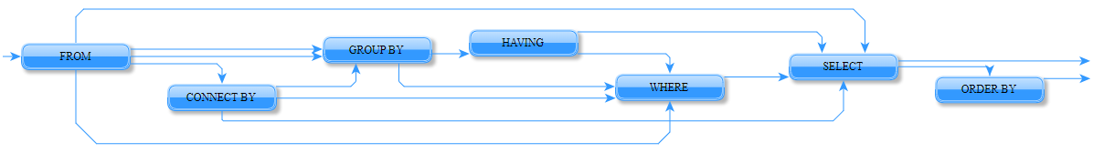

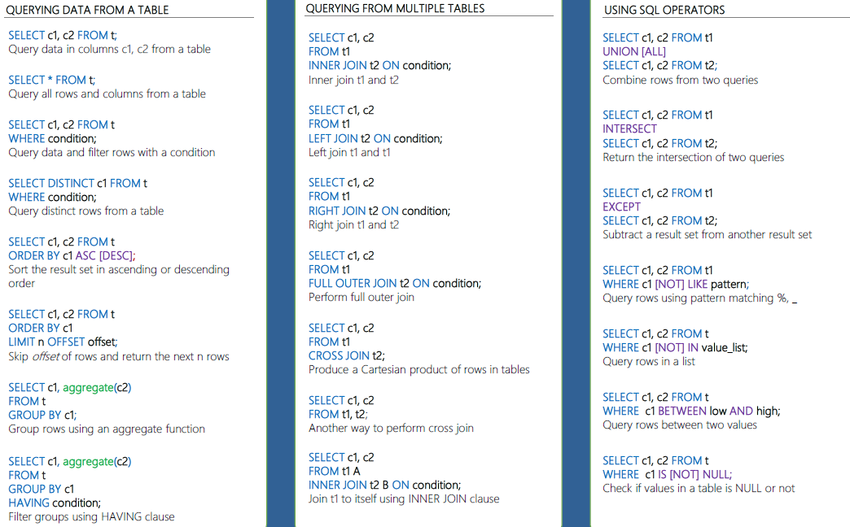

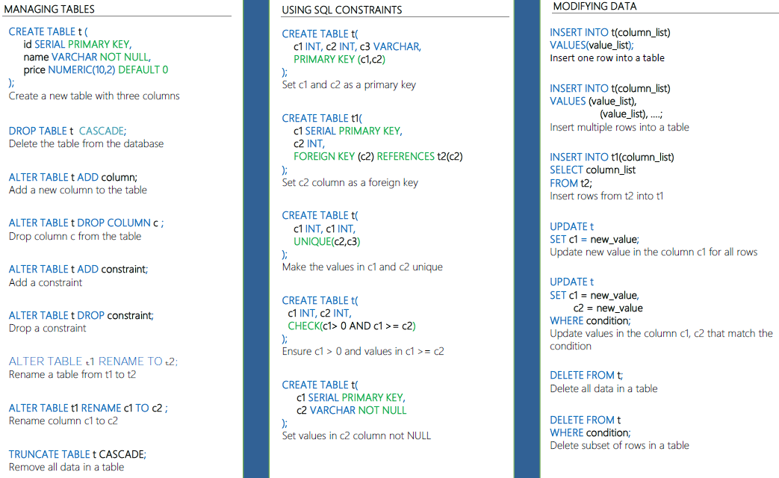

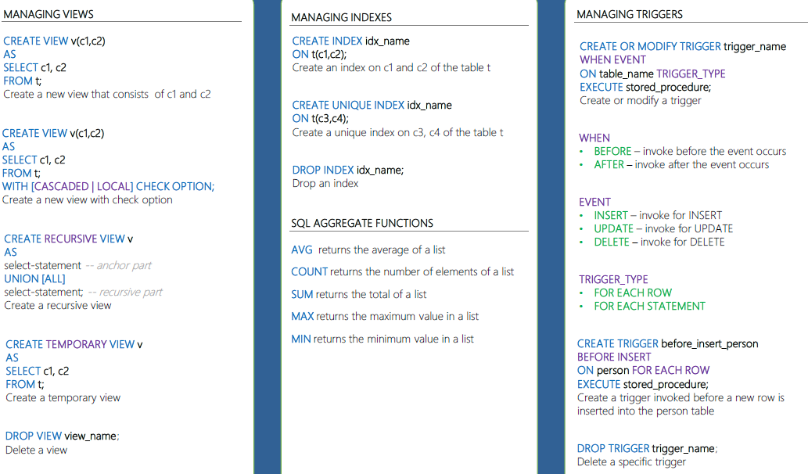

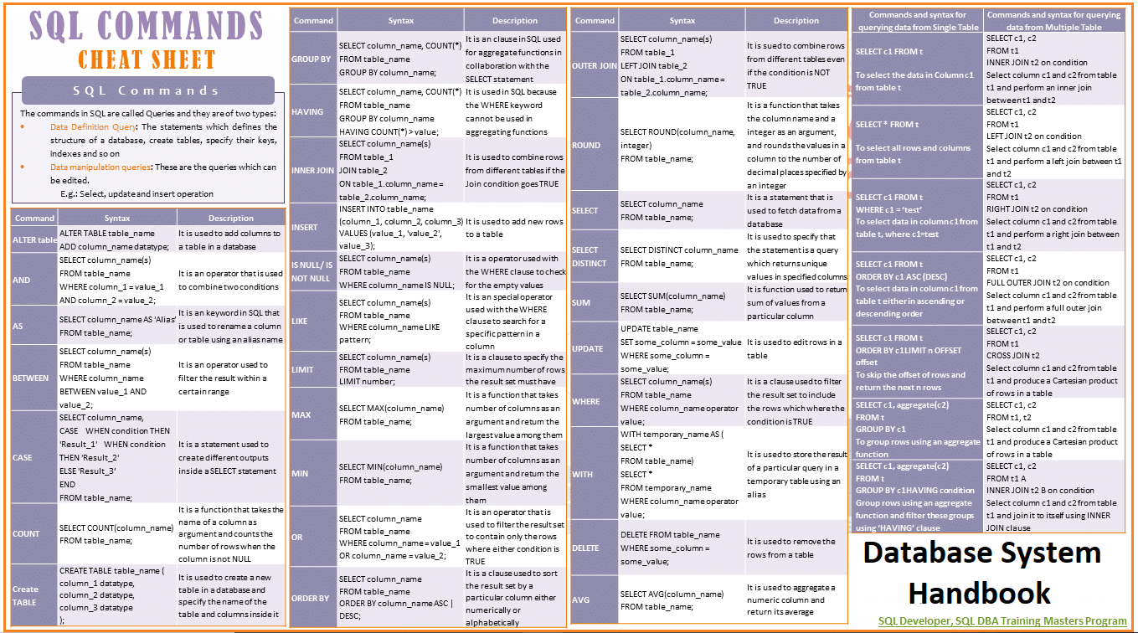

**TYPES OF SUB QUERY (SUBQUERY)**

**Subqueries Types**

1. From Subqueries
2. Attribute List Subqueries
3. Inline subquery
4. Correlated Subqueries
5. Where Subqueries
6. IN Subqueries
7. Having Subqueries
8. Multirow Subquery Operators: ANY and ALL

**Scalar Subqueries**

Scalar subqueries return one column and at most one row. You can replace a column with a scalar subquery in most cases.

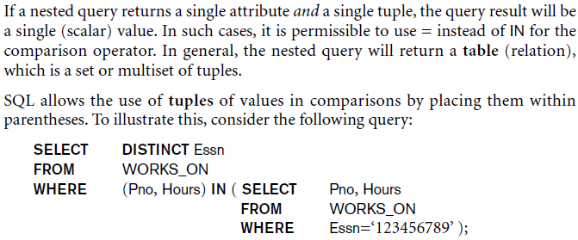

We can once again be faced with possible ambiguity among attribute names if attributes of the same name exist—one in a relation in the FROM clause of the outer query, and another in a relation in the FROM clause of the nested query. The rule is that a reference to an unqualified attribute refers to the relation declared in the innermost nested query.

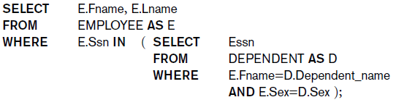

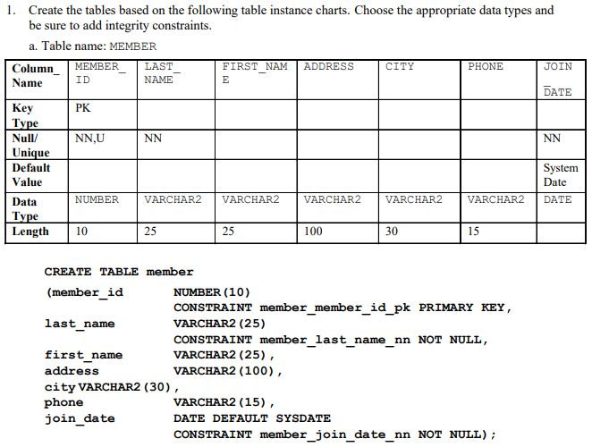

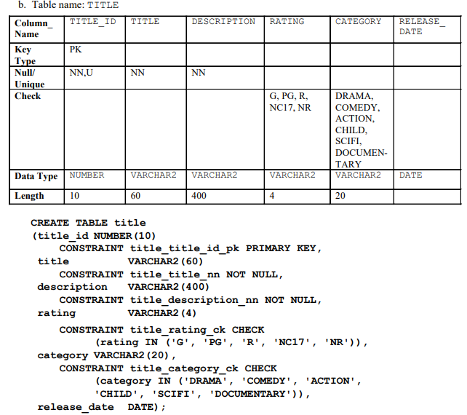

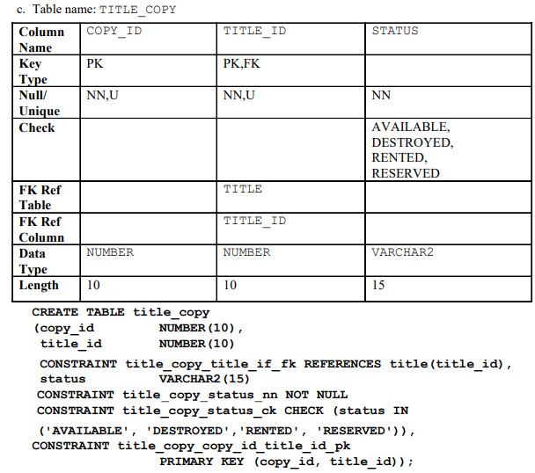

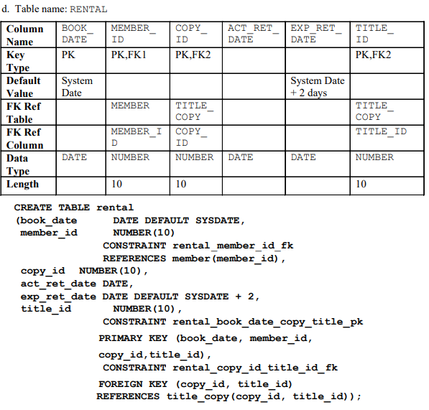

**Some important differences in DML statements:**

**Difference between DELETE and TRUNCATE statements**

There is a slight difference b/w delete and truncate statements. The DELETE statement only deletes the rows from the table based on the condition defined by the WHERE clause or deletes all the rows from the table when the condition is not specified.

But it does not free the space contained by the table.

The TRUNCATE statement: is used to delete all the rows from the table and free the containing space.

**Difference b/w DROP and TRUNCATE statements**

When you use the drop statement it deletes the table's row together with the table's definition so all the relationships of that table with other tables will no longer be valid.

**When you drop a table**

Table structure will be dropped

Relationships will be dropped

Integrity constraints will be dropped

Access privileges will also be dropped

On the other hand, when we TRUNCATE a table, the table structure remains the same, so you will not face any of the above problems.

**In general, ANSI SQL permits the use of ON DELETE and ON UPDATE clauses to cover CASCADE, SET NULL, or SET DEFAULT.**

* MS Access, SQL Server, and Oracle support ON DELETE CASCADE.
* MS Access and SQL Server support ON UPDATE CASCADE.
* Oracle does not support ON UPDATE CASCADE.
* Oracle supports SET NULL.
* MS Access and SQL Server do not support SET NULL.
* Refer to your product manuals for additional information on referential constraints.

While MS Access does not support ON DELETE CASCADE or ON UPDATE CASCADE at the SQL command-line level,

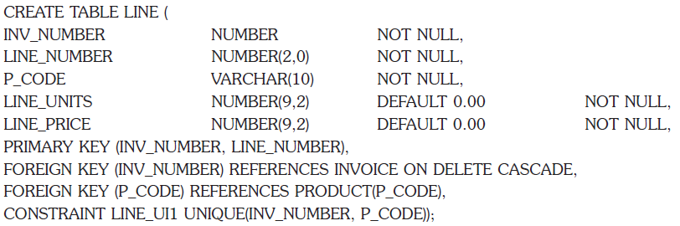

**Types of Multitable INSERT statements**

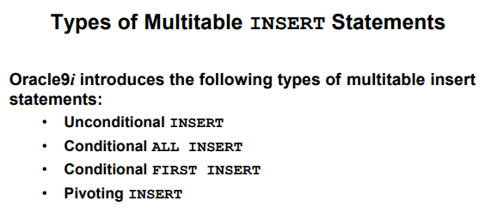

**DML before and after processing in triggers**

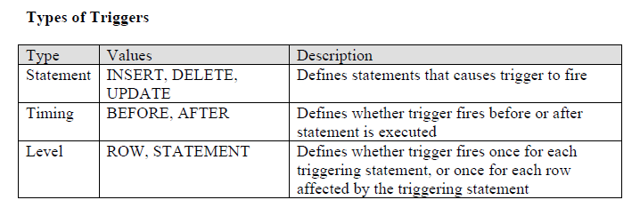**Database views and their types:**

The definition of views is one of the final stages in database design since it relies on the logical schema being finalized. Views are “virtual tables” that are a selection of rows and columns from one or more real tables and can include calculated values in additional virtual columns.

A view is a virtual relation or one that does not exist but is dynamically derived it can be constructed by performing operations (i.e., select, project, join, etc.) on values of existing base relation (a named relation that is designed in a conceptual schema whose tuples are physically stored in the database). Views are viewable in the external schema.

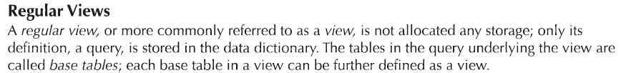

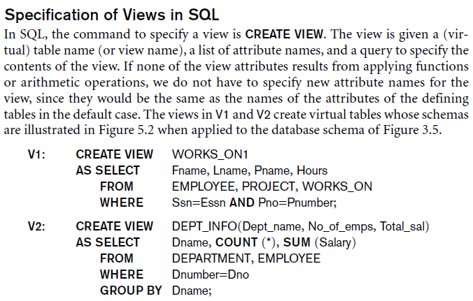

**Types of View**

1. User-defined view

* 1. Simple view (Single table view)
  2. Complex View (Multiple tables having joins, group by, and functions)
  3. Inline View (Based on a subquery in from clause to create a temp table and form a complex query)
  4. Materialized View (It stores physical data, definitions of tables)
  5. Dynamic view
  6. Static view

2. Database View

3. System Defined Views

4. Information Schema View

5. Catalog View

6. Dynamic Management View

7. Server-scoped Dynamic Management View

8. Sources of Data Dictionary Information View

* 1. General Views
  2. Transaction Service Views
  3. SQL Service Views

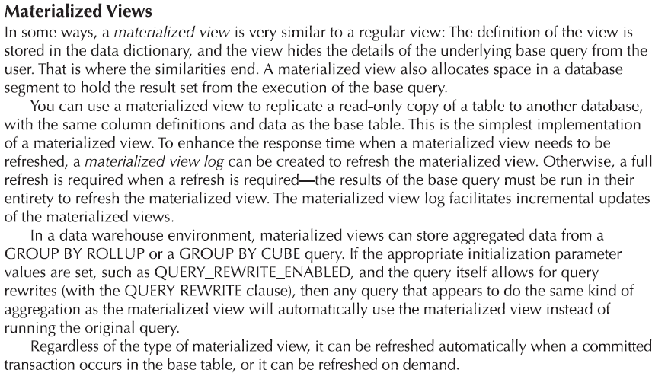

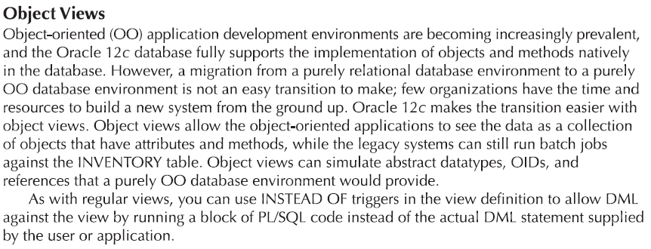

**Advantages of View:**

* Provide security
* Hide specific parts of the database from certain users
* Customize base relations based on their needs
* It supports the external model
* Provide logical independence
* Views don't store data in a physical location.
* Views can provide Access Restriction, since data insertion, update, and deletion is not possible with the view.
* We can DML on view if it is derived from a single base relation, and contains the primary key or a candidate key

**When can a view be updated?**

1. The view is defined based on one and only one table.
2. The view must include the PRIMARY KEY of the table based upon which the view has been created.
3. The view should not have any field made out of aggregate functions.
4. The view must not have any DISTINCT clause in its definition.
5. The view must not have any GROUP BY or HAVING clause in its definition.
6. The view must not have any SUBQUERIES in its definitions.
7. If the view you want to update is based upon another view, the latter should be updatable.
8. Any of the selected output fields (of the view) must not use constants, strings, or value expressions.

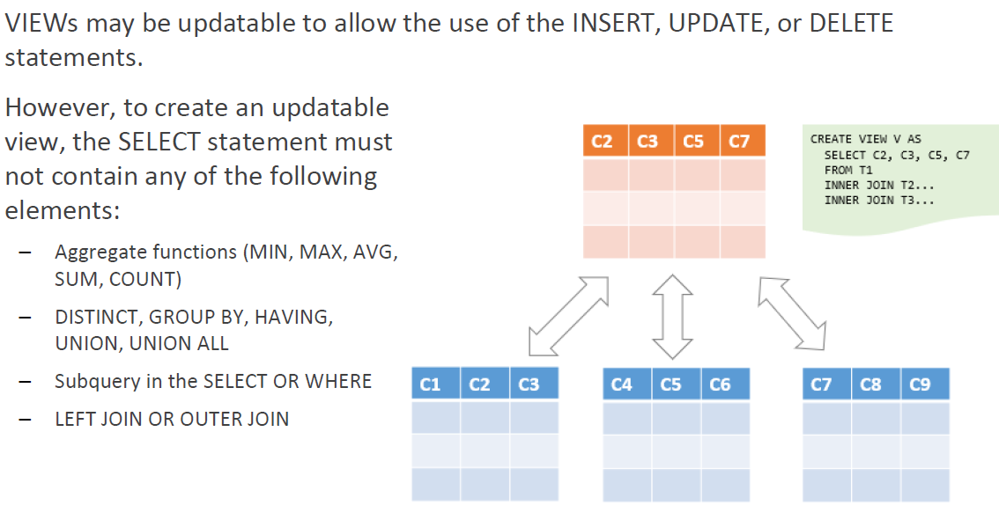

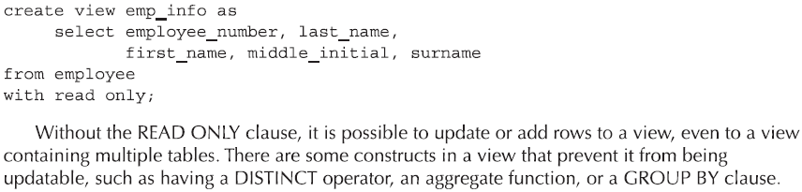

**END**

**CHAPTER 6 DATABASE NORMALIZATION AND DATABASE JOINS**

**Quick Overview of 12 Codd's Rule**

Every database has tables, and constraints cannot be referred to as a rational database system. And if any database has only a relational data model, it cannot be a [Relational Database System (RDBMS)](https://www.javatpoint.com/what-is-rdbms). So, some rules define a database to be the correct RDBMS. These rules were developed by Dr. Edgar F. Codd (E.F. Codd)  in 1985, who has vast research knowledge on the Relational Model of database Systems. Codd presents his 13 rules for a database to test the concept of [DBMS](https://www.javatpoint.com/dbms-tutorial) against his relational model, and if a database follows the rule, it is called a true relational database (RDBMS). These 12 rules are popular in RDBMS, known as Codd's 12 rules.

**Rule 0: The Foundation Rule**

The database must be in relational form. So that the system can handle the database through its relational capabilities.

**Rule 1: Information Rule**

A database contains various information, and this information must be stored in each cell of a table in the form of rows and columns.

**Rule 2: Guaranteed Access Rule**

Every single or precise data (atomic value) may be accessed logically from a relational database using the combination of primary key value, table name, and column name. Each attribute of relation has a name.

**Rule 3: Systematic Treatment of Null Values**

Nulls must be represented and treated in a systematic way, independent of data type. The null value has various meanings in the database, like missing the data, no value in a cell, inappropriate information, unknown data, and the primary key should not be null.

**Rule 4: Active/Dynamic Online Catalog based on the relational model**

It represents the entire logical structure of the descriptive database that must be stored online and is known as a database dictionary. It authorizes users to access the database and implement a similar query language to access the database. Metadata must be stored and managed as ordinary data.

**Rule 5: Comprehensive Data SubLanguage Rule**

The relational database supports various languages, and if we want to access the database, the language must be explicit, linear, or well-defined syntax, and character strings and supports the comprehensive: data definition, view definition, data manipulation, integrity constraints, and limit transaction management operations. If the database allows access to the data without any language, it is considered a violation of the database.

**Rule 6: View Updating Rule**

All views tables can be theoretically updated and must be practically updated by the database systems.

**Rule 7: Relational Level Operation (High-Level Insert, Update, and delete) Rule**

A database system should follow high-level relational operations such as insert, update, and delete in each level or a single row. It also supports the union, intersection, and minus operation in the database system.

**Rule 8: Physical Data Independence Rule**

All stored data in a database or an application must be physically independent to access the database. Each data should not depend on other data or an application. If data is updated or the physical structure of the database is changed, it will not show any effect on external applications that are accessing the data from the database.

**Rule 9: Logical Data Independence Rule**

It is similar to physical data independence. It means, that if any changes occurred to the logical level (table structures), it should not affect the user's view (application). For example, suppose a table either split into two tables, or two table joins to create a single table, these changes should not be impacted on the user view application.

**Rule 10: Integrity Independence Rule**

A database must maintain integrity independence when inserting data into a table's cells using the SQL query language. All entered values should not be changed or rely on any external factor or application to maintain integrity. It is also helpful in making the database independent for each front-end application.

**Rule 11: Distribution Independence Rule**

The distribution independence rule represents a database that must work properly, even if it is stored in different locations and used by different end-users. Suppose a user accesses the database through an application; in that case, they should not be aware that another user uses particular data, and the data they always get is only located on one site. The end users can access the database, and these access data should be independent for every user to perform the SQL queries.

**Rule 12: Non-Subversion Rule**

The non-submersion rule defines RDBMS as a [SQL](https://www.javatpoint.com/sql-tutorial) language to store and manipulate the data in the database. If a system has a low-level or separate language other than SQL to access the database system, it should not subvert or bypass integrity to transform data.

**Normalizations**

Ans It is a refinement technique, it reduces redundancy and eliminates undesirable’s characteristics like insertion, updating, and deletions. Removal of anomalies and reputations.

That normalization and E-R modeling are used concurrently to produce a good database design.

Advantages of normalization

* Reduces data redundancies
* Expending entities
* Helps eliminate data anomalies
* Produces controlled redundancies to link tables
* Cost more processing efforts
* Series steps called normal forms

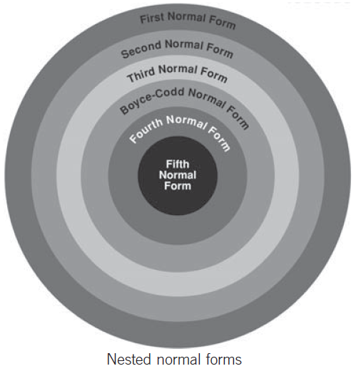

**Anomalies of a bad database design**

The table displays data redundancies which yield the following anomalies

1. **Update anomalies**

Changing the price of product ID 4 requires an update in several records. If data items are scattered and are not linked to each other properly, then it could lead to strange situations.

1. **Insertion anomalies**

The new employee must be assigned a project (phantom project). We tried to insert data in a record that does not exist at all.

1. **Deletion anomalies**

If an employee is deleted, other vital data is lost. We tried to delete a record, but parts of it were left undeleted because of unawareness, the data is also saved somewhere else.

if we delete the Dining Table from Order 1006, we lose information concerning this item's finish and price

**Anomalies type w.r.t Database table constraints**

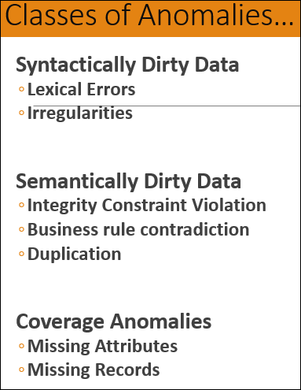

In most cases, if you can place your relations in the third normal form (3NF), then you will have avoided most of the problems common to bad relational designs. Boyce-Codd (BCNF) and the fourth normal form (4NF) handle special situations that arise only occasionally.

* **1st Normal form:**

Normally every table before normalization has repeating groups In the first normal for conversion we do eliminate Repeating groups in table records

Proper primary key developed/All attributes depends on the primary key.

Uniquely identifies attribute values (rows) (Fields)

Dependencies can be identified, No multivalued attributes

Every attribute value is atomic

A functional dependency exists when the value of one thing is fully determined by another. For example, given the relation EMP(empNo, emp name, sal), attribute empName is functionally dependent on attribute empNo. If we know empNo, we also know the empName.

Types of dependencies

Partial (Based on part of composite primary key)

Transitive (One non-prime attribute depends on another nonprime attribute)

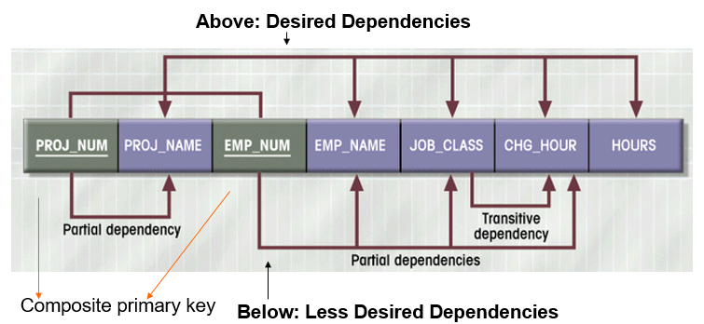

PROJ_NUM,EMP_NUM 🡪 PROJ_NAME, EMP_NAME, JOB_CLASS,CHG_HOUR, HOURS

* **2nd Normal form:**

Start with the 1NF format:

Write each key component on a separate line

Partial dependency has been ended by separating the table with its original key as a new table.

Keys with their respective attributes would be a new table.

Still possible to exhibit transitive dependency

A relation will be in 2NF if it is in 1NF and all non-key attributes are fully functional and dependent on the primary key. No partial dependency should exist in the relation

* **3rd Normal form:**

Create a separate table(s) to eliminate transitive functional dependencies

2NF PLUS no transitive dependencies (functional dependencies on non-primary-key attributes)

In 3NF no transitive functional dependency exists for non-prime attributes in a relation. It will be when a non-key attribute is dependent on a non-key attribute or a functional dependency exists between non-key attributes.

* **Boyce-Codd Normal Form (BCNF)**

3NF table with one candidate key is already in BCNF

It contains a fully functional dependency

Every determinant in the table is a candidate key.

BCNF is the advanced version of 3NF. It is stricter than 3NF.

A table is in BCNF if every functional dependency X → Y, X is the super key of the table.

For BCNF, the table should be in 3NF, and for every FD, LHS is super key.

* **4th Fourth normal form (4NF)**

A relation will be in 4NF if it is in Boyce Codd's normal form and has no multi-valued dependency.

For a dependency A → B, if for a single value of A, multiple values of B exist, then the relationship will be a multi-valued dependency.

* **5th Fifth normal form (5NF)**

A relation is in 5NF if it is in 4NF and does not contain any join dependency and joining should be lossless.

5NF is satisfied when all the tables are broken into as many tables as possible to avoid redundancy.

5NF is also known as Project-join normal form (PJ/NF).

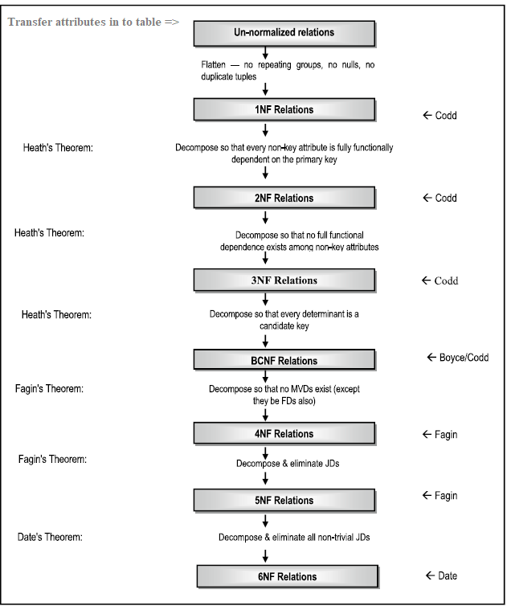

**Denormalization in Databases**

Denormalization is a database optimization technique in which we add redundant data to one or more tables. This can help us avoid costly joins in a relational database. Note that denormalization does not mean not doing normalization. It is an optimization technique that is applied after normalization.

**Types of Denormalization**

The two most common types of denormalization are two entities in **a one-to-one relationship** and two entities in a **one-to-many relationship**.

* **Pros of Denormalization: -**

Retrieving data is faster since we do fewer joins Queries to retrieve can be simpler (and therefore less likely to have bugs), since we need to look at fewer tables.

* **Cons of Denormalization: -**

Updates and inserts are more expensive. Denormalization can make an update and insert code harder to write.

Data may be inconsistent. Which is the “correct” value for a piece of data?

Data redundancy necessities more storage.

**Relational Decomposition**

Decomposition is used to eliminate some of the problems of bad design like anomalies, inconsistencies, and redundancy.

When a relation in the relational model is not inappropriate normal form then the decomposition of a relationship is required. In a database, it breaks the table into multiple tables.

**Types of Decomposition**

1. **Lossless Decomposition**

If the information is not lost from the relation that is decomposed, then the decomposition will be lossless. The process of normalization depends on being able to factor or decompose a table into two or smaller tables, in such a way that we can recapture the precise content of the original table by joining the decomposed parts.

1. **Lossy Decomposition**

Data will be lost for more decomposition of the table.

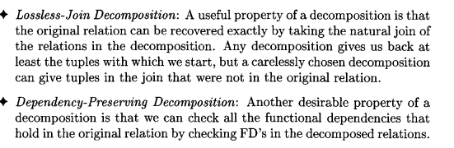

**Database SQL Joins**

Join is a combination of a Cartesian product followed by a selection process.

**Database join types:**

* **Non-ANSI Format Join**

1. Non-Equi join
2. Self-join
3. Equi Join

* **ANSI format join**

1. Semi Join
2. Left/right semi join
3. Anti Semi join
4. Bloom Join
5. Natural Join(Inner join, self join, theta join, cross join/cartesian product, conditional join)
6. Inner join (Equi and theta join/self-join)
7. Theta (θ)
8. Cross join
9. Cross products
10. Multi-join operation
11. Outer
    * Left outer join
    * Right outer join
    * Full outer join

* **Several different algorithms can be used to implement joins (natural, condition-join)**

1. Nested Loops join

* Simple nested loop join
* Block nested loop join
* Index nested loop join

1. Sort merge join/external sort join
2. Hash join

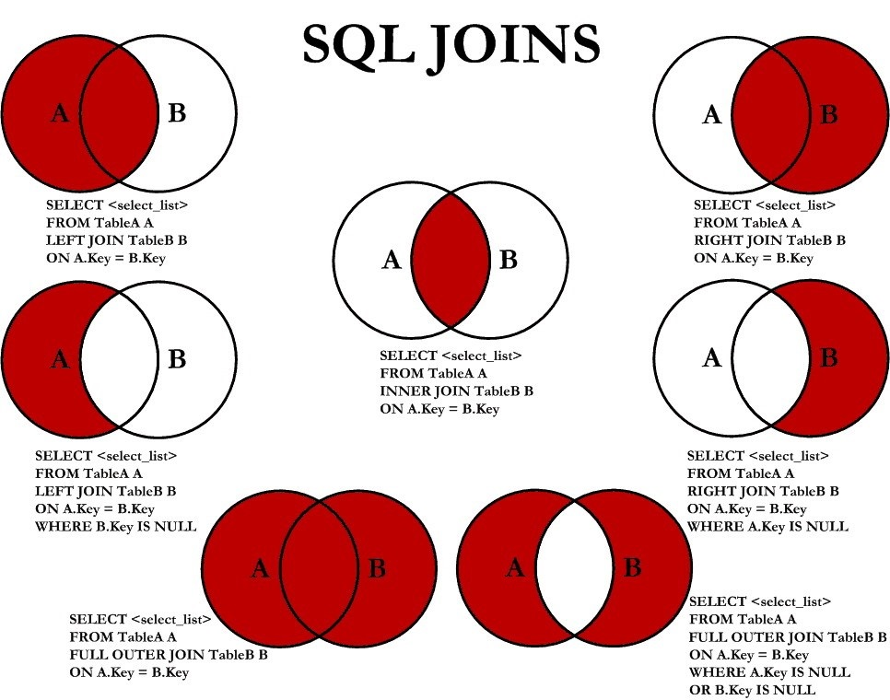

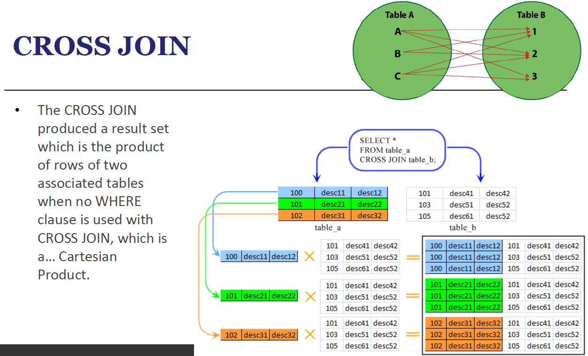

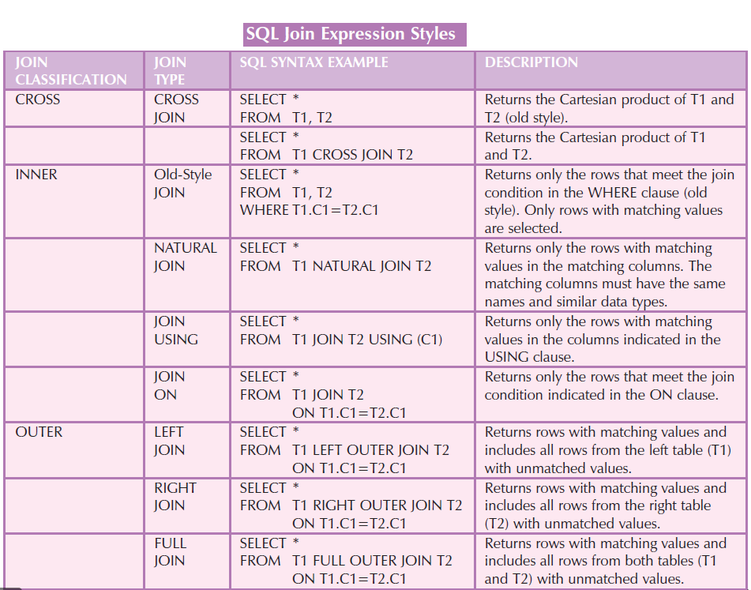

END

**CHAPTER 7 FUNCTIONAL DEPENDENCIES IN THE DATABASE MANAGEMENT SYSTEM**

**SQL Server records two types of dependency:**

**Functional Dependency**

Functional dependency (FD) is a set of constraints between two attributes in a relation. Functional dependency says that if two tuples have the same values for attributes A1, A2,..., An, then those two tuples must have to have same values for attributes B1, B2, ..., Bn.

Functional dependency is represented by an arrow sign (→) that is, X→Y, where X functionally determines Y. The left-hand side attributes determine the values of attributes on the right-hand side.

**Types of schema dependency**

**Schema-bound and non-schema-bound dependencies.**

**A Schema-bound dependencies** are those dependencies that prevent the referenced object from being altered or dropped without first removing the dependency.

An **example** of a schema-bound reference would be a view created on a table using the WITH SCHEMABINDING option.

**A Non-schema-bound dependency:** does not prevent the referenced object from being altered or dropped.

An **example** of this is a stored procedure that selects from a table. The table can be dropped without first dropping the stored procedure or removing the reference to the table from that stored procedure. Consider the following.

**Functional Dependency (FD)** is a constraint that determines the relation of one attribute to another attribute.

Functional dependency is denoted by an arrow “→”. The functional dependency of X on Y is represented by X → Y.

In this example, if we know the value of the Employee number, we can obtain Employee Name, city, salary, etc. By this, we can say that the city, Employee Name, and salary are functionally dependent on the Employee number.

| Key Terms for Functional Dependency in Database | Description |
| --- | --- |
| Axiom | Axioms are a set of inference rules used to infer all the functional dependencies on a relational database. |
| Decomposition | It is a rule that suggests if you have a table that appears to contain two entities that are determined by the same primary key then you should consider breaking them up into two different tables. |
| Dependent | It is displayed on the right side of the functional dependency diagram. |
| Determinant | It is displayed on the left side of the functional dependency Diagram. |
| Union | It suggests that if two tables are separate, and the PK is the same, you should consider putting them. Together |

**Armstrong’s Axioms**

The inclusion rule is one rule of implication by which FDs can be generated that are guaranteed to hold for all possible tables. It turns out that from a small set of basic rules of implication, we can derive all others. We list here three basic rules that we call Armstrong’s Axioms

Armstrong’s Axioms property was developed by William Armstrong in 1974 to reason about functional dependencies.

The property suggests rules that hold true if the following are satisfied:

1. Transitivity

If A->B and B->C, then A->C i.e. a transitive relation.

1. Reflexivity

A-> B, if B is a subset of A.

1. Augmentation -> The last rule suggests: AC->BC, if A->B

**Inference Rule (IR)**

**Armstrong's axioms are the basic inference rule.**

Armstrong's axioms are used to conclude functional dependencies on a relational database.

The inference rule is a type of assertion. It can apply to a set of FD (functional dependency) to derive other FD.

**The Functional dependency has 6 types of inference rules:**

1. Reflexive Rule (IR1)

2. Augmentation Rule (IR2)

3. Transitive Rule (IR3)

4. Union Rule (IR4)

5. Decomposition Rule (IR5)

6. Pseudo transitive Rule (IR6)

**Functional Dependency type**

Dependencies in DBMS are a relation between two or more attributes. It has the following types in DBMS

**Functional Dependency**

If the information stored in a table can uniquely determine another information in the same table, then it is called Functional Dependency. Consider it as an association between two attributes of the same relation.

**Major type are Trivial, non-trival, complete functional, multivalued, transitive dependency**

**Partial Dependency**

Partial Dependency occurs when a nonprime attribute is functionally dependent on part of a candidate key.

**Multivalued Dependency**

When the existence of one or more rows in a table implies one or more other rows in the same table, then the Multi-valued dependencies occur.

Multivalued dependency occurs when two attributes in a table are independent of each other but, both depend on a third attribute.

A multivalued dependency consists of at least two attributes that are dependent on a third attribute that's why it always requires at least three attributes.

**Join Dependency**

Join decomposition is a further generalization of Multivalued dependencies.

If the join of R1 and R2 over C is equal to relation R, then we can say that a join dependency (JD) exists.

**Inclusion Dependency**

Multivalued dependency and join dependency can be used to guide database design although they both are less common than functional dependencies. The inclusion dependency is a statement in which some columns of a relation are contained in other columns.

**Transitive Dependency**

When an indirect relationship causes functional dependency it is called Transitive Dependency.

**Fully-functionally Dependency**

An attribute is fully functional dependent on another attribute if it is Functionally Dependent on that attribute and not on any of its proper subset

**Trivial functional dependency**

A → B has trivial functional dependency if B is a subset of A.

The following dependencies are also trivial: A → A, B → B

{ DeptId, DeptName } -> Dept Id

**Non-trivial functional dependency**

A → B has a non-trivial functional dependency if B is not a subset of A.

Trivial − If a functional dependency (FD) X → Y holds, where Y is a subset of X, then it is called a trivial FD. It occurs when B is not a subset of A in −

A ->B

DeptId -> DeptName

Non-trivial − If an FD X → Y holds, where Y is not a subset of X, then it is called a non-trivial FD.

**Completely non-trivial** − If an FD X → Y holds, where x intersects Y = Φ, it is said to be a completely non-trivial FD. When A intersection B is NULL, then A → B is called a complete non-trivial. A ->B Intersaction is empty.

Multivalued Dependency and its types

1. Join Dependency
2. Join decomposition is a further generalization of Multivalued dependencies.
3. Inclusion Dependency

**Example of Dependency diagrams and flow**

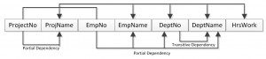

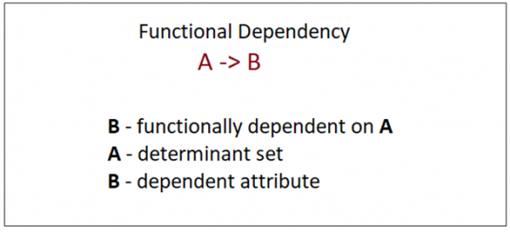

**Dependency Preserving**

If a relation R is decomposed into relations R1 and R2, then the dependencies of R either must be a part of R1 or R2 or must be derivable from the combination of functional dependencies of R1 and R2.

For example, suppose there is a relation R (A, B, C, D) with a functional dependency set (A->BC). The relational R is decomposed into R1(ABC) and R2(AD) which is dependency preserving because FD A->BC is a part of relation R1(ABC)

**Find the canonical cover?**

Solution: Given FD = { B → A, AD → BC, C → ABD }, now decompose the FD using decomposition rule( Armstrong Axiom ).

B → A

AD → B ( using decomposition inference rule on AD → BC)

AD → C ( using decomposition inference rule on AD → BC)

C → A ( using decomposition inference rule on C → ABD)

C → B ( using decomposition inference rule on C → ABD)

C → D ( using decomposition inference rule on C → ABD)

Now set of FD = { B → A, AD → B, AD → C, C → A, C → B, C → D }

**Canonical Cover/ irreducible**

A canonical cover or irreducible set of functional dependencies FD is a simplified set of FD that has a similar closure as the original set FD.

**Extraneous attributes**

An attribute of an FD is said to be extraneous if we can remove it without changing the closure of the set of FD.

**Closure Of Functional Dependency**

The Closure Of Functional Dependency means the complete set of all possible attributes that can be functionally derived from given functional dependency using the inference rules known as Armstrong’s Rules.

If “F” is a functional dependency then closure of functional dependency can be denoted using “{F}+”.

There are three steps to calculate closure of functional dependency. These are:

Step-1 : Add the attributes which are present on Left Hand Side in the original functional dependency.

Step-2 : Now, add the attributes present on the Right Hand Side of the functional dependency.

Step-3 : With the help of attributes present on Right Hand Side, check the other attributes that can be derived from the other given functional dependencies. Repeat this process until all the possible attributes which can be derived are added in the closure.

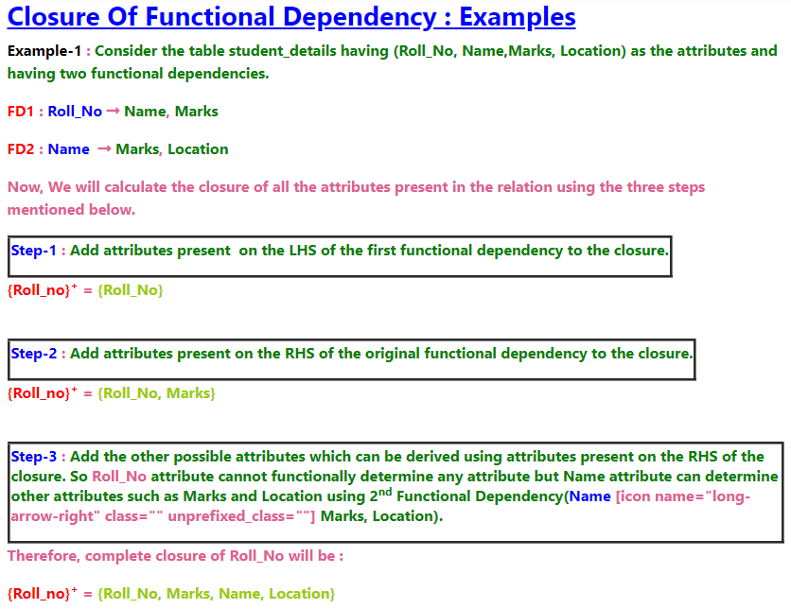

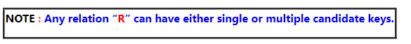

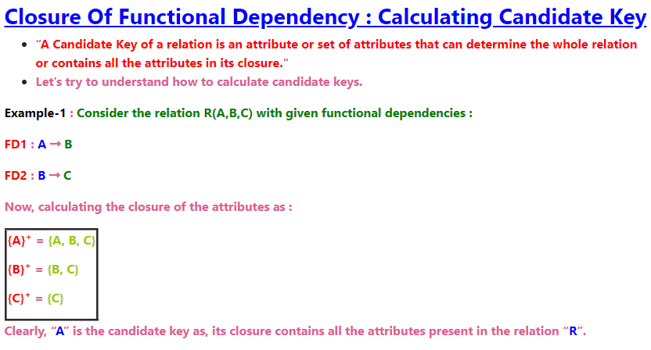

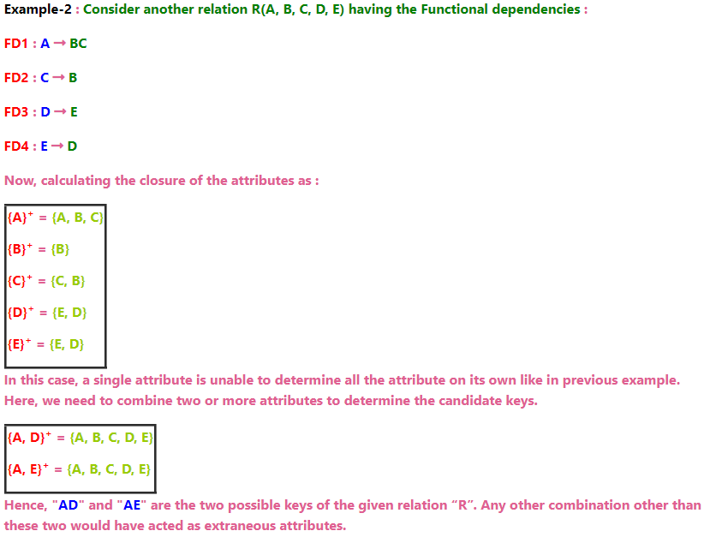

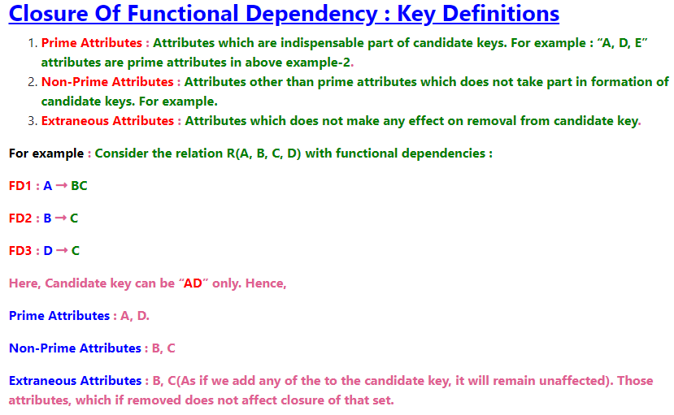

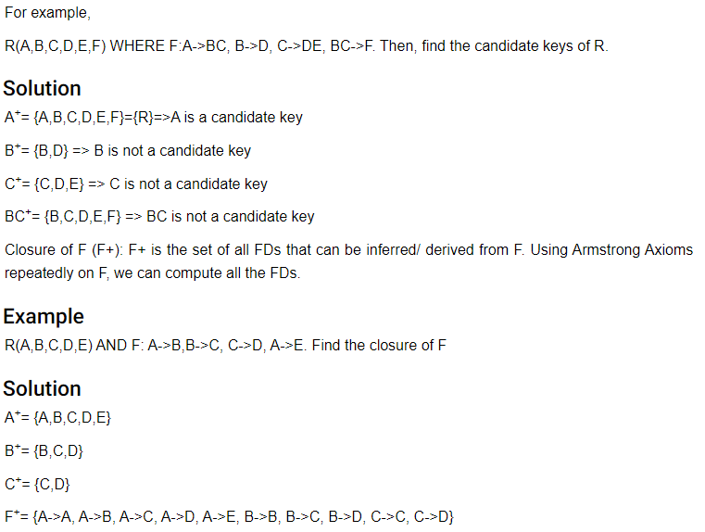

**CHAPTER 8 DATABASE TRANSACTION, SCHEDULES, AND DEADLOCKS**

**Overview:** **Transaction**

A Transaction is an atomic sequence of actions in the Database (reads and writes, commit, and abort)

Each Transaction must be executed completely and must leave the Database in a consistent state. The transaction is a set of logically related operations. It contains a group of tasks. A transaction is an action or series of actions. It is performed by a single user to perform operations for accessing the contents of the database. A transaction can be defined as a group of tasks. A single task is the minimum processing unit which cannot be divided further.

**ACID**

Data concurrency means that many users can access data at the same time.

Data consistency means that each user sees a consistent view of the data, including visible changes made by the user's transactions and transactions of other users.

The ACID model provides a consistent system for Relational databases.

The BASE model provides high availability for Non-relational databases like NoSQL MongoDB

**Techniques for achieving ACID properties**

* Write-ahead logging and checkpointing
* Serializability and two-phase locking

**Some important points:**

Property Responsibility for maintaining Transactions:

**Atomicity** Transaction Manager (Data remains atomic, executed completely, or should not be executed at all, the operation should not break in between or execute partially. Either all R(A) and W(A) are done or none is done)

**Consistency** Application programmer / Application logic checks/ it related to rollbacks

**Isolation** Concurrency Control Manager/Handle concurrency

**Durability** Recovery Manager (Algorithms for Recovery and Isolation Exploiting Semantics (aries)

**Handle failures, Logging, and recovery** (A, D)

**Concurrency control, rollback, application programmer** (C, I)

**Consistency:** The word consistency means that the value should remain preserved always, the database remains consistent before and after the transaction.

**Isolation and levels of isolation:** The term 'isolation' means separation. Any changes that occur in any particular transaction will not be seen by other transactions until the change is not committed in the memory.

**A transaction isolation level is defined by the following phenomena:**

*Concurrency Control Problems and isolation levels are the same*

The Three Bad Transaction Dependencies. Locks are often used to prevent these dependencies

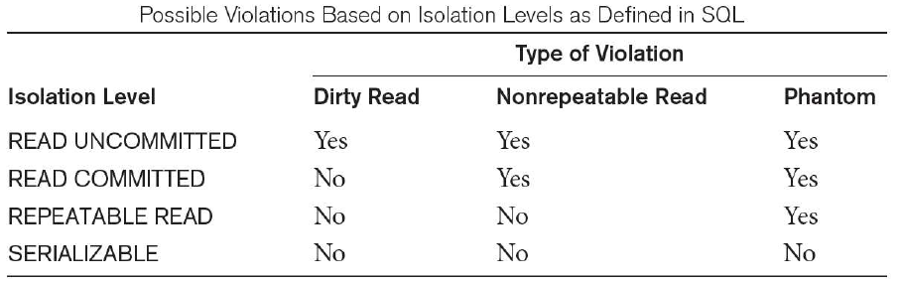

**The five concurrency problems that can occur in the database are:**

1. Temporary Update Problem
2. Incorrect Summary Problem
3. Lost Update Problem
4. Unrepeatable Read Problem
5. Phantom Read Problem

**Dirty Read** – A Dirty read is a situation when a transaction reads data that has not yet been committed. For example, Let’s say transaction 1 updates a row and leaves it uncommitted, meanwhile, Transaction 2 reads the updated row. If transaction 1 rolls back the change, transaction 2 will have read data that is considered never to have existed. (Dirty Read Problems (W-R Conflict))

**Lost Updates** occur when multiple transactions select the same row and update the row based on the value selected (Lost Update Problems (W - W Conflict))

**Non Repeatable read** – Non Repeatable read occurs when a transaction reads the same row twice and gets a different value each time. For example, suppose transaction T1 reads data. Due to concurrency, another transaction T2 updates the same data and commits, Now if transaction T1 rereads the same data, it will retrieve a different value. (Unrepeatable Read Problem (W-R Conflict))

**Phantom Read** – Phantom Read occurs when two same queries are executed, but the rows retrieved by the two, are different. For example, suppose transaction T1 retrieves a set of rows that satisfy some search criteria. Now, Transaction T2 generates some new rows that match the search criteria for transaction T1. If transaction T1 re-executes the statement that reads the rows, it gets a different set of rows this time.

**Based on these phenomena, the SQL standard defines four isolation levels :**

**Read Uncommitted –** Read Uncommitted is the lowest isolation level. In this level, one transaction may read not yet committed changes made by another transaction, thereby allowing dirty reads. At this level, transactions are not isolated from each other.

**Read Committed –** This isolation level guarantees that any data read is committed at the moment it is read. Thus it does not allows dirty reading. The transaction holds a read or write lock on the current row, and thus prevents other transactions from reading, updating, or deleting it.

**Repeatable Read –** This is the most restrictive isolation level. The transaction holds read locks on all rows it references and writes locks on all rows it inserts, updates, or deletes. Since other transactions cannot read, update or delete these rows, consequently it avoids non-repeatable read.

**Serializable –** This is the highest isolation level. A serializable execution is guaranteed to be serializable. Serializable execution is defined to be an execution of operations in which concurrently executing transactions appear to be serially executing.

**Durability:** Durability ensures the permanency of something. In DBMS, the term durability ensures that the data after the successful execution of the operation becomes permanent in the database. If a transaction is committed, it will remain even error, power loss, etc.

**ACID Example:**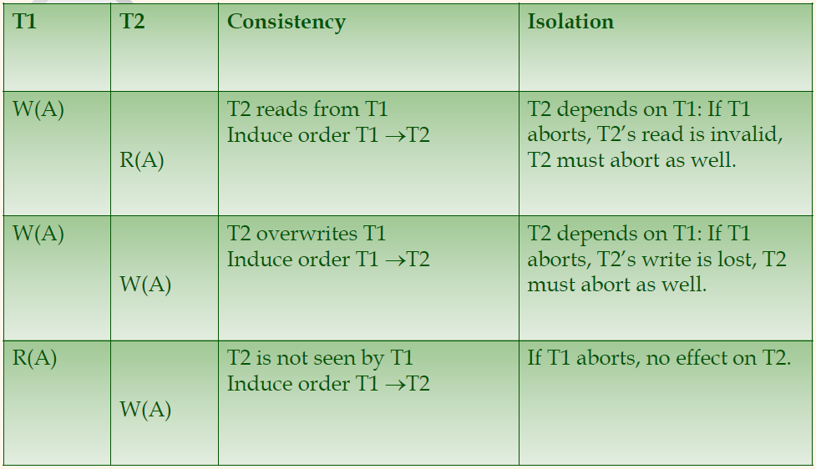

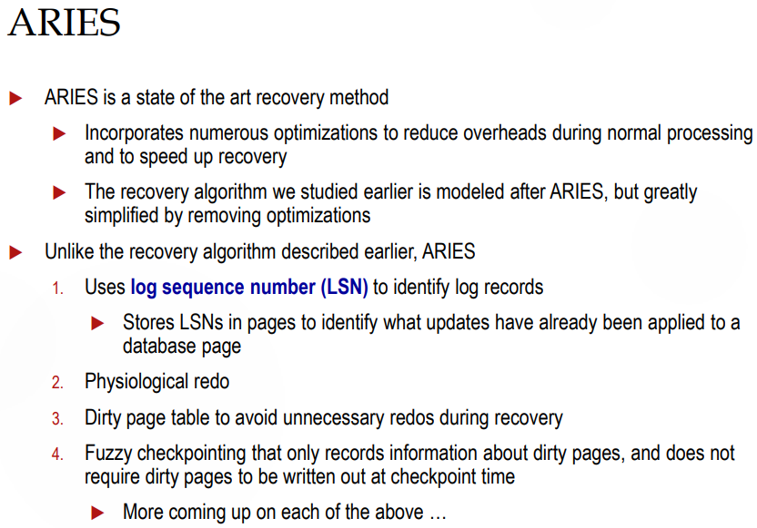

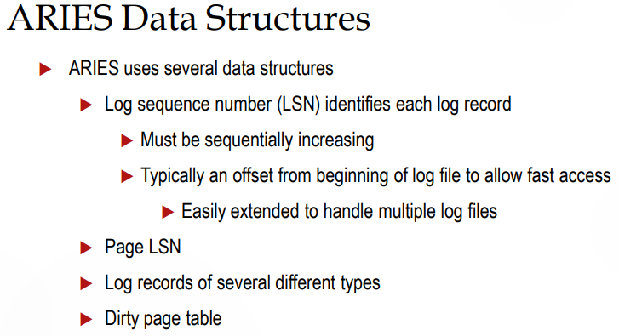

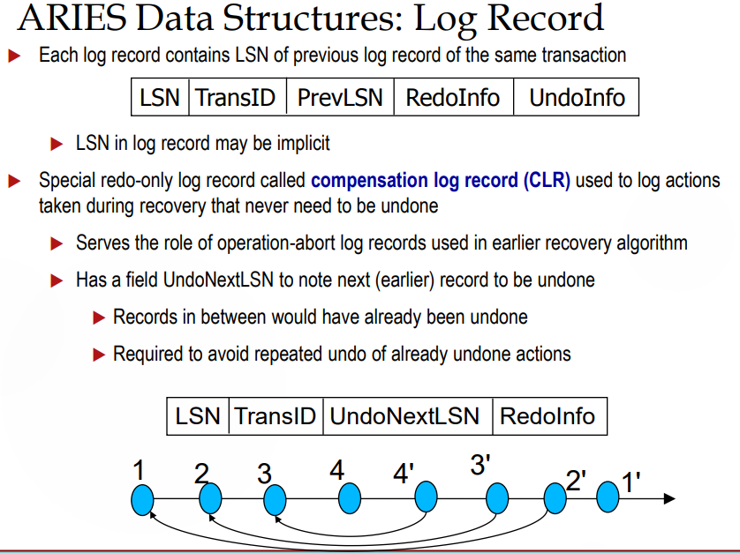

**States of Transaction**

Begin, active, partially committed, failed, committed, end, aborted

**Aborted details are necessary**

If any of the checks fail and the transaction has reached a failed state then the database recovery system will make sure that the database is in its previous consistent state. If not then it will abort or roll back the transaction to bring the database into a consistent state.

If the transaction fails in the middle of the transaction then before executing the transaction, all the executed transactions are rolled back to their consistent state. After aborting the transaction, the database recovery module will select one of the two operations: **1) Re-start the transaction 2) Kill the transaction**

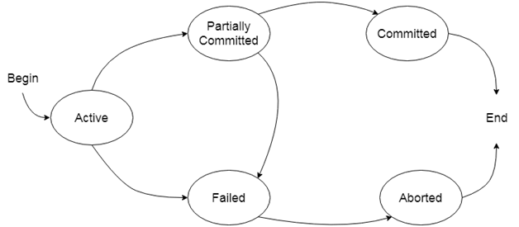

The concurrency control protocols ensure the atomicity, consistency, isolation, durability and serializability of the concurrent execution of the database transactions.

**Therefore, these protocols are categorized as:**

1. Lock Based Concurrency Control Protocol
2. Time Stamp Concurrency Control Protocol
3. Validation Based Concurrency Control Protocol

**The scheduler**

A module that schedules the transaction’s actions, ensuring serializability

Two main approaches

1. Pessimistic: locks
2. Optimistic: time stamps, MV, validation

**Scheduling**

A schedule is responsible for maintaining jobs/transactions if many jobs are entered at the same time(by multiple users) to execute state and read/write operations performed at that jobs.

A schedule is a sequence of interleaved actions from all transactions. Execution of several Facts while preserving the order of R(A) and W(A) of any 1 Xact.

Note: Two schedules are equivalent if:

Two Schedules are equivalent if they have the same dependencies.

They contain the same transactions and operations

They order all conflicting operations of non-aborting transactions in the same way

A schedule is serializable if it is equivalent to a serial schedule

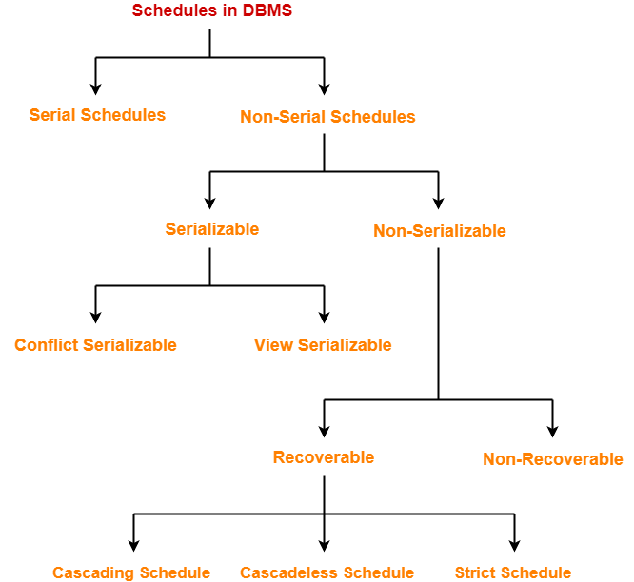

**Serial Schedule**

The serial schedule is a type of schedule where one transaction is executed completely before starting another transaction.

**Example of Serial Schedule**

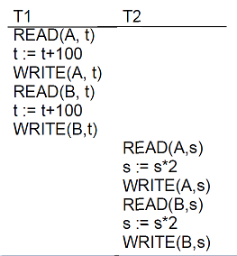

**Non-Serial Schedule and its types:**

If interleaving of operations is allowed, then there will be a non-serial schedule.

**Serializable schedule**

**Serializability** is a guarantee about transactions over one or more objects

Doesn’t impose real-time constraints

The schedule is serializable if the precedence graph is acyclic

The serializability of schedules is used to find non-serial schedules that allow the transaction to execute concurrently without interfering with one another.

**Example of Serializable**

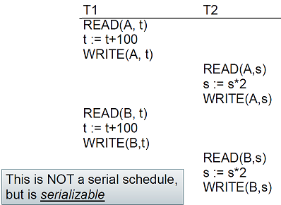

A **serializable schedule** always leaves the database in a consistent state. A serial schedule is always a serializable schedule because, in a serial schedule, a transaction only starts when the other transaction finished execution. However, a non-serial schedule needs to be checked for Serializability.

A non-serial schedule of n number of transactions is said to be a serializable schedule if it is equivalent to the serial schedule of those n transactions. A serial schedule doesn’t allow concurrency, only one transaction executes at a time, and the other stars when the already running transaction is finished.

**Linearizability**: a guarantee about single operations on single objects Once the write completes, all later reads (by wall clock) should reflect that write.

**Types of Serializability**

There are two types of Serializability.

* 1. **Conflict Serializability**
  2. **View Serializability**

**Conflict Serializable** A schedule is conflict serializable if it is equivalent to some serial schedule

Non-conflicting operations can be reordered to get a serial schedule.

In general, a schedule is conflict-serializable if and only if its precedence graph is acyclic

A precedence graph is used for Testing for Conflict-Serializability

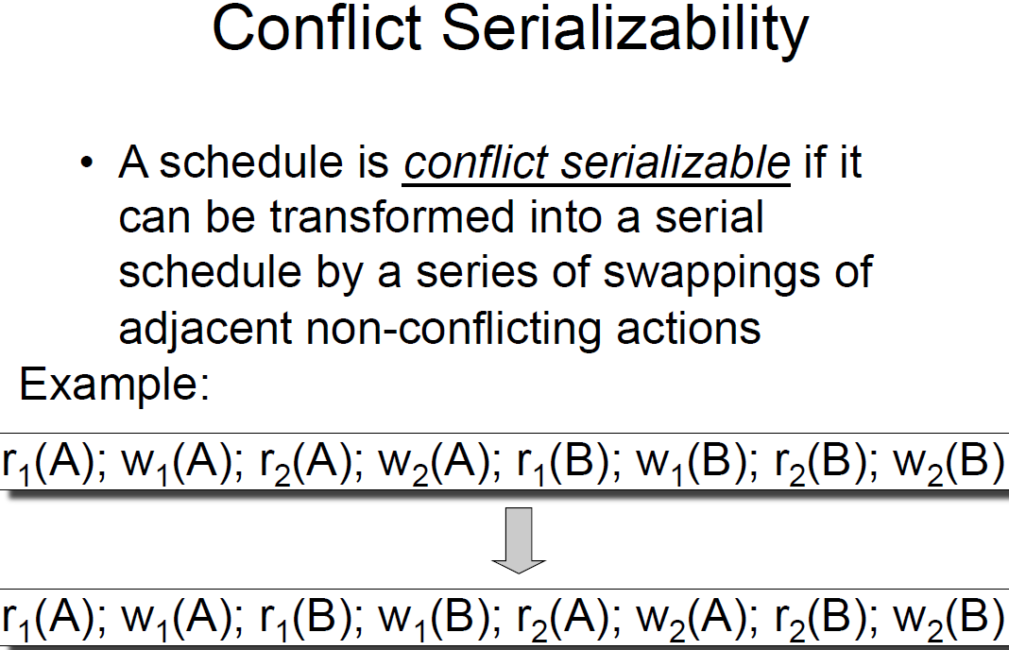

**View serializability/view equivalence** is a concept that is used to compute whether schedules are View-Serializable or not. A schedule is said to be View-Serializable if it is view equivalent to a Serial Schedule (where no interleaving of transactions is possible).

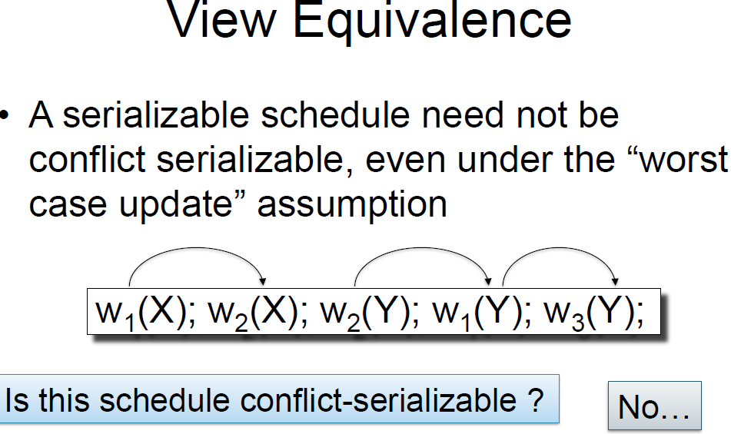

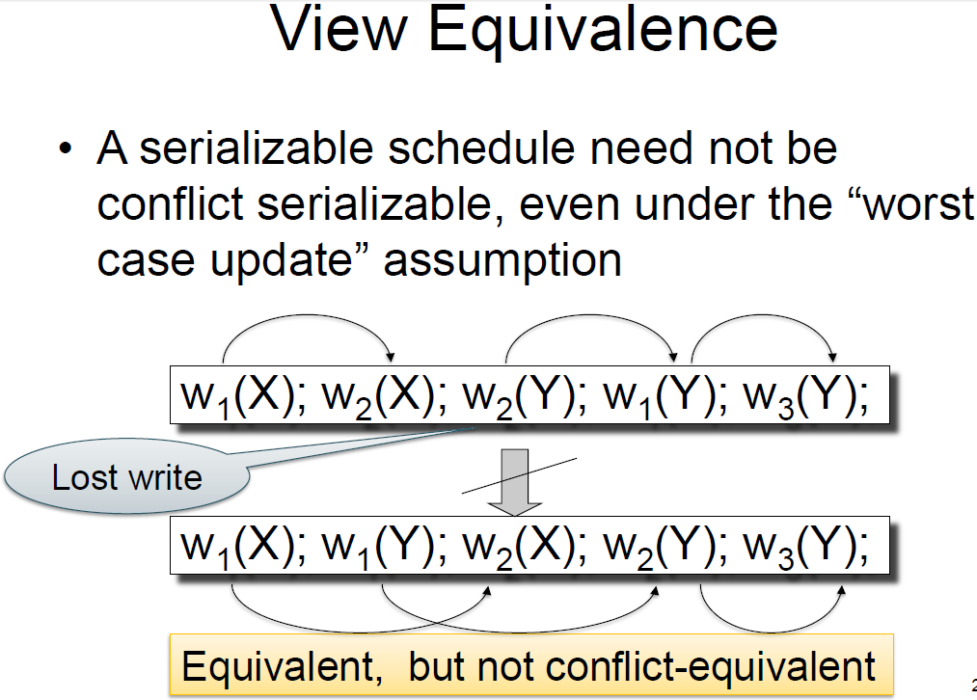

Note: A **schedule is view serializable** if it is view equivalent to a serial schedule

If a schedule is conflict serializable, then it is also viewed as serializable but not vice versa

**Non Serializable Schedule**

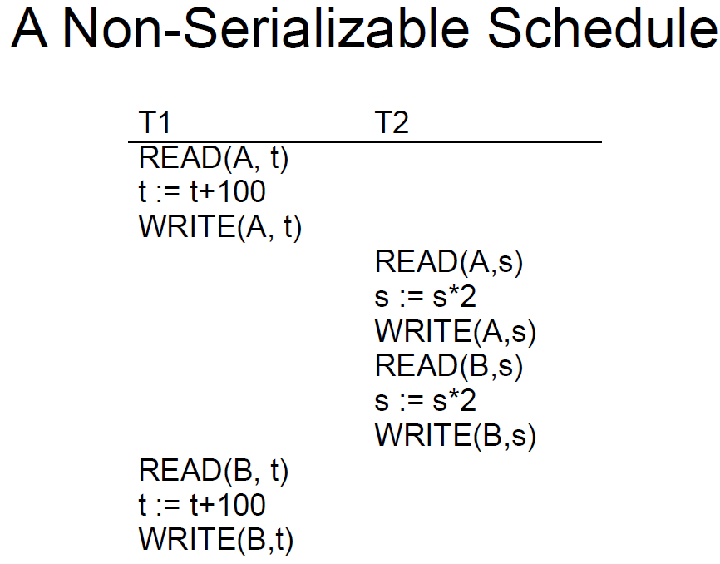

The non-serializable schedule is divided into two types, Recoverable and Non-recoverable Schedules.

**1. Recoverable Schedule**(Cascading Schedule, cascades Schedule, strict Schedule). In a recoverable schedule, if a transaction T commits, then any other transaction that T read from must also have committed.

A schedule is recoverable if:

It is conflict-serializable, and

Whenever a transaction T commits, all transactions that have written elements read by T have already been committed.

**Example of Recoverable Schedule**

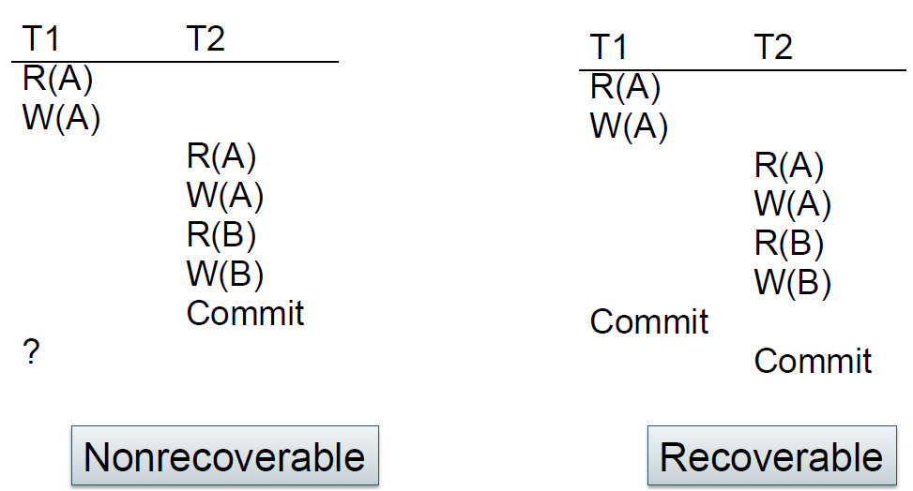

**2. Non-Recoverable Schedule**

The relation between various types of schedules can be depicted as:

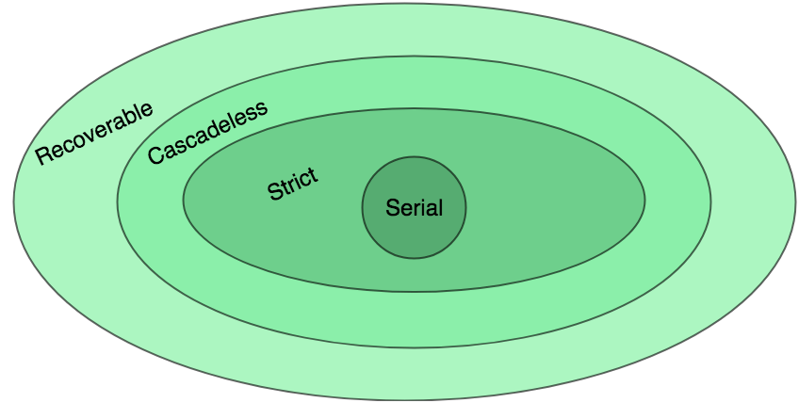

It can be seen that:

1. Cascadeless schedules are stricter than recoverable schedules or are a subset of recoverable schedules.
2. Strict schedules are stricter than cascade-less schedules or are a subset of cascade-less schedules.
3. Serial schedules satisfy constraints of all recoverable, cascadeless, and strict schedules and hence is a subset of strict schedules.

Note: Linearizability + serializability = strict serializability

Transaction behavior equivalent to some serial execution

And that serial execution agrees with real-time

**Serializability Theorems**

**Wormhole Theorem:** A history is isolated if, and only if, it has no wormhole transactions.

**Locking Theorem:** If all transactions are well-formed and two-phase, then any legal history will be isolated.

Locking Theorem (converse): If a transaction is not well-formed or is not two-phase, then it is possible to write another transaction, such that the resulting pair is a wormhole.

**Rollback Theorem:** An update transaction that does an UNLOCK and then a ROLLBACK is not two-phase.

Thomas Write Rule provides the guarantee of serializability order for the protocol. It improves the Basic Timestamp Ordering Algorithm.

The basic **Thomas writing** rules are as follows:

* If TS(T) < R_TS(X) then transaction T is aborted and rolled back, and the operation is rejected.
* If TS(T) < W_TS(X) then don't execute the W_item(X) operation of the transaction and continue processing.

**Different Types of reading Write Conflict in DBMS**

As I mentioned earlier, the read operation is safe as it does modify any information. So, there is no Read-Read (RR) conflict in the database.

**Problem 1**: Reading Uncommitted Data (WR Conflicts)

Reading the value of an uncommitted object might yield an inconsistency

Dirty Reads or Write-then-Read (WR) Conflicts.

**Problem 2:** Unrepeatable Reads (RW Conflicts)

Reading the same object twice might yield an inconsistency

Read-then-Write (RW) Conflicts (Write-After-Read)

**Problem 3:** Overwriting Uncommitted Data (WW Conflicts)

Overwriting an uncommitted object might yield an inconsistency

Lost Update or Write-After-Write (WW) Conflicts.

So, there are three types of conflict in the database transaction.

Write-Read (WR) conflict

Read-Write (RW) conflict

Write-Write (WW) conflict

**What is Write-Read (WR) conflict?**

This conflict occurs when a transaction read the data which is written by the other transaction before committing.

**What is Read-Write (RW) conflict?**

Transaction T2 is Writing data that is previously read by transaction T1.

Here if you look at the diagram above, data read by transaction T1 before and after T2 commits is different.

**What is Write-Write (WW) conflict?**

Here Transaction T2 is writing data that is already written by other transaction T1. T2 overwrites the data written by T1. It is also called a blind write operation.

Data written by T1 has vanished. So it is data update loss.

**Phase Commit (PC)**

One-phase commit

The Single Phase Commit protocol is more efficient at run time because all updates are done without any explicit coordination.

BEGIN

INSERT INTO CUSTOMERS (ID,NAME,AGE,ADDRESS,SALARY)

VALUES (1, 'Ramesh', 32, 'Ahmedabad', 2000.00 );

INSERT INTO CUSTOMERS (ID,NAME,AGE,ADDRESS,SALARY)

VALUES (2, 'Khilan', 25, 'Delhi', 1500.00 );

COMMIT;

**Two-Phase Commit (2PC)**

The most commonly used atomic commit protocol is a two-phase commit. You may notice that is very similar to the protocol that we used for total order multicast. Whereas the multicast protocol used a two-phase approach to allow the coordinator to select a commit time based on information from the participants, a two-phase commit lets the coordinator select whether or not a transaction will be committed or aborted based on information from the participants.

**Three-phase Commit**

Another real-world atomic commit protocol is a three-phase commit (3PC). This protocol can reduce the amount of blocking and provide for more flexible recovery in the event of failure. Although it is a better choice in unusually failure-prone environments, its complexity makes 2PC the more popular choice.

Transaction atomicity using a two-phase commit

Transaction serializability using distributed locking.

**DBMS Deadlock Types or techniques**

All lock requests are made to the concurrency-control manager. Transactions proceed only once the lock request is granted. A lock is a variable, associated with the data item, which controls the access of that data item. Locking is the most widely used form of concurrency control.

**Deadlock Example:**

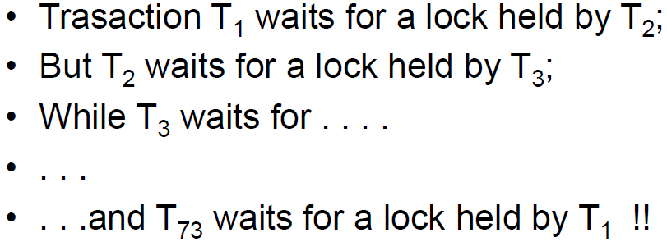

**Lock modes and types**

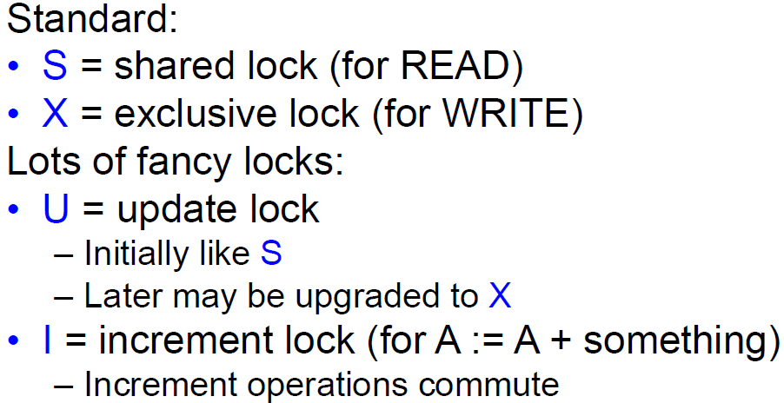

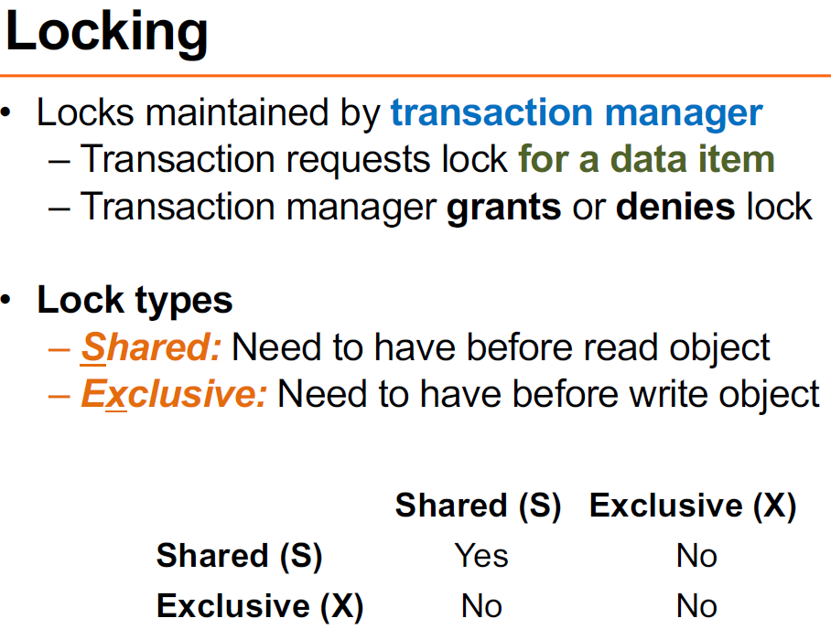

1. Binary Locks: A Binary lock on a data item can either be locked or unlocked states.
2. Shared/exclusive: This type of locking mechanism separates the locks in DBMS based on their uses. If a lock is acquired on a data item to perform a write operation, it is called an exclusive lock.
3. Simplistic Lock Protocol: This type of lock-based protocol allows transactions to obtain a lock on every object before beginning operation. Transactions may unlock the data item after finishing the ‘write’ operation.
4. Pre-claiming Locking: Two-Phase locking protocol which is also known as a 2PL protocol needs a transaction should acquire a lock after it releases one of its locks. It has 2 phases growing and shrinking.
5. Shared lock: These locks are referred to as read locks, and denoted by 'S'.

If a transaction T has obtained Shared-lock on data item X, then T can read X, but cannot write X. Multiple Shared locks can be placed simultaneously on a data item.

A deadlock is an unwanted situation in which two or more transactions are waiting indefinitely for one another to give up locks.

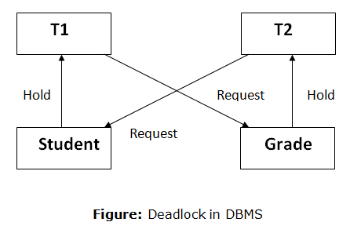

**Four necessary conditions for deadlock**

* **Mutual exclusion** -- only one process at a time can use the resource
* **Hold and wait** -- there must exist a process that is holding at least one resource and is waiting to acquire additional resources that are currently being held by other processes.
* **No preemption** -- resources cannot be preempted; a resource can be released only voluntarily by the process holding it.
* **Circular wait** – one waits for others, others wait for one.

The Bakery algorithm is one of the simplest known solutions to the mutual exclusion problem for the general case of the N process. The bakery Algorithm is a critical section solution for N processes. The algorithm preserves the first come first serve the property.

Before entering its critical section, the process receives a number. The holder of the smallest number enters the critical section.

**Deadlock detection**

This technique allows deadlock to occur, but then, it detects it and solves it. Here, a database is periodically checked for deadlocks. If a deadlock is detected, one of the transactions, involved in the deadlock cycle, is aborted. Other transactions continue their execution. An aborted transaction is rolled back and restarted.

When a transaction waits more than a specific amount of time to obtain a lock (called the deadlock timeout), Derby can detect whether the transaction is involved in a deadlock.

If deadlocks occur frequently in your multi-user system with a particular application, you might need to do some debugging.

A deadlock where two transactions are waiting for one another to give up locks.

**Deadlock detection and removal schemes**

Wait-for-graph

This scheme allows the older transaction to wait but kills the younger one.

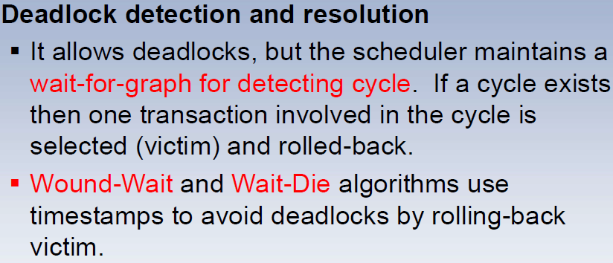

**Phantom deadlock detection** is the condition where the deadlock does not exist but due to a delay in propagating local information, deadlock detection algorithms identify the locks that have been already acquired.

**There are three alternatives for deadlock detection in a distributed system, namely.**

Centralized Deadlock Detector − One site is designated as the central deadlock detector.

Hierarchical Deadlock Detector − Some deadlock detectors are arranged in a hierarchy.

Distributed Deadlock Detector − All the sites participate in detecting deadlocks and removing them.

**The deadlock detection algorithm uses 3 data structures –**

Available

Vector of length m

Indicates the number of available resources of each type.

Allocation

Matrix of size n*m

A[i,j] indicates the number of j the resource type allocated to I the process.

Request

Matrix of size n*m

Indicates the request of each process.

Request[i,j] tells the number of instances Pi process is the request of jth resource type.

**Deadlock Avoidance**

Deadlock avoidance

* Acquire locks in a pre-defined order
* Acquire all locks at once before starting transactions

Aborting a transaction is not always a practical approach. Instead, deadlock avoidance mechanisms can be used to detect any deadlock situation in advance.

**The deadlock prevention** technique avoids the conditions that lead to deadlocking. It requires that every transaction lock all data items it needs in advance. If any of the items cannot be obtained, none of the items are locked.

The transaction is then rescheduled for execution. The deadlock prevention technique is used in two-phase locking.

To prevent any deadlock situation in the system, the DBMS aggressively inspects all the operations, where transactions are about to execute. If it finds that a deadlock situation might occur, then that transaction is never allowed to be executed.

**Deadlock Prevention Algo**

1. Wait-Die scheme
2. Wound wait scheme

Note! Deadlock prevention is more strict than Deadlock Avoidance.

The algorithms are as follows −

Wait-Die − If T1 is older than T2, T1 is allowed to wait. Otherwise, if T1 is younger than T2, T1 is aborted and later restarted.

**Wait-die:** permit older waits for younger

**Wound-Wait −** If T1 is older than T2, T2 is aborted and later restarted. Otherwise, if T1 is younger than T2, T1 is allowed to wait. Wound-wait: permit younger waits for older.

Note: In a bulky system, deadlock prevention techniques may work well.

Here, we want to develop an algorithm to avoid deadlock by making the right choice all the time

**Dijkstra's Banker's Algorithm** is an approach to trying to give processes as much as possible while guaranteeing no deadlock.

**safe state** -- a state is safe if the system can allocate resources to each process in some order and still avoid a deadlock.

**Banker's Algorithm** for Single Resource Type is a resource allocation and deadlock avoidance algorithm. This name has been given since it is one of most problems in Banking Systems these days.

In this, as a new process P1 enters, it declares the maximum number of resources it needs.

The system looks at those and checks if allocating those resources to P1 will leave the system in a [safe state](https://prepinsta.com/operating-systems/bankers-algorithm/#safeState) or not.

If after allocation, it will be in a safe state, the resources are allocated to process P1.

Otherwise, P1 should wait till the other processes release some resources.

This is the basic idea of Banker’s Algorithm.

A state is **safe** if the system can allocate all resources requested by all processes ( up to their stated maximums ) without entering a deadlock state.

**Resource Preemption:**

To eliminate deadlocks using resource preemption, we preempt some resources from processes and give those resources to other processes. This method will raise three issues –

**(a) Selecting a victim:**

We must determine which resources and which processes are to be preempted and also order to minimize the cost.

**(b) Rollback:**

We must determine what should be done with the process from which resources are preempted. One simple idea is total rollback. That means aborting the process and restarting it.

**(c) Starvation:**

In a system, the same process may be always picked as a victim. As a result, that process will never complete its designated task. This situation is called Starvation and must be avoided. One solution is that a process must be picked as a victim only a finite number of times.

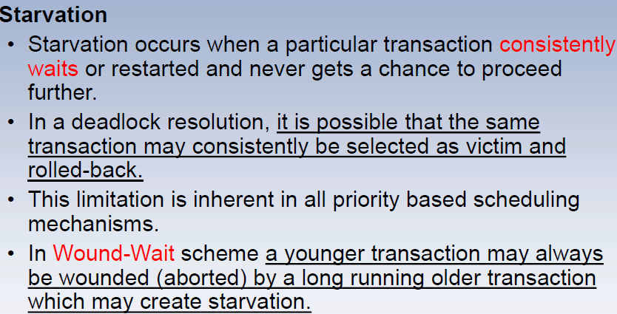

**Concurrent vs non-concurrent data access**

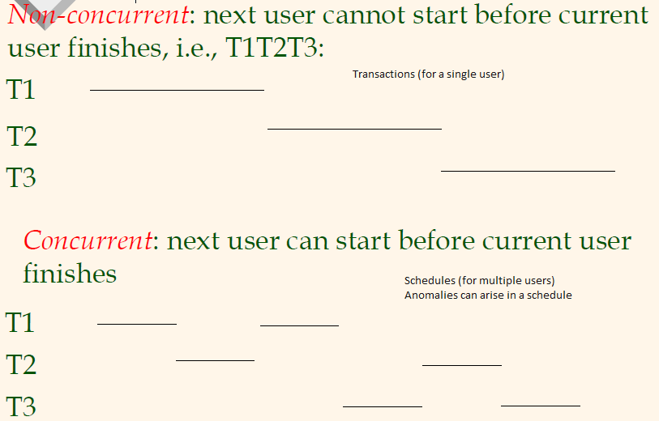

Concurrent executions are done for Better transaction throughput, response time Done via better utilization of resources

**What is Concurrency Control?**

Concurrent access is quite easy if all users are just reading data. There is no way they can interfere with one another. Though for any practical Database, it would have a mix of READ and WRITE operations, and hence the concurrency is a challenge. DBMS Concurrency Control is used to address such conflicts, which mostly occur with a multi-user system.

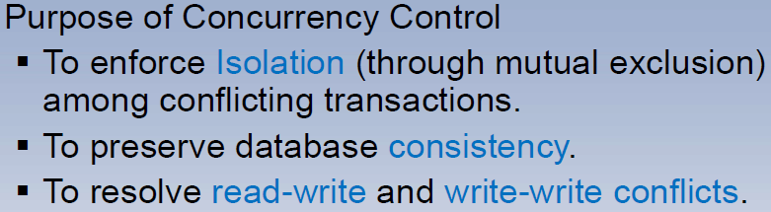

**Various concurrency control techniques/Methods are:**

1. Two-phase locking Protocol
2. Time stamp ordering Protocol
3. Multi-version concurrency control
4. Validation concurrency control
5. Optimistic Methods

**Two Phase Locking Protocol** is also known as 2PL protocol is a method of concurrency control in DBMS that ensures serializability by applying a lock to the transaction data which blocks other transactions to access the same data simultaneously. Two Phase Locking protocol helps to eliminate the concurrency problem in DBMS. Every 2PL schedule is serializable.

**Theorem**: 2PL ensures/enforce conflict serializability schedule

But does not enforce recoverable schedules

**2PL rule**: Once a transaction has released a lock it is not allowed to obtain any other locks

This locking protocol divides the execution phase of a transaction into three different parts.

In the first phase, when the transaction begins to execute, it requires permission for the locks it needs.

The second part is where the transaction obtains all the locks. When a transaction releases its first lock, the third phase starts.

In this third phase, the transaction cannot demand any new locks. Instead, it only releases the acquired locks.

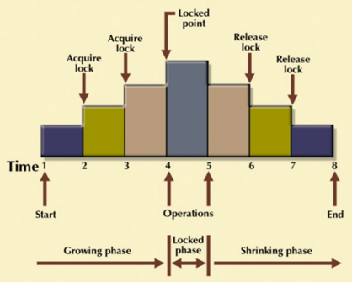

The Two-Phase Locking protocol allows each transaction to make a lock or unlock request Growing Phase and Shrinking Phase.

**2PL has the following two phases:**   
A**growing**phase, in which a transaction acquires all the required locks without unlocking any data. Once all locks have been acquired, the transaction is in its locked  
point.   
A **shrinking**phase, in which a transaction releases all locks and cannot obtain any new lock.

In practice:

– Growing phase is the entire transaction

– Shrinking phase is during the commit

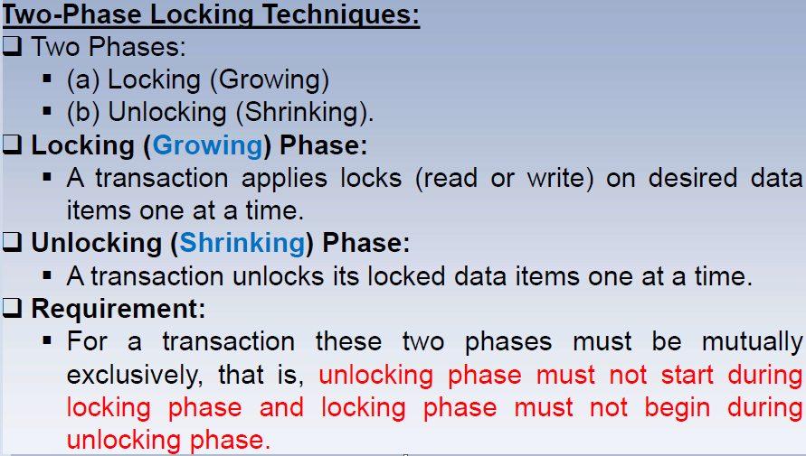

The 2PL protocol indeed offers serializability. However, it does not ensure that deadlocks do not happen.

In the above-given diagram, you can see that local and global deadlock detectors are searching for deadlocks and solving them by resuming transactions to their initial states.

**Strict Two-Phase Locking Method**

Strict-Two phase locking system is almost like 2PL. The only difference is that Strict-2PL never releases a lock after using it. It holds all the locks until the commit point and releases all the locks at one go when the process is over.

Strict 2PL: All locks held by a transaction are released when the transaction is completed. Strict 2PL guarantees conflict serializability, but not serializability.

**Centralized 2PL**

In Centralized 2PL, a single site is responsible for the lock management process. It has only one lock manager for the entire DBMS.

**Primary copy 2PL**

Primary copy 2PL mechanism, many lock managers are distributed to different sites. After that, a particular lock manager is responsible for managing the lock for a set of data items. When the primary copy has been updated, the change is propagated to the slaves.

**Distributed 2PL**

In this kind of two-phase locking mechanism, Lock managers are distributed to all sites. They are responsible for managing locks for data at that site. If no data is replicated, it is equivalent to primary copy 2PL. Communication costs of Distributed 2PL are quite higher than primary copy 2PL

**Time-Stamp Methods for Concurrency control:**

The timestamp is a unique identifier created by the DBMS to identify the relative starting time of a transaction.

Typically, timestamp values are assigned in the order in which the transactions are submitted to the system. So, a timestamp can be thought of as the transaction start time. Therefore, time stamping is a method of concurrency control in which each transaction is assigned a transaction timestamp.

**Timestamps must have two properties namely**

* Uniqueness: The uniqueness property assures that no equal timestamp values can exist.
* Monotonicity: monotonicity assures that timestamp values always increase.

**Timestamps are divided into further fields:**

* Granule Timestamps
* Timestamp Ordering
* Conflict Resolution in Timestamps

Timestamp-based Protocol in DBMS is an algorithm that uses the System Time or Logical Counter as a timestamp to serialize the execution of concurrent transactions. The Timestamp-based protocol ensures that every conflicting read and write operation is executed in timestamp order.

The timestamp-based algorithm uses a timestamp to serialize the execution of concurrent transactions. The protocol uses the System Time or Logical Count as a Timestamp.

**Conflict Resolution in Timestamps:**

To deal with conflicts in timestamp algorithms, some transactions involved in conflicts are made to wait and abort others.

**Following are the main strategies of conflict resolution in timestamps:**

**Wait-die:**

The older transaction waits for the younger if the younger has accessed the granule first.

The younger transaction is aborted (dies) and restarted if it tries to access a granule after an older concurrent transaction.

**Wound-wait:**

The older transaction pre-empts the younger by suspending (wounding) it if the younger transaction tries to access a granule after an older concurrent transaction.

An older transaction will wait for a younger one to commit if the younger has accessed a granule that both want.

**Timestamp Ordering:**

Following are the three basic variants of timestamp-based methods of concurrency control:

1. Total timestamp ordering
2. Partial timestamp ordering

Multiversion timestamp ordering

**Multi-version concurrency control**

Multiversion Concurrency Control (MVCC) enables snapshot isolation. Snapshot isolation means that whenever a transaction would take a read lock on a page, it makes a copy of the page instead, and then performs its operations on that copied page. This frees other writers from blocking due to read lock held by other transactions. Maintain multiple versions of objects, each with its timestamp. Allocate the correct version to reads. Multiversion schemes keep old versions of data items to increase concurrency.

The main difference between MVCC and standard locking:

read locks do not conflict with write locks ⇒ reading never blocks writing, writing blocks reading

**Advantage of MVCC**

locking needed for serializability considerably reduced

**Disadvantages of MVCC**

visibility-check overhead (on every tuple read/write)

**Validation-Based Protocols**

Validation-based Protocol in DBMS also known as **Optimistic** Concurrency Control Technique is a method to avoid concurrency in transactions. In this protocol, the local copies of the transaction data are updated rather than the data itself, which results in less interference while the execution of the transaction.

**Optimistic Methods of Concurrency Control:**

The optimistic method of concurrency control is based on the assumption that conflicts in database operations are rare and that it is better to let transactions run to completion and only check for conflicts before they commit.

The Validation based Protocol is performed in the following three phases:

Read Phase

Validation Phase

Write Phase

Read Phase

In the Read Phase, the data values from the database can be read by a transaction but the write operation or updates are only applied to the local data copies, not the actual database.

**Validation Phase**

In the Validation Phase, the data is checked to ensure that there is no violation of serializability while applying the transaction updates to the database.

**Write Phase**

In the Write Phase, the updates are applied to the database if the validation is successful, else; the updates are not applied, and the transaction is rolled back.

**Laws of concurrency control**

1. **First Law of Concurrency Control**Concurrent execution should not cause application programs to malfunction.
2. **Second Law of Concurrency Control**Concurrent execution should not have lower throughput or much higher response times than serial execution.

**Lock Thrashing** is the point where system performance(throughput) decreases with increasing load

(adding more active transactions). It happens due to the contention of locks. Transactions waste time on lock waits.

**The default concurrency control mechanism depends on the table type**

Disk-based tables (D-tables) are by default optimistic.

Main-memory tables (M-tables) are always pessimistic.

**Pessimistic locking (Locking and timestamp)** is useful if there are a lot of updates and relatively high chances of users trying to update data at the same time.

**Optimistic (Validation) locking** is useful if the possibility for conflicts is very low – there are many records but relatively few users, or very few updates and mostly read-type operations.

Optimistic concurrency control is based on the idea of conflicts and transaction restart while pessimistic concurrency control uses locking as the basic serialization mechanism (it assumes that two or more users will want to update the same record at the same time, and then prevents that possibility by locking the record, no matter how unlikely conflicts are.

**Properties**

Optimistic locking is useful in stateless environments (such as mod_plsql and the like). Not only useful but critical.

optimistic locking -- you read data out and only update it if it did not change.

Optimistic locking only works when developers modify the same object. The problem occurs when multiple developers are modifying different objects on the same page at the same time. Modifying one

object may affect the process of the entire page, which other developers may not be aware of.

pessimistic locking -- you lock the data as you read it out AND THEN modify it.

**Lock Granularity:**

A database is represented as a collection of named data items. The size of the data item chosen as the unit of protection by a concurrency control program is called granularity. Locking can take place at the following level :

Database level.

Table level(Coarse-grain locking).

Page level.

Row (Tuple) level.

Attributes (fields) level.

**Multiple Granularity**

Let's start by understanding the meaning of granularity.

**Granularity:** It is the size of the data item allowed to lock.

It can be defined as hierarchically breaking up the database into blocks that can be locked.

The Multiple Granularity protocol enhances concurrency and reduces lock overhead.

It maintains the track of what to lock and how to lock.

It makes it easy to decide either to lock a data item or to unlock a data item. This type of hierarchy can be graphically represented as a tree.

There are three additional lock modes with multiple granularities:

**Intention-shared (IS):** It contains explicit locking at a lower level of the tree but only with shared locks.

**Intention-Exclusive (IX):** It contains explicit locking at a lower level with exclusive or shared locks.

**Shared & Intention-Exclusive (SIX):** In this lock, the node is locked in shared mode, and some node is locked in exclusive mode by the same transaction.

**Compatibility Matrix with Intention Lock Modes:** The below table describes the compatibility matrix for these lock modes:

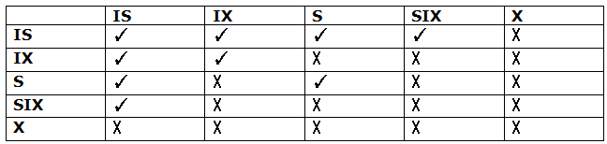

**The phantom problem**

A database is a collection of static elements like tuples.

If tuples are inserted/deleted then the phantom problem appears

A “phantom” is a tuple that is invisible during part of a transaction execution but not invisible during the entire execution

Even if they lock individual data items, could result in non-serializable execution

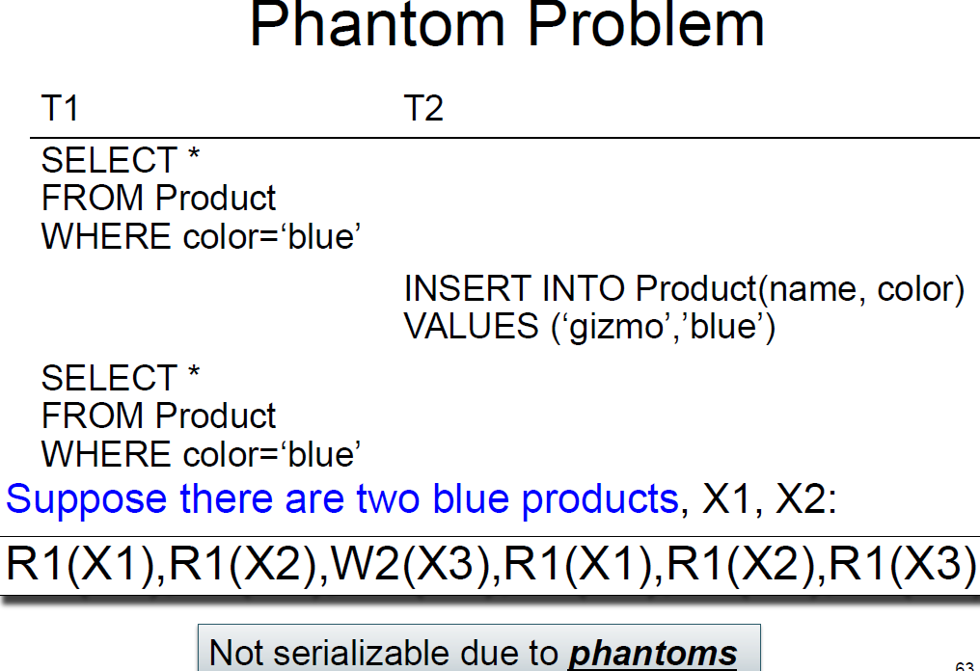

**In our example:**

– T1: reads the list of products

– T2: inserts a new product

– T1: re-reads: a new product appears!

**Dealing With Phantoms**

Lock the entire table, or

Lock the index entry for ‘blue’

– If the index is available

Or use predicate locks

– A lock on an arbitrary predicate

Dealing with phantoms is expensive!

**END**